

CRIS COVID-19

Suggested Workflow

Training Department

April 2020

Contents

Introduction 4

Purpose 4

Audience 4

Using Patient Alarms to identify COVID-19 cases 5

Creating COVID-19 Status Codes 6

Creating Cancelled Statuses 6

Creating Waiting or Planned Statuses 6

Planned Waiting List Status 6

Normal Waiting List Status 6

Using COVID-19 Status Cancellations / Waiting Lists 7

Standard Waiting List Request 7

Planned Waiting List Event with suggested deadline date 7

Using Resource Groups to identify COVID-19 requests 8

Allocating Groups to Events 8

Event Details Group Field 8

Post Processing Group Field 9

Allocating Events to a Group via the [Vetting List] 9

Allocating Events to a Group via the [Report Info List] 10

Creating Resource Groups and Resources (Stakeholders) 11

Creating a Resource Group 11

Creating a Resource 11

Creating COVID-19 Report Templates 13

Creating a COVID-19 Coded Phrases (Non VR Approach) 13

Using Coded Phrases for Reporting 15

Creating a COVID-19 Voice Commands for use with Dragon VR 16

Dragon Data Distribution Tool - Importing Commands to All Users 16

Important Notes regarding the Data Distribution Tool 17

Training the ICU COVID19 Dragon Voice Recognition Template 18

Using the ICU COVID19 Dragon Voice Recognition Template 19

Frequently Asked Questions 20

Remote Working Options 20

Changes to Appointment Letters and Output Formats 20

Radiology Training Portal Access 20

Free CRIS Training WebEx Booking Portal 20

# Copyright

© Wellbeing Software 2020

Registered Office: 3rd Floor i2 Mansfield, Hamilton Court, Oakham Business Park, Mansfield, NG18 5FB

These materials are or comprise restricted and proprietary confidential information of Wellbeing Software. Disclosure to or use by the recipient shall not convey any intellectual property rights in these materials. The right to use these materials by the recipient is subject to restrictions and limitations contained in the Provision of Integrated Care Record System and Associated Services Agreement and related agreements.

# Confidentiality

All information in this document is provided in confidence for the sole purpose of adjudication of the document and shall not be used for any other purpose and shall not be published or disclosed wholly or in part to any other party without Wellbeing Software’s prior permission in writing and shall be held in safe custody. These obligations shall not apply to information which is published or becomes known legitimately from some source other than Wellbeing Software. Many of the product, service and company names referred to in this document are trademarks or registered trademarks. They are all hereby acknowledged.

# Introduction

Purpose

The purpose of this document is to provide suggested workflow in conjunction with the current COVID-19 pandemic.

Audience

This document is intended to be used by any customers looking to facilitate workflow withing the CRIS Application in conjunction with COVID-19 care pathways.

# Using Patient Alarms to identify COVID-19 cases

Wellbeing Software would suggest utilising the Patient Alarms function to highlight any patients who are COVID-19 suspected (CVDS) or confirmed positive (CVDP).

New Alarm types can be added via Tables > Other Tables > General Tables > Alarms using the [New] button followed by [Save] once all relevant details have been completed.

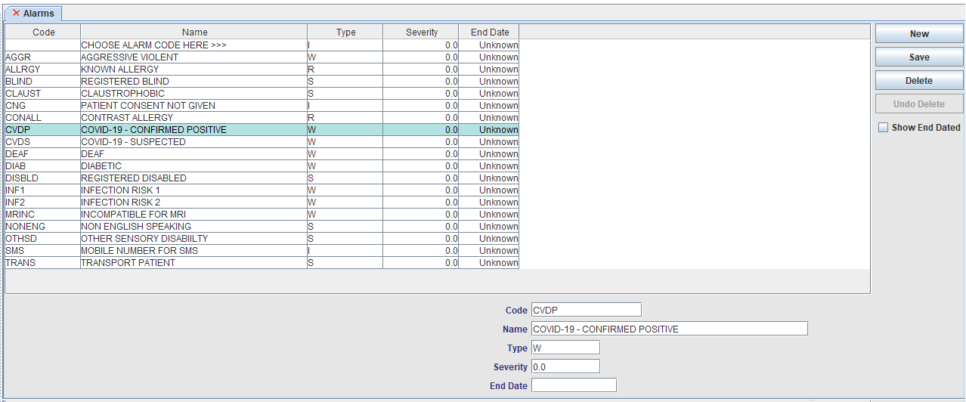

Alarms can then be added via Patient Details by clicking the [Add] button on the ‘Alarms’ section of the screen. Selecting the appropriate alarm ‘Code’ will populate the rest of the details, ahead of clicking [OK] followed by [Save Patient].

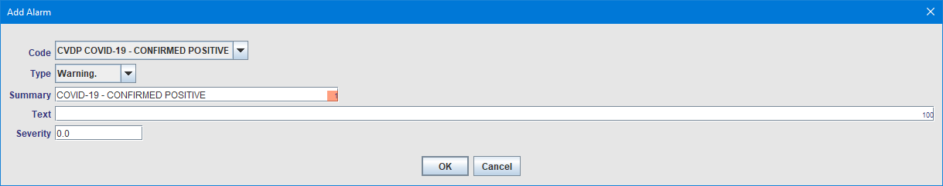

The alarm will flash via the patient banner upon loading the record, and highlight appointed records via the CRIS System Diary, enabling the appropriate safety measures to be undertaken during examinations.



Recording data in this manner would also facilitate the collection of statistical data to identify how many patients had booking changes, cancellations, breaches etc. due to the virus. Alarms can also be received via PAS if this function is supported by the 3rd party system.

# Creating COVID-19 Status Codes

The current COVID-19 pandemic has inevitably led to the need to cancel routine appointments. Given the on-going situation we recognise customers will need a method cancelling appointments and placing patients into waiting lists to process once normal working practice resumes. To create new COVID-19 cancellation statuses go to Tables > Other Tables > Status Codes and click [New] to add the following suggested options, prior to clicking [Save]

Creating Cancelled Statuses

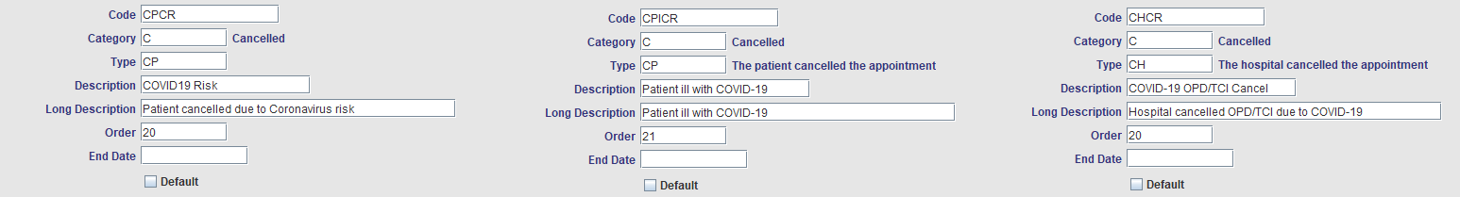The following codes are suggested by Wellbeing software based on customer requested processed to date, however each Trust can feel free to create their own codes and descriptions based on local practices and terminology.

Creating Waiting or Planned Statuses

The following codes are suggested by Wellbeing software based on customer requested processed to date. However each Trust should feel free to create their own codes and descriptions based on local practices and terminology and to determine if they would prefer events to be placed on a standard Waiting list (WN), or on a Planned Waiting (WPN) and therefore exempt from normal Diagnostic Waiting Times.

Planned Waiting List Status

Planned waiting statuses are exempt from normal Diagnostic Waiting Times, but will require an suggested deadline date to be specified when placed onto this list.

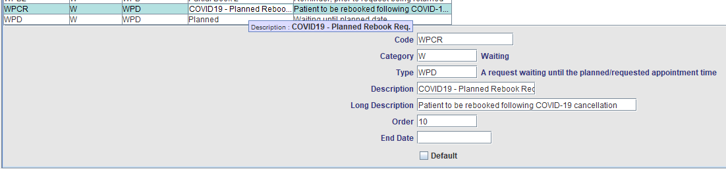

Normal Waiting List Status

Normal waiting statuses are counted in normal Diagnostic Waiting Times, but do not require a date to be specified when placed on this list.

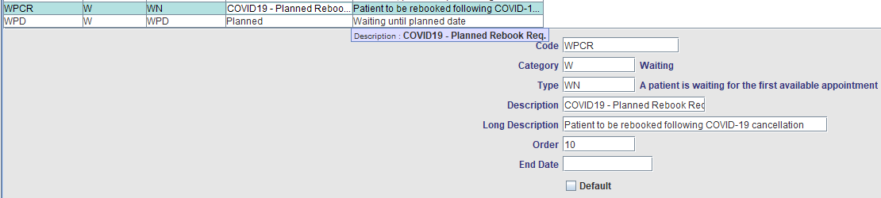

# Using COVID-19 Status Cancellations / Waiting Lists

Wellbeing Software would suggest all orders, requests and appointments affected by the current COVID-19 pandemic are cancelled using a COVID-19 Cancellation status. These can then either remain in that state to be picked up for subsequent rebooking at a later date, or placed on a COVID-19 Waiting List subject to agreed local workflow.

In all cases the action of cancel should be undertaken prior to placing on a waiting list or rebooking, in order to record the cancellation for audit purposes and clock resets as applicable.

The following routine Outpatient appointment has been cancelled by the hospital:

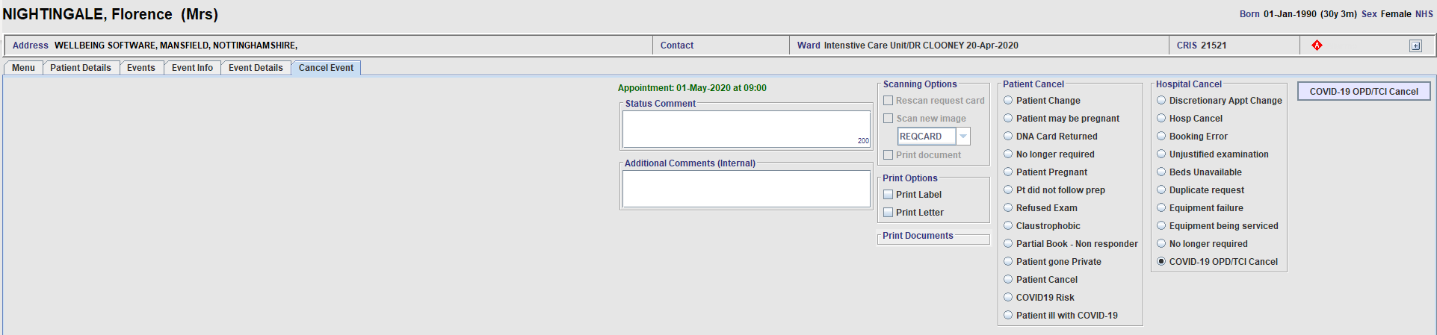

This can remain cancelled, to be rebooked later using CRIS Statistical Reports in order to identify all applicable records, or placed onto a CRIS Waiting List – either Standard or Planned dependant on local Trust policy.

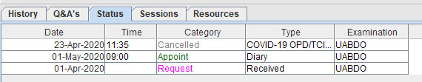

Standard Waiting List Request

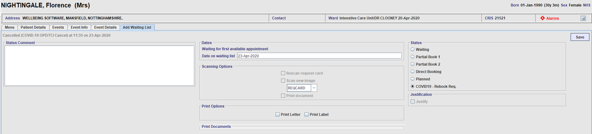

Planned Waiting List Event with suggested deadline date

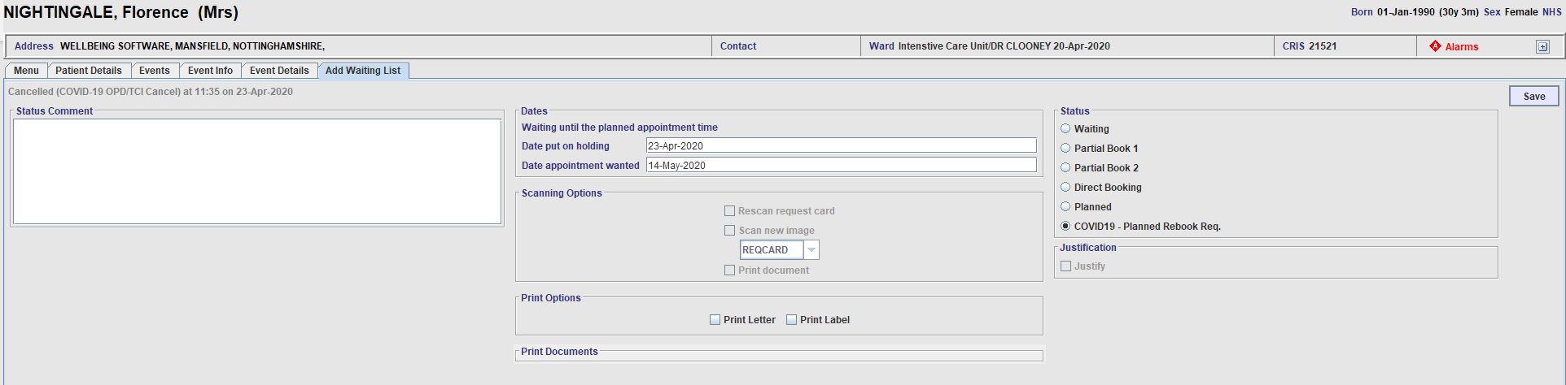

# Using Resource Groups to identify COVID-19 requests

The Resource Module can be utilised for allocating and managing requests in conjunction with Vetting, Scheduling and Reporting.

The resource module is available to all customer using 2.09.10t1 and above. A license is required and can be requested via the Wellbeing Service Desk or Prime Service Provider.

Full details on setting up the Resource Module can be found via CRIS_CRIB_IM_350_Resource Management Module_V3.0.doc

To make use of the Group you will need to ensure the following XR setting **GENERAL.SingleResourceGroupPerEvent** is set to 'Yes' at XRTR level and create the relevant Resource Group and associated Resources (i.e. Stakeholders).

Allocating Groups to Events

It is possible to allocate the Group field in the Event Details and Post Processing screens and to batch allocate events to a group via any Worklists such as the [Vetting List] and [Report Info List].

Event Details Group Field

Once implemented the ‘Group’ field can be allocated via the Event Details screen at any point.

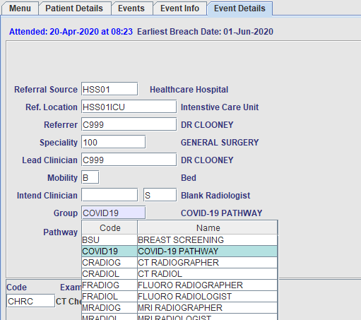

Post Processing Group Field

The ‘Group’ field can also be allocated at the time of Post processing

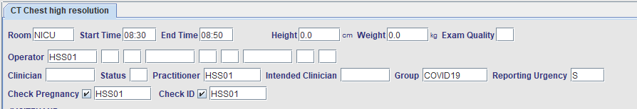

Allocating Events to a Group via the [Vetting List]

To allocate one or more events to a Group, you should select all required events via the use of use [Ctrl + Click], [Shift + Click] or by dragging a range, then select the required option via the ‘Group’ field at the bottom right hand corner of the screen and click [Assign].

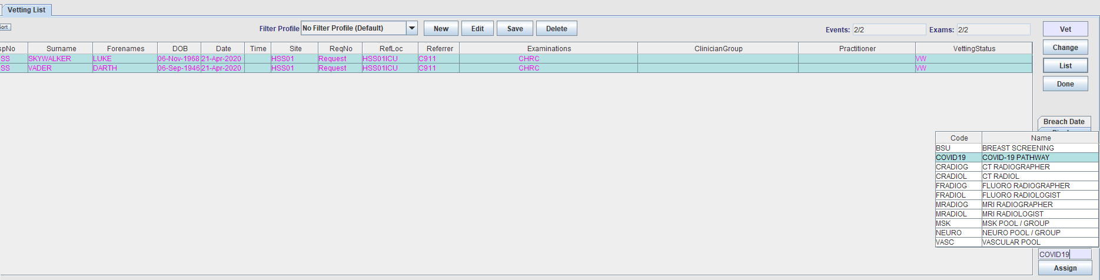

By adding the ‘Clinician Group’ Column to the Worklist it is possible to see the Group displayed on the list and filter by the ‘Group = COVID19’.

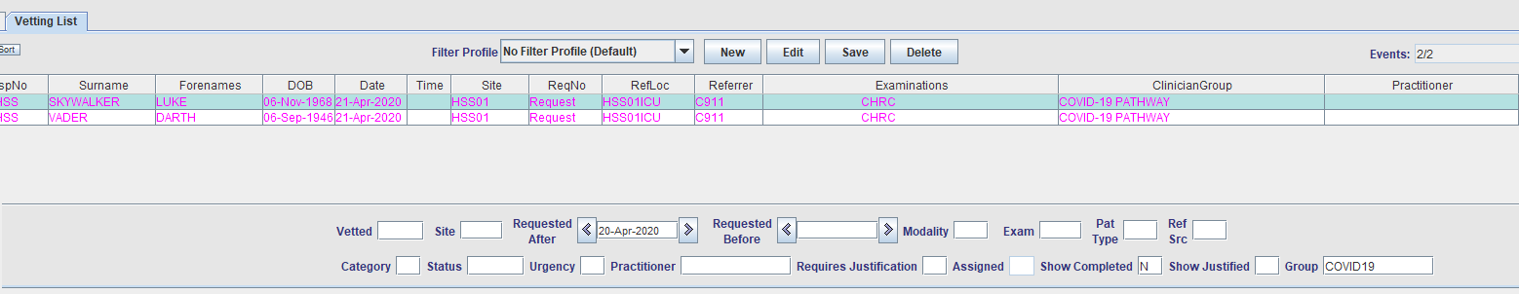

Please note: The Clinician Group column is only available to customer using CRIS 2.10.00 and above.

Allocating Events to a Group via the [Report Info List]

To allocate one or more events to a Group you should select all required events via the use of use [Ctrl + Click], [Shift + Click] or dragging a range, followed by right clicking your mouse to display the menu and choosing ‘allocate event(s) to group’.

Once the menu displays you can select the required group and click [Ok] to allocate events.

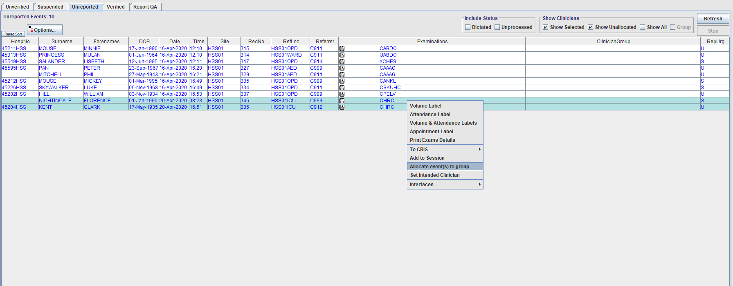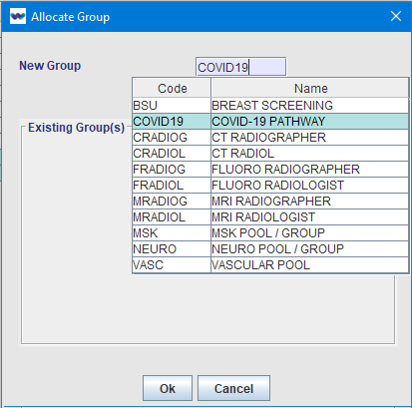

By adding the ‘Clinician Group’ Column to the Worklist it is possible to see the Group displayed on the list and filter the [Report Info List] by the ‘Group = COVID-19’

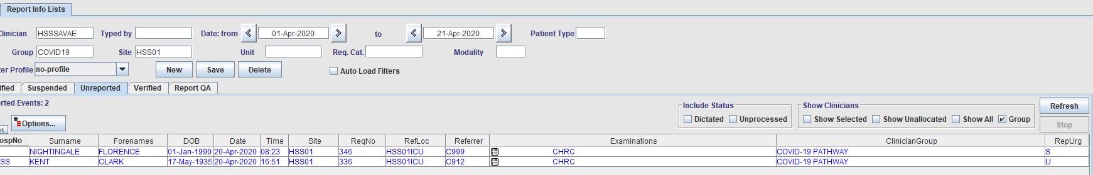

Please note: Events can also be allocated to a ‘Group’ individually, or as a batch via most Worklists including [Daylist], [Unprocessed], [Appointments], [Waiting List] and [Request List] using the right click menu. It is also possible to assign to Group via the ‘Events’ list on an individual patient record.

Creating Resource Groups and Resources (Stakeholders)

CRIS System Managers can create Resource Groups and Resources for use throughout the system as follows:

Creating a Resource Group

**Resource Groups** are groups of available staff / resources (i.e. COVID19 – a pool of stakeholders who can vet, perform or report examinations). Resources can belong to multiple groups at any time.

To create a Resource Group for use via the Personnel Management System, go to **TABLES > PEOPLE TABLES > RESOURCE GROUPS**

1. Click the [New] button to create a Resource Group and enter the following details:

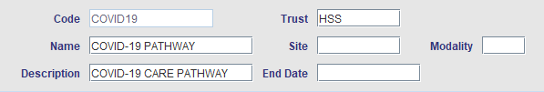

|  |  |
| --- | --- |
| Field | Description |
| Code | Enter the unique code for the group being created (i.e. COVID19) |
| Trust | Enter the Trust code which the group belongs |
| Name | Use this field to identify the group being setup (i.e. Radiologists, Radiographers, or Nurses etc.) which will appear in the [F4] prompt |
| Site | Enter a site code if the group is site specific or leave blank if this group is applicable across multiple sites |
| Description | Enter a description of the purpose of the group if applicable (i.e. COVID-19 CARE PATHWAY) |
| End date | If the resource group is no longer in use, type an end date. |

1. Click [Save] to complete the creation of the new group.

You can subsequently edit any part of the category except the code should the need arise in future. Wellbeing Software do not however recommend the use of [Delete] unless you are removing a code that you have only just added and reconsider, not a code which could conceivably have become available and become in use within the system. Wellbeing Software would instead recommend the use of the end date.

Creating a Resource

**Resources** represent clinical personnel who are specifically required to perform examinations (i.e. Radiologist or Sonographer) or any other kind of requirement (i.e. Radiographic assistant, or equipment such as mobile imaging) for an examination. A resource may belong to several groups.

To create a Resource for use via the Personnel Management System, go to **TABLES > PEOPLE TABLES > RESOURCES**

1. Click the [New] button to create a Resource and enter the following details:

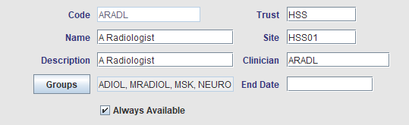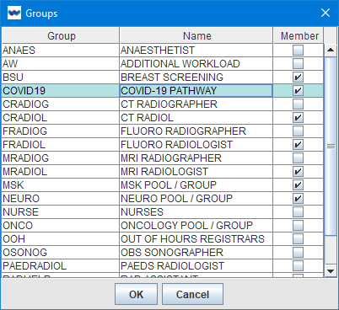

|  |  |
| --- | --- |
| Field | Description |
| Code | Enter a code to identify the resource. Wellbeing Software would recommend using the existing CRIS Login ID, or you should ensure that you use the Clinician ID if this is different to Login ID if you wish to use Reporting Groups. Reporting Groups will not function if the Resource Code and Clinician code are different. |
| Name | Enter the full name of the human resource being created, or alternative a description of the type of resource (i.e. Mobile Imager 1) |
| Description | Enter the description of the resource (i.e. General and CT Radiographer or Mobile Imaging) Used to identify what type of resource the person is i.e. Radiologist, Radiographer Nurse etc. |
| [Groups] | Click the [Groups] function button to assign the resource to all relevant groups via the ‘Groups’ selection dialogue box |
| Trust | Enter the Trust the resource is associated with |
| Site | Enter the Site the resource is primarily associated or leave blank if they would equally at more one site. |
| Clinicians | If the human resource being setup on the system already has an existing ‘Clinician’ code, ensure that this is entered in order to facilitate the auto assignment of the resource when the ‘Required Clinician’ field is completed via the Event Details or Vetting screens. |
| End Date | If the resource is no longer in use, type an end date. |
| Always Available | This function is designed to indicate that the individual resource is exempt from Appointment Scheduling – i.e. When the resource module is being used to assign groups for Vetting and Reporting purposes but not scheduling via the CRIS Appointments module in conjunction with the Resource Module Personnel Rota functionality. This is also useful for equipment.  Selecting this option negates the need to create / maintain daily personnel resource schedules for resources that are always available or subject to standard CRIS Room Diary schedules.  Please note: Most customers will need to tick this option as it should be utilised by anyone who is not using the CRIS Personnel Rota functionality – i.e. Staff Rota’s via CRIS. |

1. Click [Save] to complete the creation of the new resource.

# Creating COVID-19 Report Templates

It is possible to create report templates using Dragon Voice Recognition or via CRIS Coded Phrases in the event VR is not in use or available at the time of reporting. The following phrases have been created in conjunction with NHS Digital who would like all suppliers to help Trusts with a template to standardise reporting of COVID19 cases.

Creating a COVID-19 Coded Phrases (Non VR Approach)

Coded phrases enable reporting clinicians to type a code and press [Alt + P] to expand the code into a phrase comprising one or several sentences of text. This is a fast and convenient way of inserting standard report text with minimum effort on the part of the reporter.

CRIS System Managers can set-up coded phrases via **TABLES > OTHER TABLES > REPORTS > CODED PHRASES**

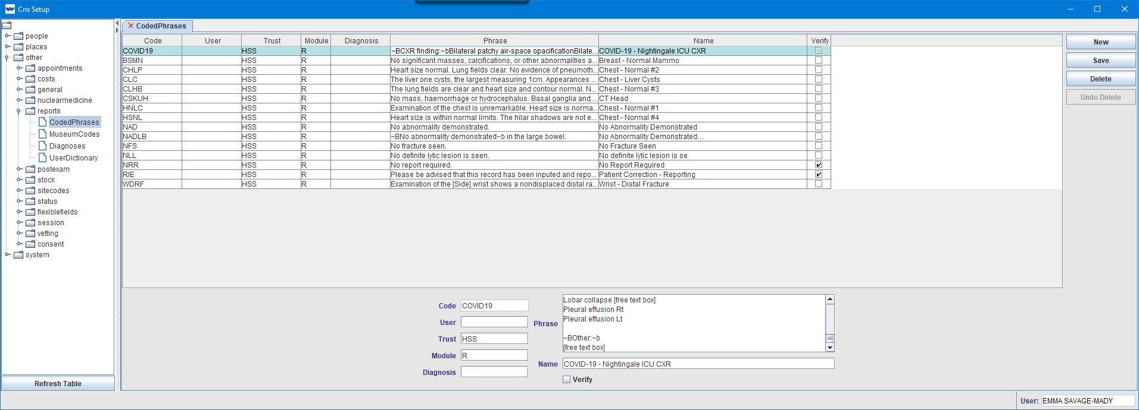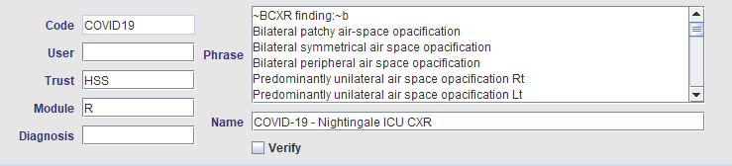

To add a Coded Phrase, click on [NEW], complete the fields as below and click on [SAVE].

|  |  |
| --- | --- |
| Details | |
| Code | Type in the Phrase Code – i.e. COVID19 |
| User | If the phrase is to be specific to one person, insert his/her user ID in the USER Field, otherwise leave it blank. (Please note, if the person typing the report, is different to the person assigned in the User field, the coded phrase cannot be used, i.e. code assigned to a Radiologist but Secretary is typing, he/she will not be able to use the code). |
| Trust | Enter your own Trust code in order to enable Trust specific codes and negate the need to ensure all reporting codes are unique at Consortium level – i.e. An NAD code can be applied at each Trust with an alternative phrase if required |
| Module | R (for Reporting) will be auto populated |
| Diagnosis | Enter the Diagnosis code as defined in TABLES > OTHER > REPORTS > DIAGNOSES if required |
| Text* | Type the phrase that is to be displayed. This can be one word or several paragraphs in length.  Text can be formatted using the following simple options, but tab formatting and tables is not supported:  **~B**Use to create Bold Text**~b** **~I**Use to create Italic Text**~i** **~U**Use to underline Text**~u** |
| Name | Enter the name of the phrase which will appear in the prompt list up to a maximum of 30 characters – i.e. COVID-19 - Nightingale ICU CXR |
| Verify | Clicking on the Verify box will determine whether or not the phrase is automatically verified |

NHS Digital Standard Text for use in conjunction with Nightingale ICU Chest Reports*

The following text including formatting should be copied and pasted into the ‘Text’ field when setting up the coded phrase:

~BCXR finding:~b

Bilateral patchy air-space opacification

Bilateral symmetrical air space opacification

Bilateral peripheral air space opacification

Predominantly unilateral air space opacification Rt

Predominantly unilateral air space opacification Lt

~BStable or progressive since previous:~b

Stable Marginal improvement

Marginal progression

Significant progression

~BLines and Tubes Satisfactory:~b

Misplaced ETT

Misplaced NGT

Misplaced IJV line

Other

~BOther findings:~b

Nil

Pneumothorax Rt / Lt

Lobar collapse [free text box]

Pleural effusion Rt

Pleural effusion Lt

~BOther:~b

[free text box]

Please note: The above text has been provided by NHS Digital for us by customers in conjunction with Nightingale ICU Chest reporting.

Using Coded Phrases for Reporting

Coded phrases can be used in conjunction with the CRIS Report Editor, when accessed via the [Report Info List] or any other applicable method – i.e. clicking [Report] on an individual patient record.

From the report editor, reporting clinicians should insert Clinical History and Exam Titles are normal using [Alt + E] in each relevant section of the screen.

Having done this type the required coded phrase – i.e. COVID19 and press [Alt + P] immediately afterwards to insert the full text of the phrase as follows:

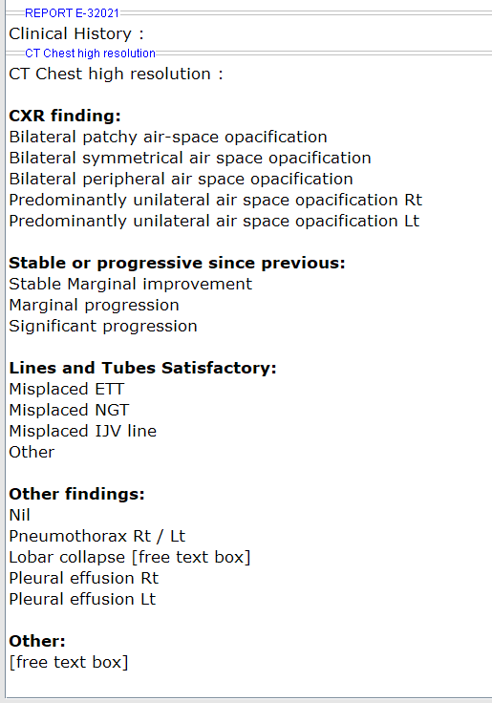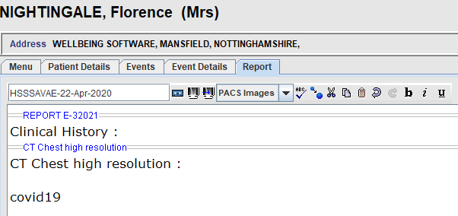

The report can then be edited as applicable to the patient and saved as normal by clicking [Verify].

Creating a COVID-19 Voice Commands for use with Dragon VR

The Wellbeing Service Team have created the following Dragon Command in conjunction with NHS Digital, who would like all suppliers to help Trusts with a template to standardise reporting of COVID19 cases. This file will need to be unzipped before use. This file is also available via <http://cloud.hssnet.com/training/%23COVID-19%20Resources/>



Please note: Advanced scripting to create conditional and context specific commands, is also available on demand via the Wellbeing Service Desk in conjunction with COVID-19 requirements.

Dragon Data Distribution Tool - Importing Commands to All Users

The unzipped command can be deployed to all Dragon users via use of the Dragon ‘Data Distribution Tool’. This is located via Start > Dragon Medical 13 > Dragon Medical Practice Edition > Data Distribution Tool. Select the 'Add or Remove shared commands' option and click [Next] before choosing the appropriate language. On the following screen click [Import] and choose the unzipped **ICU COVID19 Template.dat** file

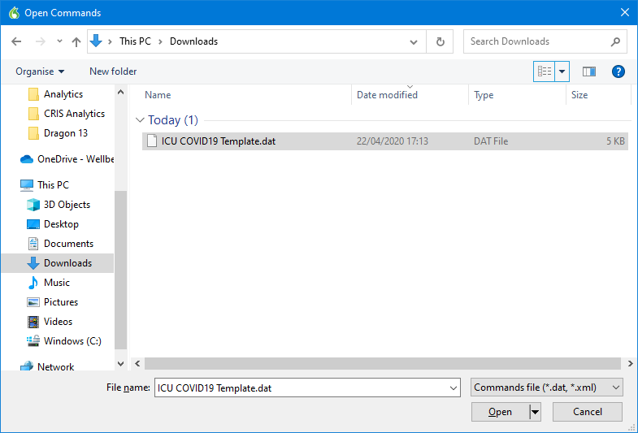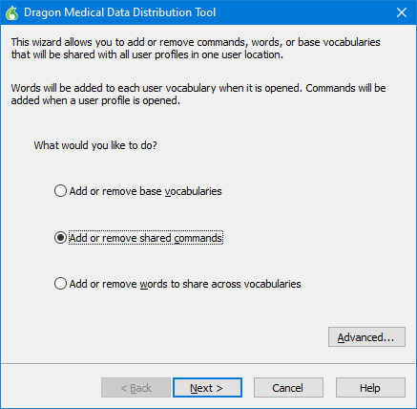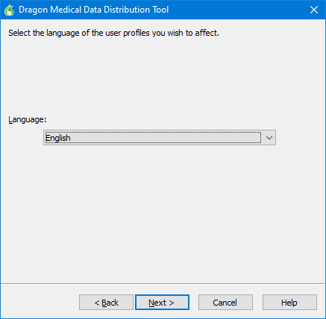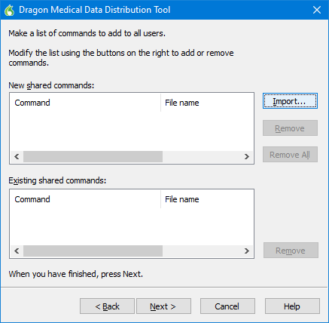

Having done this click [Next], this will then begin importing the commands.

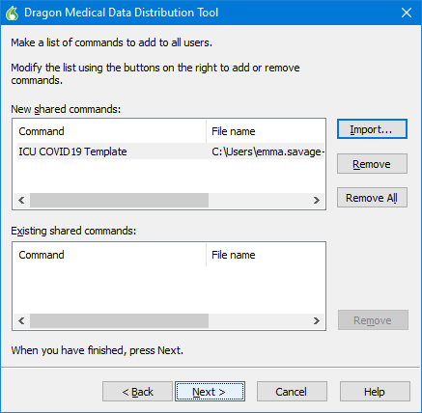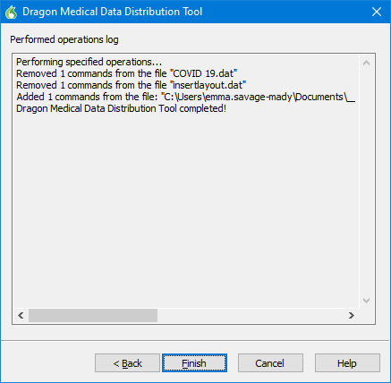

If roaming is enabled and is mapped on workstation the commands will be imported to all users on the roaming share. If roaming is not enabled, then the commands will be passed to all users who are set up on the individual terminal.

Please note: Commands can be removed from all users using the 'existing shared commands section' and selecting remove.

Important Notes regarding the Data Distribution Tool

The ‘Data Distribution Location’ should be set as a location that all Dragon users have access to allow each user to import the available commands (usually the dragon roaming profiles location). A folder should be created at the location named ‘SharedCommands’, commands placed in the folder are available to all users. Commands will need to be trained by each Dragon user.

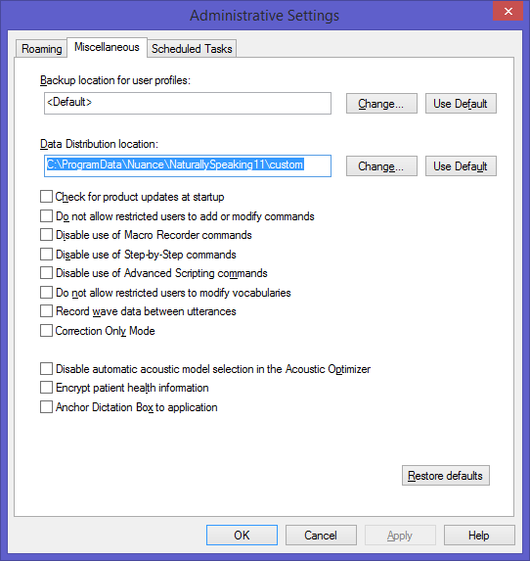

Training the ICU COVID19 Dragon Voice Recognition Template

Once the new command is imported for all users, it will be necessary for each Dragon user to Train the new command for use in conjunction with reporting.

To do this click the ‘VR Command Browser’ from the Tools Menu via CRIS:

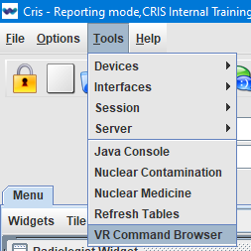

Select the **ICU COVID19 Template**, right click and select ‘Edit’ from the resulting menu followed by [Train]

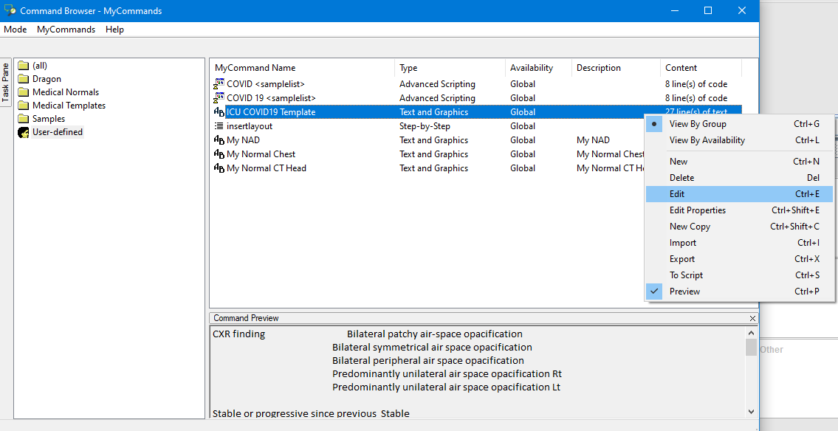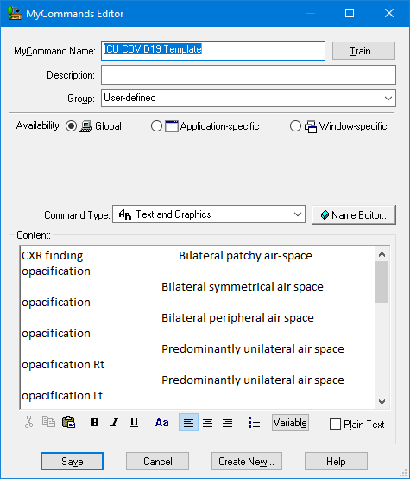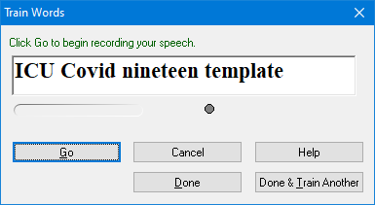

Click [Done] to save and complete the training.

Using the ICU COVID19 Dragon Voice Recognition Template

Dragon VR Commands can be used in conjunction with the CRIS Report Editor, when accessed via the [Report Info List] or any other applicable method – i.e. clicking [Report] on an individual patient record.

From the report editor reporting clinicians should insert Clinical History and Exam Titles via the use of either the combined **Insert All Titles** command or individual **Insert Exam Titles** command.

Having done this, they can proceed to dictate **ICU COVID19 Template** which will insert the report text as follows:

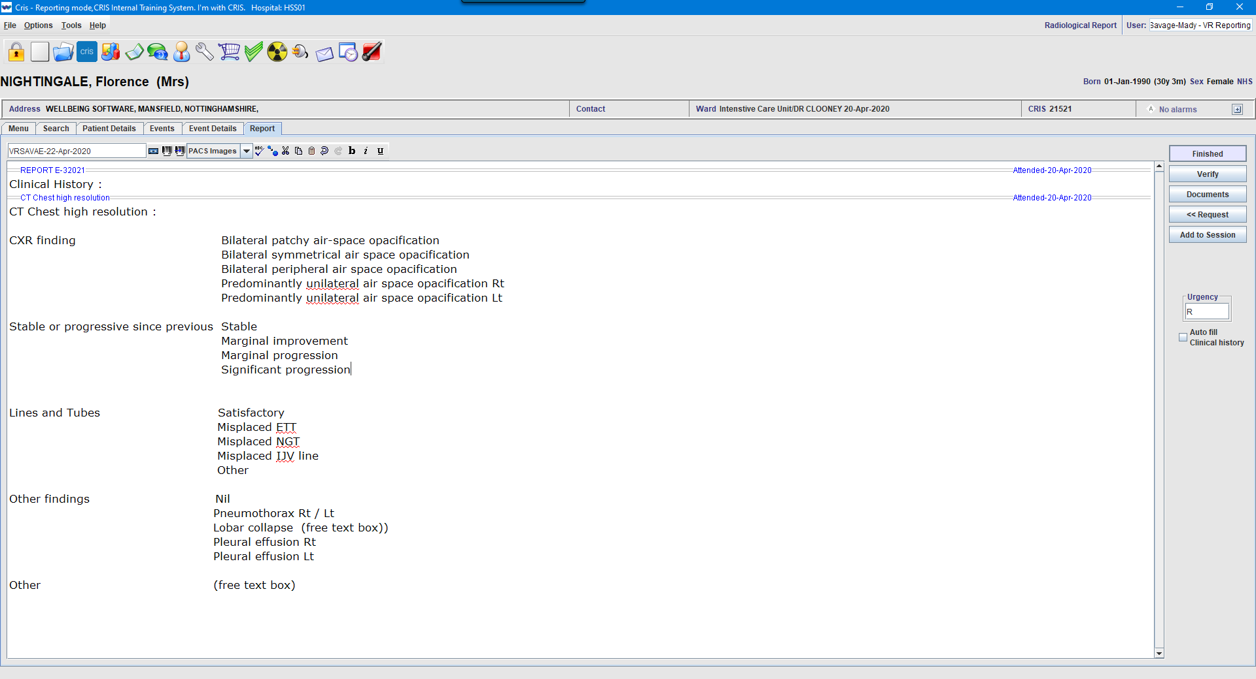

The report can then be edited as applicable to the patient and saved as normal by dictating [Verify Report].

# Frequently Asked Questions

Remote Working Options

The Wellbeing Service Team have put together a number of documents to support IT departments and customers in facilitating working from home. All documents can be accessed via <http://cloud.hssnet.com/training/%23COVID-19%20Resources/RemoteWorking_Support_Documents/>

Changes to Appointment Letters and Output Formats

The Wellbeing Service Team has already supported a number of customers in making changes to Appointment and Cancellation letters and will be happy to help should you have any COVID-19 related requirements during this time.

Please log a service request through the usual channels to access this service.

Radiology Training Portal Access

All Training Documentation including CRIB Sheets, User Release Notes, Training Guides, WebCasts and eLearning Modules are now located via <http://cloud.hssnet.com/training/> and requires the following access details:

Username: **radiology**

Password: **p0rt4l**

In addition to this our training team also provide a variety of training WebEx’s free of charge. They can be seen and booked on the link below. It is worth bookmarking this site as courses will be added over time.

Free CRIS Training WebEx Booking Portal

<https://bookwhen.com/wellbeingtraining>

As courses are interactive there is a limit to the number of people that can sign up for each one. There is however a waiting list function where you can register interest and will be informed if any places are cancelled, or the Wellbeing Training Team increase places. The Wellbeing Training Team is constantly assessing the demand for each course and either extending sessions or scheduling additional sessions. We would however ask that you please only sign up for yourself, not on behalf of someone else (although feel free to pass the link onto your users).

This is to ensure we only holding details of people who have provided their own information. We also ask that if you do book a course and are unable to attend, please cancel via the bookings page so someone else can utilise the slot as sessions are often in high demand.

# Document Control

|  |  |  |  |  |  |
| --- | --- | --- | --- | --- | --- |
| Title | | COVID-19 CRIS Suggested Workflow | | | |
| Owner | | Wellbeing Training Manager | | Date Created | 22/04/2020 |
| File Ref. | | CRIS_COVID-19_Suggested_Workflow_WS_V1.0.docx | | | |
| CRIS Version | |  | | | |
| Change History | | | | | |
| Issue | Date | | Author / Editor | Details of Change | |
| D1.0 | 22/04/2020 | | Emma Savage-Mady | Draft Issue | |
| V1.0 | 23/04/2020 | | Emma Savage-Mady | First Issue | |
|  |  | |  |  | |
|  |  | |  |  | |
|  |  | |  |  | |
|  |  | |  |  | |
|  |  | |  |  | |
|  |  | |  |  | |
| Review Date | | | 23/05/2020 | | |