

Training Department

### 

CRIS Letter Formats: Exercises

September 2022

Copyright

© Healthcare Software Solutions 2022

Registered Office: 3rd Floor i2 Mansfield, Hamilton Court, Oakham Business Park, Mansfield, NG18 5FB

These materials are or comprise restricted and proprietary confidential information of Healthcare Software Solutions. Disclosure to or use by the recipient shall not convey any intellectual property rights in these materials. The right to use these materials by the recipient is subject to restrictions and limitations contained in the Provision of Integrated Care Record System and Associated Services Agreement and related agreements.

**Confidentiality**

All information in this document is provided in confidence for the sole purpose of adjudication of the document and shall not be used for any other purpose and shall not be published or disclosed wholly or in part to any other party without HSS prior permission in writing and shall be held in safe custody. These obligations shall not apply to information which is published or becomes known legitimately from some source other than HSS. Many of the product, service and company names referred to in this document are trademarks or registered trademarks. They are all hereby acknowledged.

Table of Contents

Exam Preparation Letters 4

US General 4

US Full Bladder (Standard Outpatient) 5

US Fast & Full Bladder (Alternative Exam Preparation) 7

US Fast (Standard Outpatient) 9

Barium Meal (Standard Out Patient – Adult, Child AM &PM) 11

Barium Meal (Standard Inpatient) 12

Barium Enema (Standard Out Patient) 16

CT Oral & Starve (Standard Out Patient) 16

MRI GENERAL INFORMATION 17

MRI Sedation Letter (Alternative MRI Letter) 18

Defecating Proctogram X-Ray (Standard Out Patient) 19

DEXA Scan X-Ray (Standard Out Patient) 21

Directions 22

DIRS_HSS_CARPARK 22

DIRS_HSS_US 22

DIRS_HSS_CT 22

DIRS_HSS_XR 22

DIRS_HSS_FL 22

LMP Text (Pregwarn) 23

Modality CT or MR = 10 day Rule 23

Modality Angiography or Fluoroscopy = 28 day Rule 23

Modality Nuclear Medicine or Radiology = Other Rule 23

Partial Booking 2 - Telephone Letter (WPB2) 23

Partial Booking Non Responder - Cancellation Letter (CPNR) 24

Referrer Rejection Letter – Vetting Rejected (CHUN) 25

6. MRI Questionnaire 26

Reference Sources 27

Appendix 28

# Exam Preparation Letters

ULTRASOUND LETTERS

US General

ARRIVAL

On arrival you will be asked if you want to undress and change into a gown. A hospital gown will be provided for you to wear if necessary. If you wish to bring a dressing gown with you to wear please do so.

VALUABLES

Most x-ray procedures necessitate the removal of items of jewellery. Please do not bring large sums of money or items of value to the hospital.

CONFIRMATION

**\*\*\*IMPORTANT\*\*\***

Please bring this letter with you when you attend.

Alternatively, if you are unable to attend for your appointment please contact us immediately for an alternative date. Your prompt action will enable us to offer this appointment to another patient.

FAILURE TO ATTEND

If you failed to attend and have not telephoned the department in advance, no further appointment will be sent out.

If you require an ambulance please contact the department at least one week before your appointment time to allow us to arrange it.

DIRECTIONS

The Ultrasound Department is located on the 1st floor of the MAIN ENTRANCE to the hospital.

ULTRASOUND GENERAL INFORMATION

**WHAT DOES AN ULTRASOUND SCAN INVOLVE?**

An ultrasound scan obtains a picture of the inside of your body by using high frequency sound waves which are transmitted through a part of the body and reflected by the internal organs and structures. These "echoes" form a picture on a television monitor which can then be analysed.

In the ultrasound room you will be asked to lie down on the ultrasound couch. The examination is performed by a Radiologist (a doctor specialising in X-ray work) or an Ultrasonographer (a Radiographer specialising in ultrasound). A Nurse may also be present.

Ultrasound gel will be put on your skin over the area being examined. A small handheld instrument will then be moved over the skin.

The instrument causes no pain, but if the area is already tender there may be a little discomfort if the doctor has to press more firmly in order to obtain a clear picture.

The examination should take approximately 20 minutes to complete and you should not have any side effects.

We cannot guarantee the exact time your examination will be started as it is often the case that the previous patient's examination has taken a little longer than expected.

**WHY DO I NEED A ULTRASOUND SCAN?**

Your doctor has asked for an ultrasound to try and determine the cause of your problems. This is a simple way to examine your body. There are no known side effects from medical ultrasound.

During the examination do not hesitate to ask any questions or queries about your test however, you will NOT be given the results of your test on the day. The results will be sent to the doctor who has requested this test.

US Full Bladder (Standard Outpatient)

EXAM PREPARATION

INFANT PREP – LESS THAN 2 YEARS OLD

Your child must drink at least half a cup of water 90 minutes before their appointment time. After drinking the water your child should not go to the toilet.

CHILD PREP – OVER 2 YEARS OLD

Your child must drink at least a cup of water 90 minutes before their appointment time. After drinking the water your child should not go to the toilet.

ADULT PREP

You must have a very full bladder. Drink approximately 2 pints of water 90 minutes before your appointment time. Please drink this over a period of 30 minutes. After drinking the water DO NOT go to the toilet.

You may take any medication as normal, including water tablets.

**FAILURE TO FOLLOW THIS PREPARATION WILL CAUSE A DELAY OR A RE-APPOINTMENT OF YOUR EXAMINATION.**

ARRIVAL

On arrival you will be asked if you want to undress and change into a gown. A hospital gown will be provided for you to wear if necessary. If you wish to bring a dressing gown with you to wear please do so.

VALUABLES

Most x-ray procedures necessitate the removal of items of jewellery. Please do not bring large sums of money or items of value to the hospital.

CONFIRMATION

**\*\*\*IMPORTANT\*\*\***

Please bring this letter with you when you attend.

Alternatively, if you are unable to attend for your appointment please contact us immediately for an alternative date. Your prompt action will enable us to offer this appointment to another patient.

FAILURE TO ATTEND

If you failed to attend and have not telephoned the department in advance, no further appointment will be sent out.

If you require an ambulance, please contact the department at least one week before your appointment time to allow us to arrange it.

DIRECTIONS

The Ultrasound Department is located on the 1st floor of the MAIN ENTRANCE to the hospital.

ULTRASOUND GENERAL INFORMATION

**WHAT DOES AN ULTRASOUND SCAN INVOLVE?**

An ultrasound scan obtains a picture of the inside of your body by using high frequency sound waves which are transmitted through a part of the body and reflected by the internal organs and structures. These "echoes" form a picture on a television monitor which can then be analysed.

In the ultrasound room you will be asked to lie down on the ultrasound couch. The examination is performed by a Radiologist (a doctor specialising in X-ray work) or an Ultrasonographer (a Radiographer specialising in ultrasound). A Nurse may also be present.

Ultrasound gel will be put on your skin over the area being examined. A small hand held instrument will then be moved over the skin.

The instrument causes no pain, but if the area is already tender there may be a little discomfort if the doctor has to press more firmly in order to obtain a clear picture.

The examination should take approximately 20 minutes to complete and you should not have any side effects.

We cannot guarantee the exact time your examination will be started as it is often the case that the previous patient's examination has taken a little longer than expected.

**WHY DO I NEED A ULTRASOUND SCAN A SCAN?**

Your doctor has asked for an ultrasound to try and determine the cause of your problems. This is a simple way to examine your body. There are no known side effects from medical ultrasound.

During the examination do not hesitate to ask any questions or queries about your test however, you will NOT be given the results of your test on the day. The results will be sent to the doctor who has requested this test.

US Fast & Full Bladder (Alternative Exam Preparation)

EXAM PREPARATION

You must not eat or drink anything (except water) for 6 hours before your examination. Drink approximately 2 pints of water 90 minutes before your appointment time. Please drink this over a period of 30 minutes. After drinking the water DO NOT go to the toilet until you had your scan.

DIABETIC PREP

If you are diabetic controlled by diet alone, fast for 6 hours.

If you are diabetic requiring tablets or insulin DO NOT take these on the morning of your examination. Do bring your medication with you to take after the examination with something to eat.

If you are diabetic controlled by tablets or insulin you should have an early morning appointment (before 10.00AM). Please contact the department if you do not have an early appointment.

All other medication can be taken as normal.

**FAILURE TO FOLLOW THIS PREPARATION WILL CAUSE A DELAY OR A RE-APPOINTMENT OF YOUR EXAMINATION.**

ARRIVAL

On arrival you will be asked if you want to undress and change into a gown. A hospital gown will be provided for you to wear if necessary. If you wish to bring a dressing gown with you to wear please do so.

VALUABLES

Most x-ray procedures necessitate the removal of items of jewellery. Please do not bring large sums of money or items of value to the hospital.

CONFIRMATION

**\*\*\*IMPORTANT\*\*\***

Please bring this letter with you when you attend.

Alternatively, if you are unable to attend for your appointment please contact us immediately for an alternative date. Your prompt action will enable us to offer this appointment to another patient.

FAILURE TO ATTEND

If you failed to attend and have not telephoned the department in advance, no further appointment will be sent out.

If you require an ambulance please contact the department at least one week before your appointment time to allow us to arrange it.

DIRECTIONS

The Ultrasound Department is located on the 1st floor of the MAIN ENTRANCE to the hospital.

ULTRASOUND GENERAL INFORMATION

**WHAT DOES AN ULTRASOUND SCAN INVOLVE?**

An ultrasound scan obtains a picture of the inside of your body by using high frequency sound waves which are transmitted through a part of the body and reflected by the internal organs and structures. These "echoes" form a picture on a television monitor which can then be analysed.

In the ultrasound room you will be asked to lie down on the ultrasound couch. The examination is performed by a Radiologist (a doctor specialising in X-ray work) or an Ultrasonographer (a Radiographer specialising in ultrasound). A Nurse may also be present.

Ultrasound gel will be put on your skin over the area being examined. A small hand held instrument will then be moved over the skin.

The instrument causes no pain, but if the area is already tender there may be a little discomfort if the doctor has to press more firmly in order to obtain a clear picture.

The examination should take approximately 20 minutes to complete and you should not have any side effects.

We cannot guarantee the exact time your examination will be started as it is often the case that the previous patient's examination has taken a little longer than expected.

**WHY DO I NEED A ULTRASOUND SCAN A SCAN?**

Your doctor has asked for an ultrasound to try and determine the cause of your problems. This is a simple way to examine your body. There are no known side effects from medical ultrasound.

During the examination do not hesitate to ask any questions or queries about your test however, you will NOT be given the results of your test on the day. The results will be sent to the doctor who has requested this test.

US Fast (Standard Outpatient)

EXAM PREPARATION

You must not eat or drink anything for 6 hours before the examination.

DIABETIC PREP

If you take water tablets, please DO take them as normal.

If you are diabetic controlled by diet alone fast for 6 hours.

If you are diabetic requiring tablets or insulin DO NOT take these on the morning of your examination. Do bring your medication with you to take after the examination with something to eat.

If you are a diabetic controlled by tablets or insulin you should have an early morning appointment (before 10.00AM). Please contact the department if you do not have an early appointment.

All other medication can be taken as normal.

**FAILURE TO FOLLOW THIS PREPARATION WILL CAUSE A DELAY OR A RE-APPOINTMENT OF YOUR EXAMINATION.**

ARRIVAL

On arrival you will be asked if you want to undress and change into a gown. A hospital gown will be provided for you to wear if necessary. If you wish to bring a dressing gown with you to wear please do so.

VALUABLES

Most x-ray procedures necessitate the removal of items of jewellery. Please do not bring large sums of money or items of value to the hospital.

CONFIRMATION

**\*\*\*IMPORTANT\*\*\***

Please bring this letter with you when you attend.

Alternatively, if you are unable to attend for your appointment please contact us immediately for an alternative date. Your prompt action will enable us to offer this appointment to another patient.

FAILURE TO ATTEND

If you failed to attend and have not telephoned the department in advance, no further appointment will be sent out.

If you require an ambulance please contact the department at least one week before your appointment time to allow us to arrange it.

DIRECTIONS

The Ultrasound Department is located on the 1st floor of the MAIN ENTRANCE to the hospital.

ULTRASOUND GENERAL INFORMATION

**WHAT DOES AN ULTRASOUND SCAN INVOLVE?**

An ultrasound scan obtains a picture of the inside of your body by using high frequency sound waves which are transmitted through a part of the body and reflected by the internal organs and structures. These "echoes" form a picture on a television monitor which can then be analysed.

In the ultrasound room you will be asked to lie down on the ultrasound couch.

The examination is performed by a Radiologist (a doctor specialising in X-ray work) or an Ultrasonographer (a Radiographer specialising in ultrasound). A Nurse may also be present.

Ultrasound gel will be put on your skin over the area being examined. A small hand held instrument will then be moved over the skin.

The instrument causes no pain, but if the area is already tender there may be a little discomfort if the doctor has to press more firmly in order to obtain a clear picture.

The examination should take approximately 20 minutes to complete and you should not have any side effects.

We cannot guarantee the exact time your examination will be started as it is often the case that the previous patient's examination has taken a little longer than expected.

**WHY DO I NEED A ULTRASOUND SCAN A SCAN?**

Your doctor has asked for an ultrasound to try and determine the cause of your problems. This is a simple way to examine your body. There are no known side effects from medical ultrasound.

During the examination do not hesitate to ask any questions or queries about your test however, you will NOT be given the results of your test on the day. The results will be sent to the doctor who has requested this test.

FLUOROSCOPY

Barium Meal (Standard Out Patient – Adult, Child AM &PM)

Adult AM

Please have nothing to eat or drink from midnight on the night of examination. The examination is expected to take approximately 1 hour.

**YOU SHOULD NOT STOP TAKING VITAL MEDICINES (HEART DRUGS, STEROIDS, ETC.)**

INSULIN DEPENDENT DIABETICS AND PATIENTS TAKING METFORMIN (Glucophage) PLEASE TELEPHONE THE DEPARTMENT.

**FAILURE TO FOLLOW THIS PREPARATION WILL CAUSE A DELAY OR THE NEED TO RE-BOOK YOUR EXAMINATION.**

ARRIVAL

On arrival you will be asked if you want to undress and change into a gown. A hospital gown will be provided for you to wear if necessary. If you wish to bring a dressing gown with you to wear please do so.

VALUABLES

Most x-ray procedures necessitate the removal of items of jewellery. Please do not bring large sums of money or items of value to the hospital.

Child AM

YOUR CHILD SHOULD HAVE NOTHING TO EAT OR DRINK FROM 10:30pm THE PREVIOUS EVENING.

PLEASE BRING A SELECTION OF YOUR CHILD'S FAVOURITE FOOD FROM THE LIST BELOW

1. LIQUID: Juice or milk - please bring the child's own bottle and teat or cup/spoon as appropriate.

2. SEMI-SOLID: Custard or yoghurt or baby food.

3. SOLID: Bread or biscuit

**DO NOT STOP YOUR CHILD TAKING VITAL MEDICINES (HEART DRUGS, STEROIDS, ETC.) INSULIN DEPENDENT DIABETICS PLEASE TELEPHONE THE DEPARTMENT.**

The time stated for the appointment is approximate and delay is often due to the length of time taken for a previous examination. If there is a problem please contact reception and notify them of this.

**MOTHERS/GUARDIANS PLEASE NOTE -** If there is any possibility of your being pregnant at the time of your child's x-ray, please bring someone else along to go into the x-ray room.

Adult PM

Please have nothing to eat or drink from 8am on the day of examination. The examination is expected to take approximately 1 hour. Please note this is an afternoon appointment.

**YOU SHOULD NOT STOP TAKING VITAL MEDICINES (HEART DRUGS, STEROIDS, ETC.)**

INSULIN DEPENDENT DIABETICS AND PATIENTS TAKING METFORMIN (Glucophage) PLEASE TELEPHONE THE DEPARTMENT.

**FAILURE TO FOLLOW THIS PREPARATION WILL CAUSE A DELAY OR THE NEED TO RE-BOOK YOUR EXAMINATION.**

ARRIVAL

On arrival you will be asked if you want to undress and change into a gown. A hospital gown will be provided for you to wear if necessary. If you wish to bring a dressing gown with you to wear please do so.

VALUABLES

Most x-ray procedures necessitate the removal of items of jewellery. Please do not bring large sums of money or items of value to the hospital.

Child PM

YOUR CHILD SHOULD HAVE NOTHING TO EAT OR DRINK FOR 4 HOURS BEFORE THE APPOINTMENT TIME.

PLEASE BRING A SELECTION OF YOUR CHILD'S FAVOURITE FOOD FROM THE LIST BELOW

1. LIQUID: Juice or milk - please bring the child's own bottle and teat or cup/spoon as appropriate.

2. SEMI-SOLID: Custard or yoghurt or baby food.

3. SOLID: Bread or biscuit

DO NOT STOP YOUR CHILD TAKING VITAL MEDICINES (HEART DRUGS, STEROIDS, ETC.) INSULIN DEPENDENT DIABETICS PLEASE TELEPHONE THE DEPARTMENT.

The time stated for the appointment is approximate and delay is often due to the length of time taken for a previous examination. If there is a problem, please contact reception and notify them of this.

**MOTHERS/GUARDIANS PLEASE NOTE -** If there is any possibility of your being pregnant at the time of your child's x-ray, please bring someone else along to go into the x-ray room.

Barium Meal (Standard Inpatient)

Adult AM Prep

Your patient should have nothing to eat or drink from midnight on the night of examination. The examination is expected to take approximately 1 hour.

**YOUR PATIENT SHOULD NOT STOP TAKING VITAL MEDICINES (HEART DRUGS, STEROIDS, ETC.)**

FOR INSULIN DEPENDENT DIABETICS AND PATIENTS TAKING METFORMIN (Glucophage) PLEASE TELEPHONE THE DEPARTMENT.

Adult PM Prep

Your patient should have nothing to eat or drink 8am on the day of examination. The examination is expected to take approximately 1 hour. Please note this is an afternoon appointment.

**YOUR PATIENT SHOULD NOT STOP TAKING VITAL MEDICINES (HEART DRUGS, STEROIDS, ETC.)**

FOR INSULIN DEPENDENT DIABETICS AND PATIENTS TAKING METFORMIN (Glucophage) PLEASE TELEPHONE THE DEPARTMENT.

Barium Meal (Standard Outpatient)

Please read carefully and bring this letter with you when you attend.

EXAM PREPARATION

**WHAT IS A BARIUM ENEMA?**

A barium enema is an examination of your large bowel. This is done because your bowel is not demonstrated on ordinary x-rays, so we need to use a contrast agent. This is a white fluid that contains Barium Sulphate. It will outline your bowel on the x-rays.

**WHAT DO I HAVE TO DO BEFORE MY BARIUM ENEMA?**

You should continue to take any medications that have been prescribed for you, except iron and bran (Fybogel etc.).

For 4 days before your appointment date you should follow a low residue diet (sheet enclosed).

**ON THE DAY PRIOR TO YOUR EXAMINATION**

On the day before your examination date you must not eat any solid foods but you may drink fluid e.g. tea, coffee, squashes, minerals, fruit juices, milk, milk drinks, Build up, Complan, Oxo, Bovril and clear soup. You may suck boiled sweets or pastilles. You may have jelly, ice-cream, plain / flavoured yoghurts (but no solid fruit).

**At 8am on the day before** your examination, dissolve the contents of one of the sachets in water (about 3 to 4 tablespoons). The mixture will then become warm. After 5 minutes or so add cold water to fill the glass and drink the mixture. **At 4pm** take the contents of the second sachet in the same way. Be prepared for your bowels to open about 1-3 hours after the first dose and frequently during the day. Drink plenty of water or other drinks (about 4 pints) throughout the day before and on the day of the examination.

You cannot eat any solid food until after the barium enema, but you can drink as much clear fluid as you like e.g. water, minerals etc.

When you arrive, you will be asked to change into a gown as buttons and zips will show up on the x-ray.

**HOW LONG WILL IT TAKE?**

Usually 15 -30 minutes.

DIABETIC PREPARATION

**DIABETIC PATIENTS PLEASE NOTE:**

Inform the department about your diabetes so that you can be given a morning appointment and the correct instructions.

**WHAT WILL HAPPEN DURING MY BARIUM ENEMA?**

The Radiologist / Radiographer may give you a small injection (Buscopan) into a vein in your arm. This is to relax your bowel muscles, but you should feel no effects.

You will then be asked to lie on the x-ray table and a small tube will be inserted into the rectum (back passage). A quantity of the white fluid (barium) is introduced into the bowel via the tube in your rectum. You will be asked to lie in various positions on the table so the barium will coat the walls of the bowel. Some of the barium is then drained off and replaced with a small amount of air via the same tube. The combination of the barium and air coat the bowel wall to give good definition of the large bowel.

During the examination, apart from being asked to lie on your back, stomach and sides, the table will be tilted until you are standing up.

The radiologist / radiographer will watch on a TV screen, taking pictures throughout the procedure. When the examination is finished, you will be escorted to the toilet. Occasionally, we may require further x-rays before you leave.

**WHAT WILL HAPPEN AFTER MY BARIUM ENEMA?**

You should be able to eat and drink normally but you will need to drink plenty of warm fluids and eat plenty of fibre i.e. fruit and vegetables.

The injection may cause slight blurring of vision; this is due to the relaxation of muscles and should last no longer than 20-30 minutes. You may feel a little constipated for a day or two and you may also notice that your stools may be white for a couple of days. This is just the remains of the barium. If you do get constipated, take a mild laxative such as Fibogel.

Once your vision has returned to normal you will be able to drive.

**LOW RESIDUE DIET**

**FOODS ALLOWED**

Meat, eggs, fish, cheese

Milk, plain yoghurt, butter, margarine, lard, oil

White bread, white flour

Cream crackers, plain biscuits (e.g. arrowroot, rich tea), plain sponge cake

Rice crispies, cornflakes

White rice, white macaroni / spaghetti

Squash, fizzy drinks, sieved fruit juice, tea, coffee, oxo, Bovril, marmite, sieved or clear soups, malted milk drinks, drinking chocolate

Boiled or creamed potatoes

Milk puddings, custard, ice-cream, jelly, honey, syrup, sugar, boiled sweets, toffee, pastilles, mints, chocolate

**FOODS TO AVOID**

Fruit and muesli yoghurts

Brown / wholemeal / granary / wheatmeal bread, wholemeal flour

Digestive / bran biscuits containing dried fruit or nuts, fruit cake, crispbread (e.g. Ryvita)

Wholegrain and high fibre cereals ego porridge, muesli, Weetabix, bran flakes

Vegetable soups (unless sieved)

All other vegetables

All fruit, nuts, pips and peel in jam and marmalade.

ARRIVAL

On arrival you will be asked if you want to undress and change into a gown. A hospital gown will be provided for you to wear if necessary. If you wish to bring a dressing gown with you to wear please do so.

VALUABLES

Most x-ray procedures necessitate the removal of items of jewellery. Please do not bring large sums of money or items of value to the hospital.

CONFIRMATION

**\*\*\*IMPORTANT\*\*\***

Please bring this letter with you when you attend.

Alternatively, if you are unable to attend for your appointment please contact us immediately for an alternative date. Your prompt action will enable us to offer this appointment to another patient.

FAILURE TO ATTEND

If you failed to attend and have not telephoned the department in advance, no further appointment will be sent out.

If you require an ambulance please contact the department at least one week before your appointment time to allow us to arrange it.

DIRECTIONS

Please attend the Main X-ray Department located on the ground floor of the MAIN ENTRANCE to the hospital.

Barium Enema (Standard Out Patient)

Before the x-rays are taken, you will be given an enema of fluid called barium. It may be necessary to give you an injection to relax the bowel. The examination will take place in a partially lit room. You will be in the department for approximately 45 minutes, however on occasions the examination may take a little longer.

The ward nurses will administer the laxative necessary, but the following information should be noted.

1. DO NOT take any BRAN or IRON TABLETS for SEVEN days before the examination.
2. You must NOT eat any food whatsoever from 10pm on the evening two days before your procedure until the barium enema is completed.

If you have diabetes, please ensure that you have the 'instruction sheet for patients with diabetes'.

Please contact the Radiology department on the number at the top of this letter if this is not the case.

CT Letters

CT Oral & Starve (Standard Out Patient)

EXAM PREPARATION

Please do not eat anything 4 hours prior to your examination.

**DIABETIC PATIENTS MUST NOT STARVE**

Please mix the Gastrografin with 1 pint of water and drink 2 hours prior to your examination.

As part of this examination we have asked you to drink some fluid to outline your upper bowel. However, to complete the examination we need to demonstrate the lower end of your bowel by inserting a small tube into your back passage and running some of the same fluid into your bowel. This will be done by a Nurse when you are in the CT scan room.

ARRIVAL

On arrival you will be asked if you want to undress and change into a gown. A hospital gown will be provided for you to wear if necessary. If you wish to bring a dressing gown with you to wear, please do so.

VALUABLES

Most x-ray procedures necessitate the removal of items of jewellery. Please do not bring large sums of money or items of value to the hospital.

CONFIRMATION

**\*\*\*IMPORTANT\*\*\***

Please bring this letter with you when you attend.

Alternatively, if you are unable to attend for your appointment please contact us immediately for an alternative date. Your prompt action will enable us to offer this appointment to another patient.

FAILURE TO ATTEND

If you failed to attend and have not telephoned the department in advance, no further appointment will be sent out.

If you require an ambulance please contact the department at least one week before your appointment time to allow us to arrange it.

DIRECTIONS

Please attend the CT/MRI department located on the ground floor of the MAIN ENTRANCE to the hospital.

MRI Letters

MRI GENERAL INFORMATION

**WHY DO I NEED AN MRI SCAN?**

An MRI scan can create clear pictures of most parts of the body. So it is useful for all sorts of reasons where other tests (such as X-rays) do not give enough information required. It is commonly used to get detailed pictures of the brain and spinal cord, to detect abnormalities and tumours. Even torn ligaments around joints can be detected by an MRI scan. So, it is being used more and more following sports injuries.

**WHAT PREPARATION DO I NEED TO DO BEFORE AN MRI SCAN?**

Usually very little. But there are certain safety procedures as you will be inside a strong magnet. You have to fill in a safety questionnaire (when you attend) that asks about things that may contain metal such as pacemakers, hearing aids, etc. Try not to wear anything with metal in. Fixed bits of metal in your body such as an artificial hip or screws used to fix fractures are usually fine after eight weeks, but you should tell the radiographer if you have any metal inside your body. (There will be a section on the safety questionnaire about this for you to fill in.)

**WHAT CAN I EXPECT AFTER THE SCAN?**

There are no after-effects from the scan. You can return to your normal activities as soon as the scan is over.

The pictures from the scan are studied by an X-ray doctor (a radiologist) who sends a report to the doctor who requested the scan.

**WHAT IS AN MRI SCAN?**

MRI stands for magnetic resonance imaging. An MRI scan uses a strong magnetic field and radio waves to create pictures on a computer of tissues, organs and other structures inside your body.

**HOW DOES AN MRI SCAN WORK?**

Your body contains millions of hydrogen atoms. When you are in an MRI scanner a strong magnetic field aligns particles called protons which are within the hydrogen atoms. All the protons line up in parallel to the magnetic field like tiny magnets. (Normally the millions of protons all lie in random directions.) Then, short bursts of radio waves are sent from the scanner into your body. The radio waves knock the protons from their position.

When the burst of radio waves stops, the protons realign back into place. As they do so they emit radio signals. The protons in different tissues of the body realign at different speeds. Therefore, the signal emitted from different body tissues varies. So, for example, softer tissues can be distinguished from harder tissues on the basis of the signals sent.

These signals are detected by a receiving device in the scanner. The receiving device transmits the signals to a computer. The computer creates a picture based on the radio signals emitted from the body.

**WHAT DOES AN MRI SCAN INVOLVE?**

The MRI scanner is like a tunnel about 1.5 meters long surrounded by a large circular magnet. You lie on a couch which then slides into the scanner. A 'receiving device', like an ariel, is placed behind, or around, the part of the body being examined. This detects the tiny radio signals emitted from your body. When each 'picture' is being taken you need to keep still for a few minutes otherwise the scan picture may be blurred.

The scan itself is painless. The whole procedure can take 15-40 minutes. It may be a little uncomfortable lying still on the couch for this time. Small children may need a general anaesthetic to keep them still long enough for the pictures to be taken. In some cases an injection of a special contrast dye is given into the bloodstream via a vein on the arm. This helps to give clearer pictures of certain tissues or organs being examined.

The radiographer sits in the control room next to the scanner and observes through the window. However, you can talk to them, usually via an intercom, and you will be observed at all times on a monitor.

The scanner is noisy so you will be given some headphones or earplugs to protect your ears from the noise. Quite often you can listen to the radio through the headphones or bring a CD to listen to.

**ARE THERE ANY POSSIBLE COMPLICATIONS?**

MRI scans are painless and safe. Unlike X-rays and some other imaging tests, an MRI scan does not use radiation. However rarely, some people have reactions to the contrast dye which is sometimes used.

Pregnant women are usually advised not to have an MRI scan unless it is urgent. Although the scan is thought to be safe, the long-term effects of strong magnetic fields on a developing baby are not yet known.

MRI Sedation Letter (Alternative MRI Letter)

Please report to Ward 18 at 12.00 noon to prepare for the scan.

Please contact the department if you cannot attend or have any of the following:-

* Cardiac Pacemaker
* Replacement Heart valve
* Cochlea Implant
* Surgical clips in your head or hydrocephalus shunt in your head
* If you may be pregnant or breastfeeding
* Surgery in the last six weeks
* If you have EVER had any metal fragments in your eyes
* If you have any known kidney problems or have ever had to see a doctor
* Related to kidney trouble
* Ladies should avoid wearing heavy make-up when attending for their scan.

Radiology Letters

Defecating Proctogram X-Ray (Standard Out Patient)

EXAM PREPARATION

When you arrive in the department you will be given 2 cups of a white liquid called barium to drink.

You will then be asked to wait for 1 hour before we can begin the test.

ARRIVAL

On arrival you will be asked if you want to undress and change into a gown. A hospital gown will be provided for you to wear if necessary. If you wish to bring a dressing gown with you to wear please do so.

VALUABLES

Most x-ray procedures necessitate the removal of items of jewellery. Please do not bring large sums of money or items of value to the hospital.

CONFIRMATION

**\*\*\*IMPORTANT\*\*\***

Please bring this letter with you when you attend.

Alternatively, if you are unable to attend for your appointment please contact us immediately for an alternative date. Your prompt action will enable us to offer this appointment to another patient.

FAILURE TO ATTEND

If you failed to attend and have not telephoned the department in advance, no further appointment will be sent out.

If you require an ambulance please contact the department at least one week before your appointment time to allow us to arrange it.

DIRECTIONS

Please attend the Main X-ray Department located on the ground floor of the MAIN ENTRANCE to the hospital.

GENERAL INFORMATION SHEET

**WHAT IS A DEFAECATING PROCTOGRAM?**

This is an X-ray examination to demonstrate the mechanism of passing bowel motions. It demonstrates the anatomy of the rectum (back passage) during the passage of a stool (motions). The procedure will be performed by a Radiographer. A Healthcare Assistant will be with you in the X-ray room to assist you.

After one hour you will be asked to undress, remove your underwear and put on a hospital gown. In the X-ray room you will be asked to lie on your side on the X-ray table. A thin plastic tube will be placed into your back passage and thin white liquid (barium) will be slowly run through the tube into your bowel. This will give you a 'full' feeling in your lower abdomen. The Radiographer will watch this on the monitor (like a TV screen) and will ask you to move into various positions. You will be asked to sit on a special seat, and then open your bowels to pass the liquid barium. The Radiographer will observe this also on the monitor. We appreciated that this examination is potentially embarrassing and everything possible will be done to keep the procedure as private as possible. The examination takes about 30 minutes.

**WHY DO I NEED A DEFAECATING PROCTOGRAM?**

Your doctor suspects there may be an abnormality of the mechanism by which your bowels open. This examination will give your doctor information that will help him to plan the appropriate treatment for your condition.

**ARE THERE ANY ASSOCIATED RISKS?**

We aim to make your examination as safe as possible but all examinations do carry some risk.

**RADIATION**

This examination does involve the use of X-rays but the amount is kept as low as possible by the Radiographer. The additional dose of radiation you will receive is small.

**CONSTIPATION**

You may suffer with slight constipation following the examination. Please drink plenty of fluids after the examination.

**BOWEL PERFORATION**

There is a very small risk of making a small hole in the bowel. If this happens barium may leak into the abdomen, causing severe inflammation (peritonitis). This is very rare.

It is your decision whether or not to proceed with this examination. However, if you do not, your doctor may not be able to arrange the appropriate treatment. If you decide not to have this examination you should discuss this with your doctor.

**WHEN WILL I GET THE RESULTS?**

A Radiologist (a doctor trained in X-rays) will review the examination and compile a report. This report will be sent to the doctor who requested the examination. You will receive the results when you attend the Outpatient Clinic.

DEXA

DEXA Scan X-Ray (Standard Out Patient)

**DEXA - (Dual Energy X-ray Absorptiometry)**

This is a scan to measure the density of bones. Routinely, the bones of the lower spine and hips are scanned. The scan uses X-rays, but these are of a low dose.

**EXAM PREPARATION**

Please wear clothing without zips, hooks and eyes etc., if possible. This is because metal interferes with the scan reading. If you are wearing clothing with metal in, it may be necessary to change into a gown.

**DURATION OF THE SCAN**

The scan takes about 10 minutes. Prior to the examination you will be weighed and measured and be asked to lie on an open couch. The Radiographer performing your examination will position you for each area in turn and ask you to lie still, breathing comfortably while the scanner arm passes above your hips and lower spine.

ARRIVAL

On arrival you will be asked if you want to undress and change into a gown. A hospital gown will be provided for you to wear if necessary. If you wish to bring a dressing gown with you to wear please do so.

VALUABLES

Most x-ray procedures necessitate the removal of items of jewellery. Please do not bring large sums of money or items of value to the hospital.

CONFIRMATION

**\*\*\*IMPORTANT\*\*\***

Please bring this letter with you when you attend.

Alternatively, if you are unable to attend for your appointment please contact us immediately for an alternative date. Your prompt action will enable us to offer this appointment to another patient.

FAILURE TO ATTEND

If you failed to attend and have not telephoned the department in advance, no further appointment will be sent out. If you require an ambulance please contact the department at least one week before your appointment time to allow us to arrange it.

DIRECTIONS

Please attend the Main X-ray Department located on the ground floor of the MAIN ENTRANCE to the hospital.

# Directions

DIRS_HSS_CARPARK

CAR PARKING IS EXTREMELY DIFFICULT. Please allow 30 minutes to park your car. If possible, arrange for someone to drop you off at the hospital.

Visitor Carparks A and B are in closest proximity to the department at a cost of:

£1.50 = 1 - 2 hours £3.00 = 2 - 4 hours £5.00 = up to 8 hours

Please be advised that the hospital is a NO SMOKING hospital, it is forbidden to smoke in the hospital or any of the hospital grounds.

DIRS_HSS_US

The Ultrasound Department is located on the 1ST FLOOR OF THE MAIN ENTRANCE to the hospital.

DIRS_HSS_CT

Please attend the CT/MRI department located on the ground floor of the MAIN ENTRANCE to the hospital.

DIRS_HSS_XR

Please attend the Main X-ray Department located on the ground floor of the MAIN ENTRANCE to the hospital.

DIRS_HSS_FL

Please attend the Main X-ray Department located on the ground floor of the MAIN ENTRANCE to the hospital.

# LMP Text (Pregwarn)

Modality CT or MR = 10 day Rule

If there is any possibility that you may be pregnant, please contact us on the above number.

Imaging procedures can be dangerous to unborn babies. It is for this reason that in females of child bearing age (12-50) we usually carry out X-rays within the first 10 days of the start of your last menstrual period.

If your appointment does not coincide, please telephone the X-ray department on the number shown to re-arrange your appointment.

*Adults 16 or over only*

This DOES NOT APPLY if you have been sterilised, have had a hysterectomy, or are taking the contraceptive pill or if you are willing to sign a form stating that there is no chance of you being pregnant.

Modality Angiography or Fluoroscopy = 28 day Rule

If there is any possibility that you may be pregnant, please contact us on the above number.

Imaging procedures can be dangerous to unborn babies. It is for this reason that in females of child bearing age (12-50) we usually carry out X-rays within the first 28 days of the start of your last menstrual period.

If your appointment does not coincide, please telephone the X-ray department on the number shown to re-arrange your appointment.

*Adults 16 or over only*

This DOES NOT APPLY if you have been sterilised, have had a hysterectomy, or are taking the contraceptive pill or if you are willing to sign a form stating that there is no chance of you being pregnant.

Modality Nuclear Medicine or Radiology = Other Rule

If there is any possibility that you may be pregnant, or are breast feeding please contact us on the above number.

# Partial Booking 2 - Telephone Letter (WPB2)

##

## DO NOT EDIT

##

#parse ("dear")

We recently asked you to contact us to make an appointment for the following examination(s): #parse ("examinations").

**We have also subsequently called you to follow-up but have been unable to make contact.**

As soon as you receive this letter:

- Please telephone our Booking Clerk on #parse ("deptphone") who will arrange an appointment at a mutually convenient time.

- This line is open Monday to Friday 9.00am to 5.00pm. Outside these times, you can leave a message on our answerphone. Please leave your daytime number and we will phone you back as soon as possible.

- If the line is engaged, please try again later.

- Please make this contact as soon as possible.

Please use this letter to note the date and time of the appointment when it has been agreed.

~BDate of appointment:~b

~BTime of appointment:~b

If you no longer need this examination, please telephone the Booking Clerk on #parse("deptphone") as soon as possible.

If you do not contact us within two weeks of receiving this letter, we will assume you no longer need your appointment. We will contact your referring doctor to let them know that you did not require an appointment.

#parse ("signed_by")

# Partial Booking Non Responder - Cancellation Letter (CPNR)

We would like to inform you that we attempted to contact your patient by mail and phone, and they have subsequently failed to respond to our written invitation to book an appointment for a $firstexam.getdescription() examination.

Patient: $patient.getName(true,true)

Date of birth: $patient.getdobString()

NHS Number: $patient.getnhs_number()

Hospital Number: $patient.gethospital_number()

CRIS Number: $patient.getcris_number()

We therefore assume that no appointment is required and have removed the patient from our waiting list with effect from today.

#parse ("signed_by")

# Referrer Rejection Letter – Vetting Rejected (CHUN)

**##There are 3 x '#end' clauses due to this format having 2 x #foreach clauses and 1 x #if clause.**

Dear **$printManager.getReferrerName($event.referrer),**

The following radiology request has been ~BREJECTED~b as it failed to meet the guidelines for requesting diagnostic procedures as defined by the Directorate.

**#foreach ($exam in $event.exams)**

~BExamination(s) Requested:~b**${exam.description}#foreach ($s in $firstexam.StatusHistory)**

**#if ($s.StatusCode.Category == "V")**

~BRejected / Cancelled on:~b **$pm.shortdate($s.Date)**

~BReject / Cancel reason:~b **$s.StatusCode.ShortDescription**

~BAdditional Comments:~b **$s.Description.replaceAll("~"," ")**

~BPatient: **$patient.getName(true,true)~b**

~BDate of birth:**~b $patient.getdobString()**

~BNHS Number:**~b $patient.getnhs_number()**

~BHospital Number:**~b $patient.gethospital_number()**

~BCRIS Number:**~b $patient.getcris_number()**

**#end**

**#end**

**#end**

#parse ("signed_by")

# MRI Questionnaire

**MAGNETIC RESONANCE IMAGING UNIT**

**PATIENT SCREENING FORM STAFF SIGNATURE........................................................**

NAME OF PATIENT: DOB: AGE:

CRISNO: HOSPNO: EVENT-:

DATE:

EXAM(S):

**Before you are taken through for your scan it is very important that you remove ALL METAL OBJECTS such as watches, pens, loose change, keys, hair clips, all jewellery, cheque and cash point cards.** Place all metal objects in the locker provided and replace key in locker after use.

**PRE-PROCEDURE QUESTIONS**

How much do you weigh?...................... KG or ...................... STONES

|  |  |
| --- | --- |
| Have you removed all metal items including those listed above? | Yes / No |
| Have you ever had any surgery? | Yes / No |
| Do you have a pacemaker or artificial heart valve? | Yes / No |
| Do you have any aneurysm clips, a cochlear implant or shunt in your head? | Yes / No |
| Have you ever had a brain hemorrhage or an operation on your head? | Yes / No |
| Have you ever worked with metal or ever had any metal fragments in your eyes? | Yes / No |
| Have you ever had any metal fragments (i.e. Shrapnel) in any part of your body? | Yes / No |
| Do you have any metal implants (i.e. Joint Replacements or Harrington rods)? | Yes / No |
| Do you wear a denture plate with metal in it or a hearing aid? | Yes / No |
| Do you suffer from epilepsy or diabetes? | Yes / No |
| Do you suffer from heart disease? | Yes / No |

**Female Patients Only**

|  |  |
| --- | --- |
| Is there any possibility you may be pregnant? | Yes / No |
| Do you use a contraceptive coil (IUD)? | Yes / No |
| Have you been sterilised using clips, if so when................? | Yes / No |
| Are you breastfeeding at the present time? | Yes / No |

I have read and understood the questions above and have answered them correctly

Signature: ...................................... Date: .......................

I have signed on behalf of the above-named patient who is unable to complete the questionnaire. I understand that I take responsibility for the safety of the patient with respect to the presence of internal or external metal and to the best of my knowledge the answers given are correct.

Signature: ...................................... Date: .......................

Status: Referring Clinician / Nurse / Relation / Other please specify........................................

# Reference Sources

HSS would recommend that the Trust visit <http://www.rcr.ac.uk/content.aspx?PageID=323> which is a free resource provided by the Royal College of Radiologists and provides sample Patient Information leaflets.

These leaflets have been prepared by the Clinical Radiology Patients' Liaison Group (CRPLG) of The Royal College of Radiologists and the British Society of Interventional Radiology (BSIR). They are intended as information leaflets for patients who are recommended to have any one of these 15 specific interventional radiology procedures, and as a starting point to aid discussions with the patient's consultant clinical radiologist, prior to obtaining informed consent.

You can download one or all example leaflets in WORD format.

# Appendix

DIRECTIONS

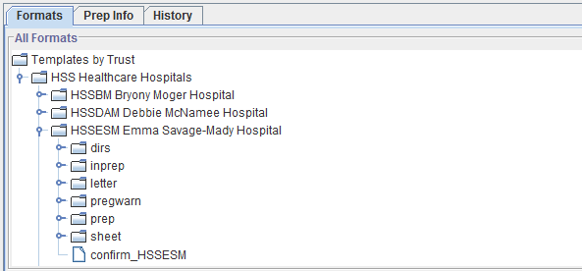

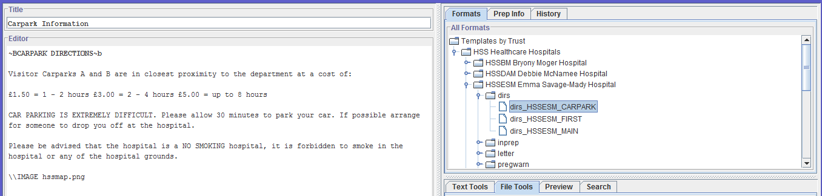

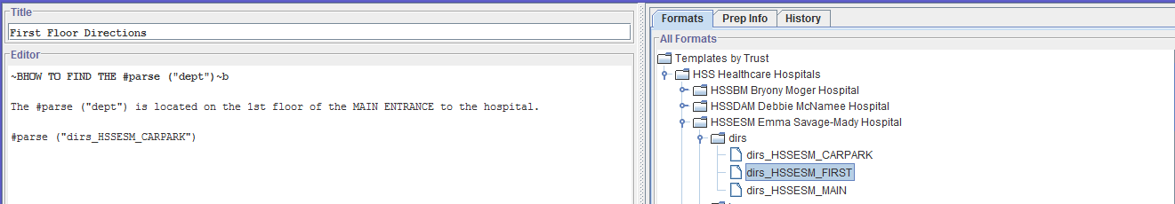

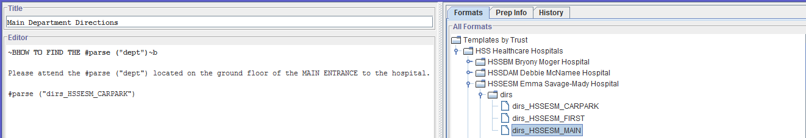

CONFIRMATION

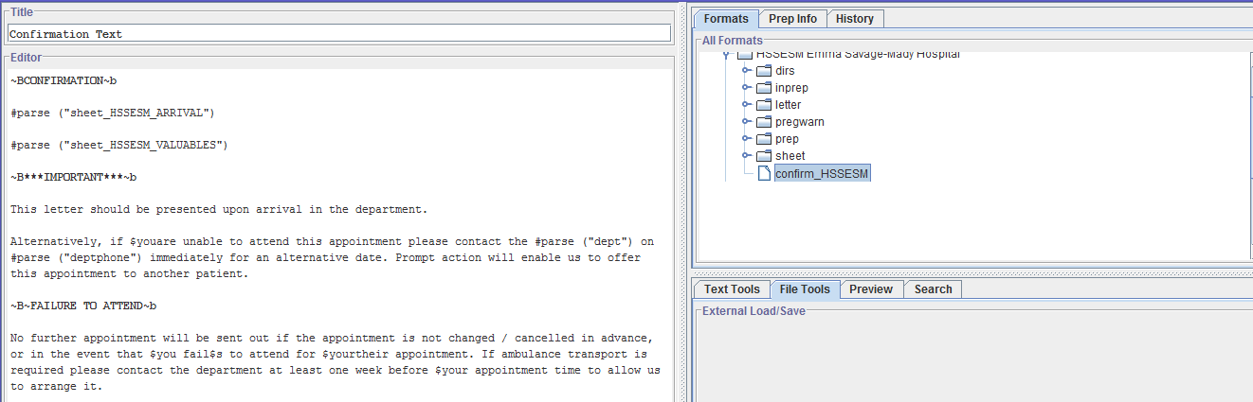

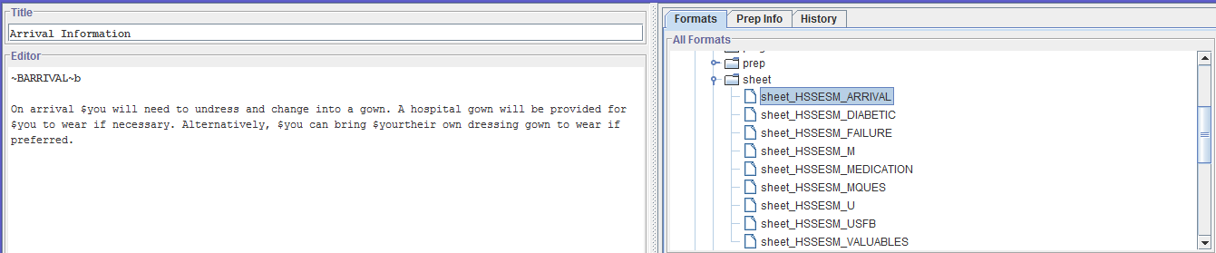

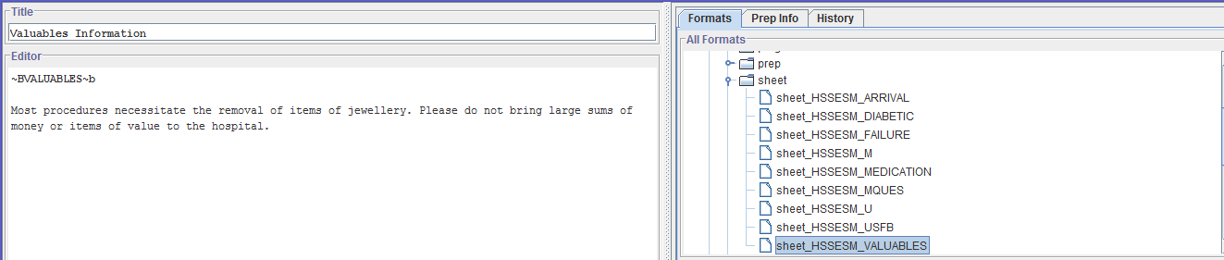

GENERAL ULTRASOUND

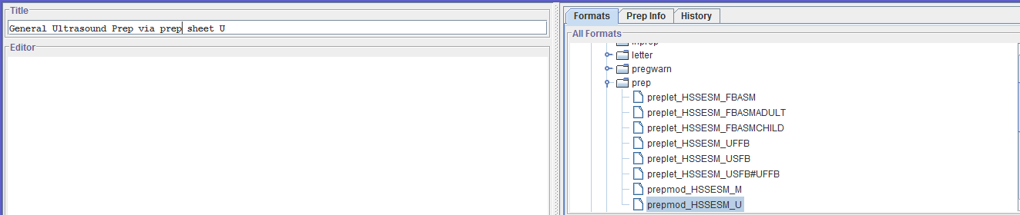

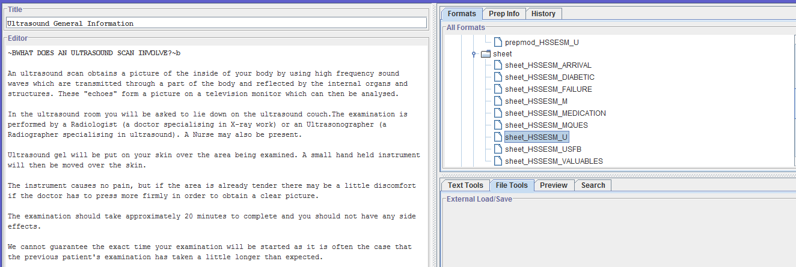

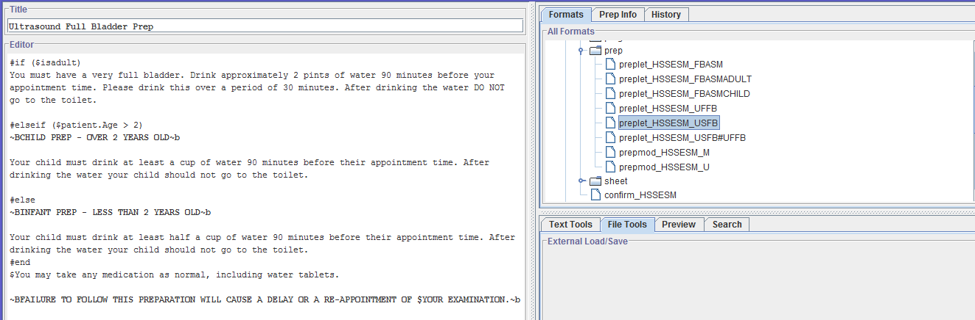

ALTERNATIVE US PREP LETTER

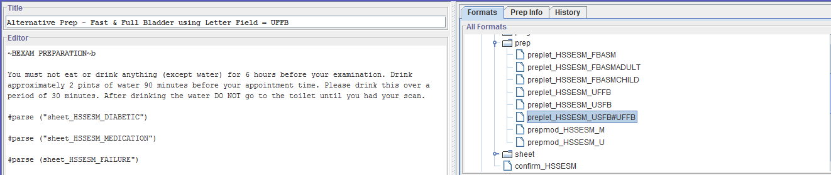

ADDITIONAL TEXT

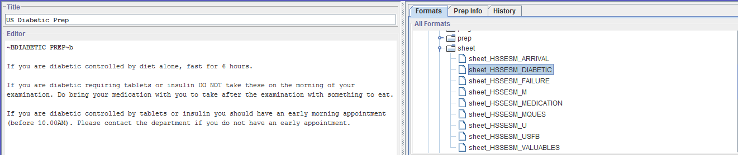

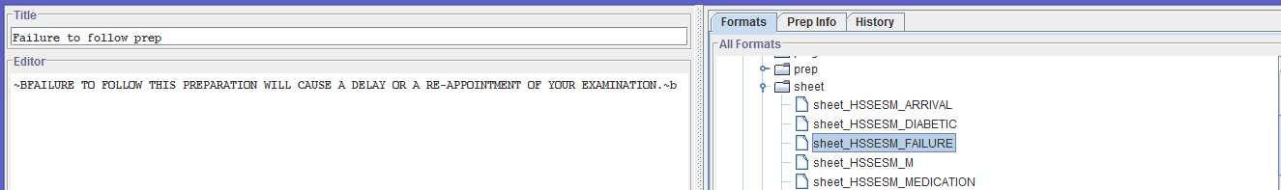

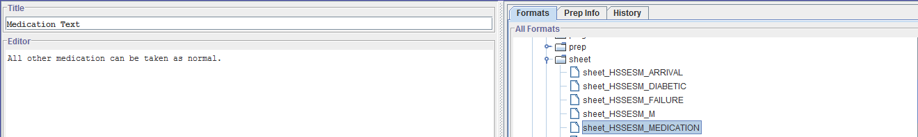

LMP TEXT

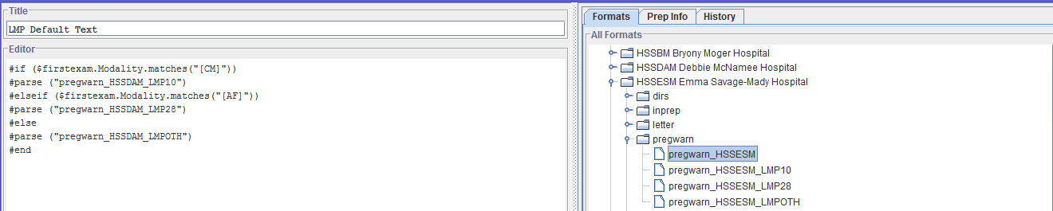

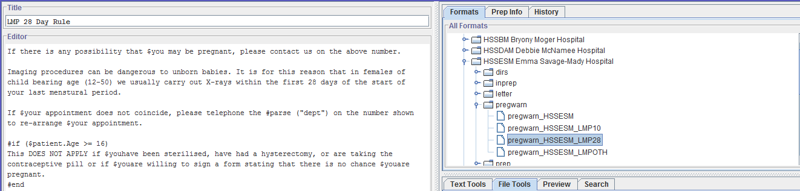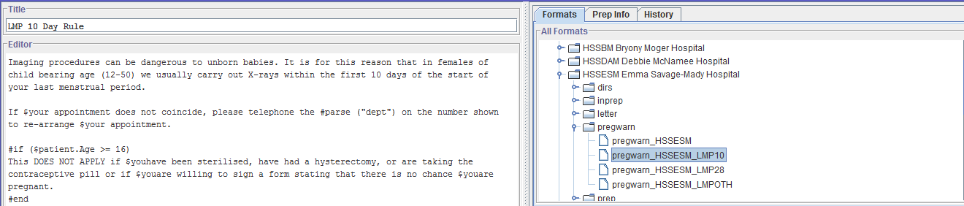

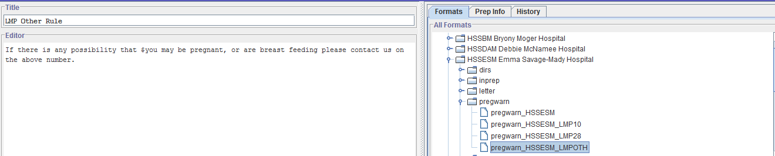

BARIUM MEAL PREP

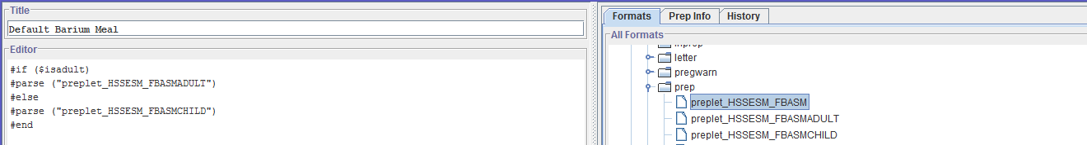

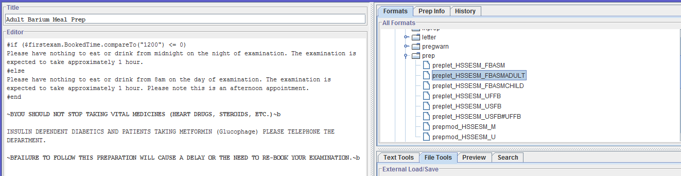

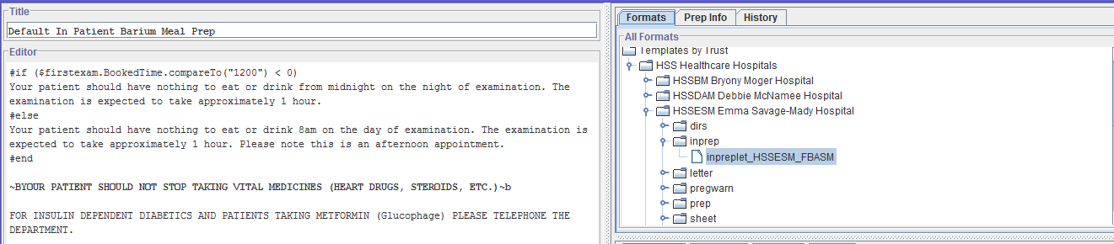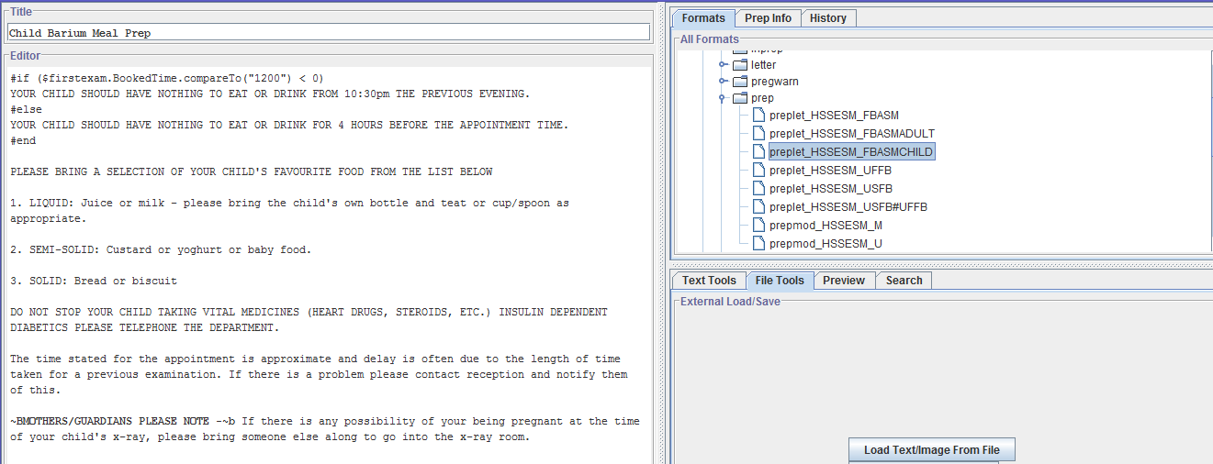

CHANGING LETTER COMPOSITION

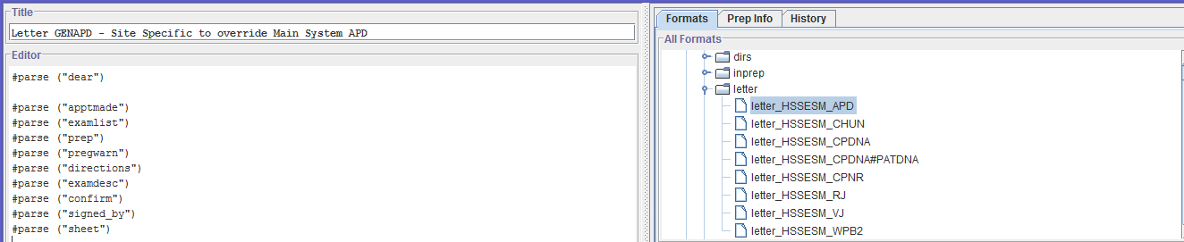

ALTERNATIVE STATUS LETTERS

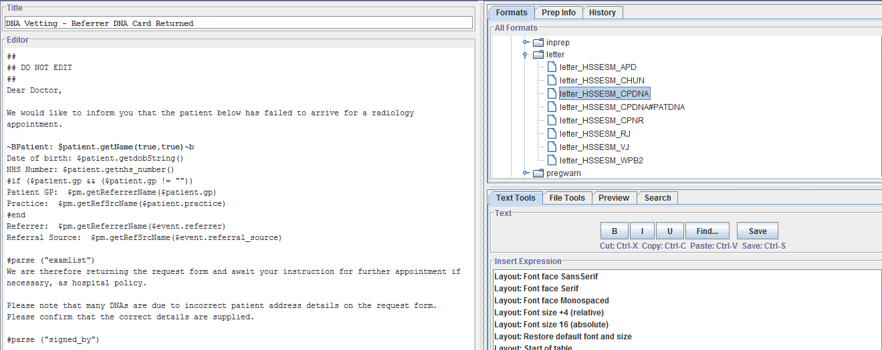

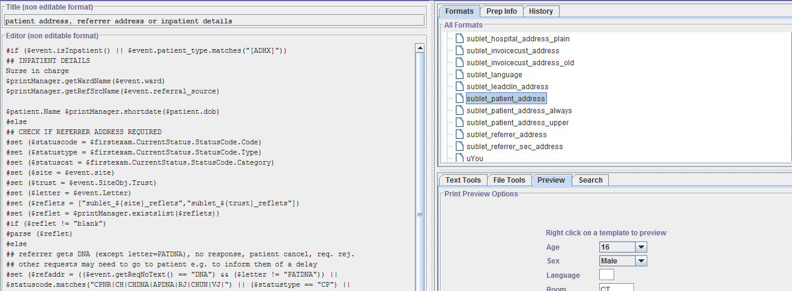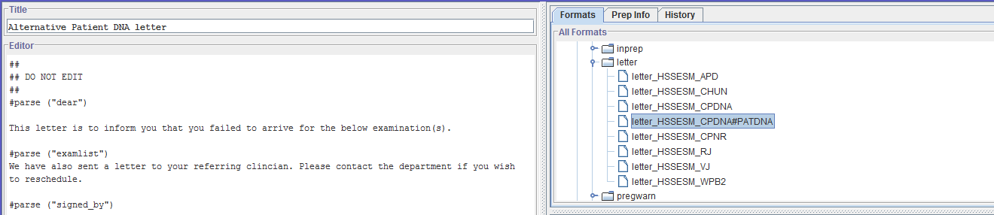

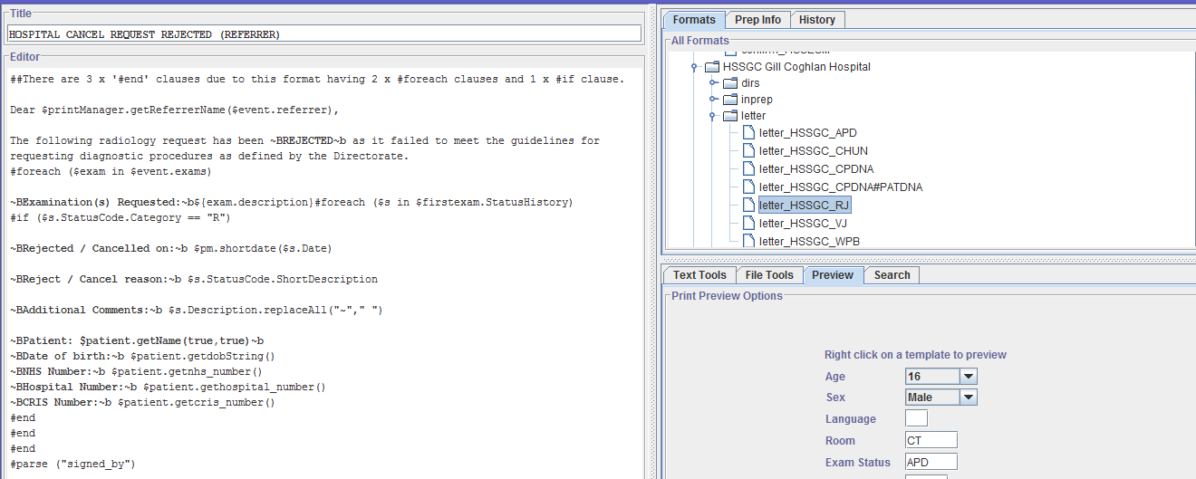

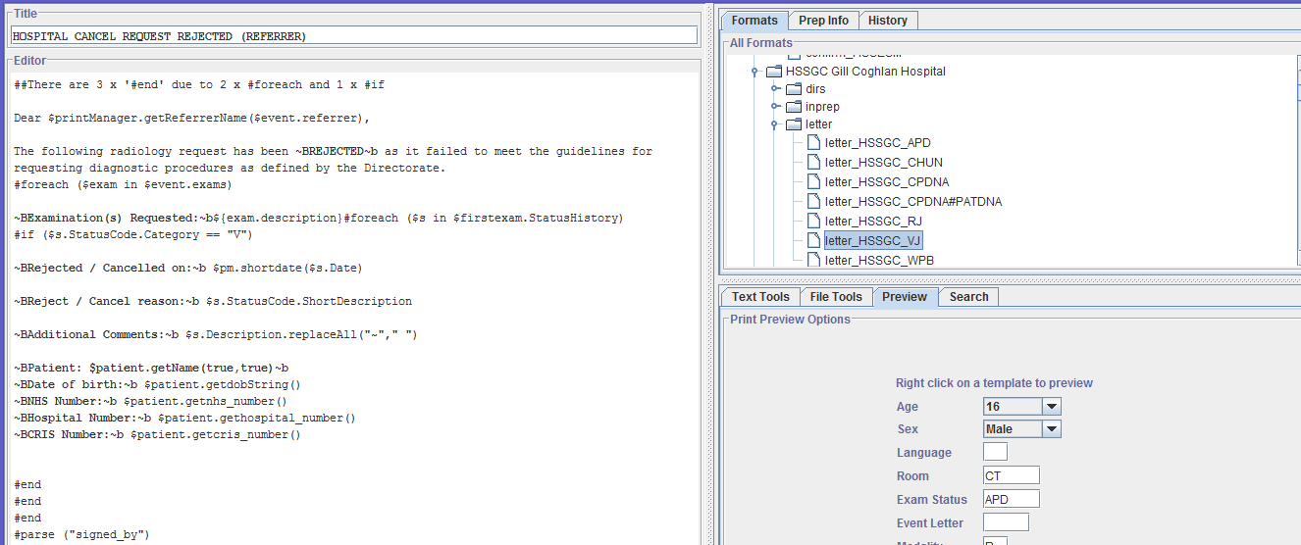

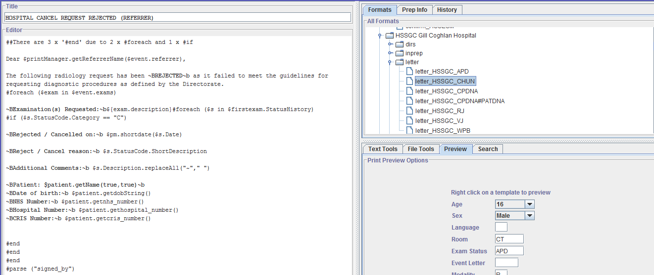

PARTIAL BOOKING ALTERNATIVES

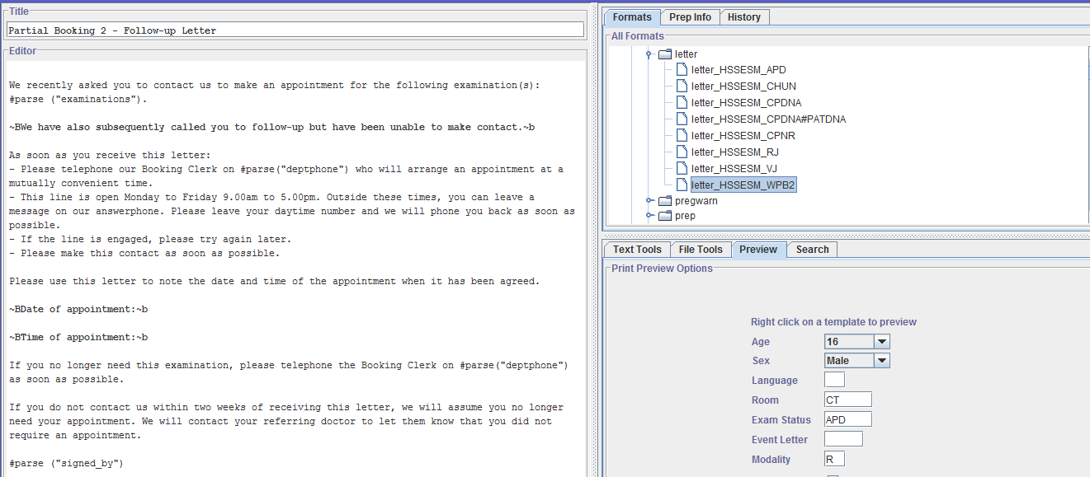

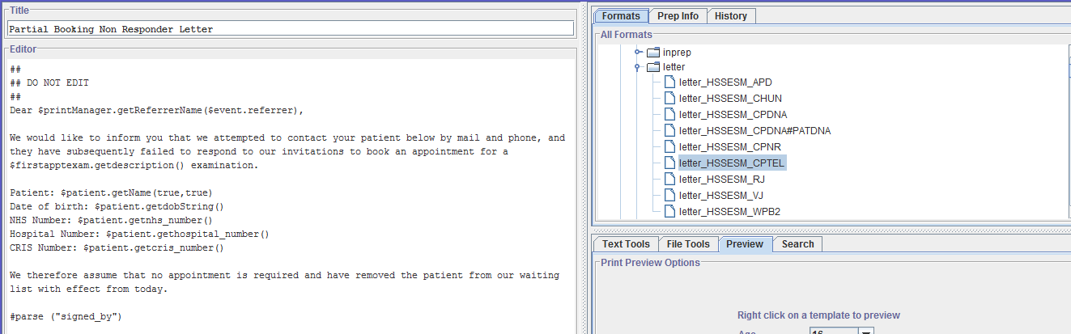

MRI LETTER & QUESTIONNAIRE

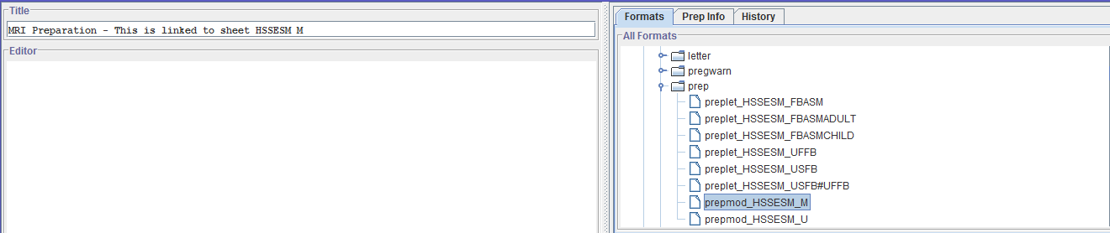

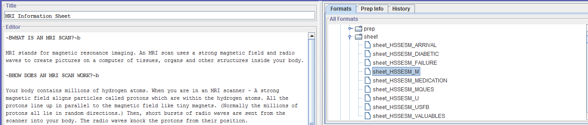

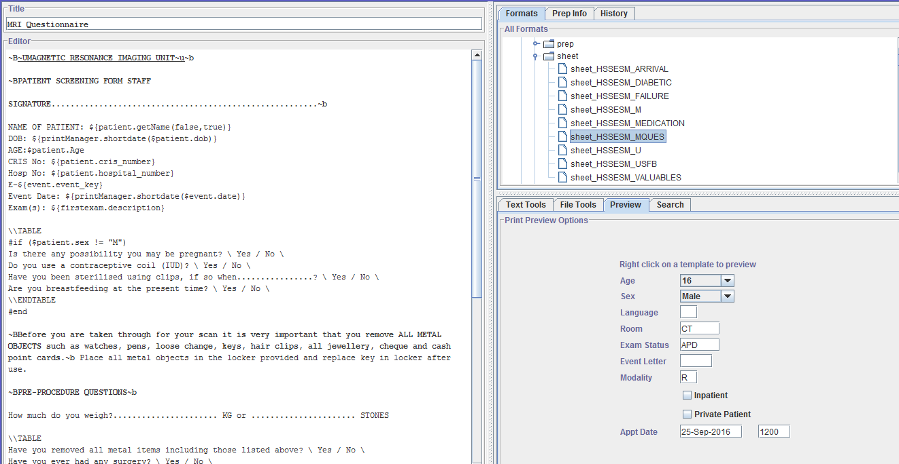

# Document Control

|  |  |  |  |  |  |
| --- | --- | --- | --- | --- | --- |
| Title | | CRIS Letters Training Exercises | | | |
| Owner | | Wellbeing Training Manager | | Date Created | 17/10/2019 |
| File Ref. | | CRIS_CTS315_Exercises_CRIS_Letter_Formats_WS_V1.0.docx | | | |
| CRIS Version | | 2.09.10p onwards | | | |
| Change History | | | | | |
| Issue | Date | | Author / Editor | Details of Change | |
| V1.0 | 17/10/2019 | | Emma Savage-Mady | First Issue | |
| V2.0 | 16/09/2022 | | Emma Savage-Mady | Typo corrections | |
|  |  | |  |  | |
|  |  | |  |  | |
|  |  | |  |  | |
|  |  | |  |  | |
|  |  | |  |  | |
| Review Date | | | 16/09/2024 | | |