Vetting Module Course Overview

VETTING TRAINING SET-UP

The CRIS Trainer should prepare the following for each delegate ahead of the session using Fictional Characters or the specific delegate names who will be attending the sessions.

4 REQUESTS (or ORDERS for OCS sits)

- OPD / CT ABDOMEN (CABDO)
- OPD / BARIUM ENEMA (FBAEN)
- WARD / US ABDOMEN (UABDO) and ABDOMEN (XABDO)
- OPD / MRI LUMBAR SPINE (MLSPN)

The CRIS Trainer can prepare this for each delegate ahead of the session using Fictional Characters or the specific delegate names who will be attending the sessions. It’s probably helpful to get each delegate to create requests for when they do their own sessions but your choice.

INTRODUCTION TO VETTING – TRAINER DEMO

Begin by discussing the difference between standard vetting and full vetting using the VETTING MODULE – i.e. Standard Vetting = Justifying for IRMER, Full Vetting = Standard vetting plus Protocols which can then be assigned to examinations at the time of vetting in order to facilitate clerical staff in booking appointments, and clinical staff in performing procedures.

Protocols are designed to present the users with context specific options based on Exam, Area of the Body and Modality, and can be personalised where applicable using the standard category / folder options. This is a major step towards achieving a paperless workflow.

Once FULL VETTING is in place the [Vetting List] will replace the [ORDERS], [REQUEST] and [WAITING] list.

UNDERTAKE A VETTING DEMONSTRATION COVERING THE FOLLOWING:

- Vetting demonstration, show how to create a request and assign to a Clinician for vetting.

- Show how to select Events that require vetting (from both the [VETTING LIST] or directly from a patient record)

- Show how to filter the vetting list to find assigned requests.

- Load selected ‘Request’ and talk about the fields before discussing [VETTING EXEMPT / NO PROTOCOL REQUIRED], and show REJECTED in principal.

- Select the [Vet] button to specify protocol information.

- Use pre-defined protocol, explain that custom protocols can be created if needed but this will be covered later.

- Explain function [Buttons] then click [Complete].

- Discuss ‘Vetting Icons’ and ‘Justified’ icons explain how each icon is generated.

- Discuss / demonstrate ON HOLD and REFERRED and related icons.

- Show how to VIEW VETTING INFORMATION from the Event Details screen using ‘Event info’ tab and also via Dictation Screen, and Reporting Screen.

EXERCISE 1 - VETTING A NEW CT REQUEST (CUSTOM PROTOCOL – i.e. TYPING YOUR PROTOCOL)

- Load the [Vetting List] and explain all filters. Apply Vetted = VW (Awaiting Vetting), Modality = C Filter.

- Select / Load CT Abdomen (CABDO) request and click [Vet]

- Explain ‘Event Info’ Screen – Reasons for Examination, Clinical History Event Comment and Clinical Safety Questions which originates from the Request Card or is send via the Electronic Order.

- Suggest that the CT Abdomen will actually be with contrast and change code to CABDOC (CT Abdomen with contrast) to illustrate the need to amend examinations to ensure the procedure is corrected and to load the correct protocols associated with the examination. Also encourage the clinician to enter an “Event Comment” to say why the procedure has changed.

- As the request is Justifiable according to IRMER tick ‘JUSTIFIED’ then select the [Vet (2.09.10p) or Protocol (2.09.10r)] button to move onto ADDING A PROTOCOL.

- EXPLAIN ‘Vetting’ Screen and fields.

- Type a PROTOCOL MANUALLY (i.e. don’t choose one) and explain fields. Enter Prep “Drink 240ml Gastrografin 30 mins before scan” and CHOOSE ‘Gastrografin’ via CONTRAST FIELD using [F4]. This will populate the Post processing screen later.

TRAINER NOTE – Leave your screen loaded as an example, and encourage delegates to undertake this exercise.

- Finally click [Completed] and press [F9] to display Vetted icons.

EXERCISE 2 - VETTING A BARIUM ENEMA AND STANDARD PROTOCOL SELECTION

- Amend the [Vetting List] filters to Apply Vetted = VW (Awaiting Vetting), Modality = F Filter.

- Select / Load Barium Enema (FBAEN) using [Vet].

- From the ‘Event Info’ screen – click ‘Justify’ and select the [Vet (2.09.10p) or Protocol (2.09.10r)] button to add a Protocol template.

- Choose the existing Barium Enema Prep template.

- Choose [Completed]

EXERCISE 3 - AMENDING VETTING PROTOCOL

- Filter the VETTING LIST to show exams that have been ‘Completed’.

- Reload the Barium Enema Request using [Vet].

- Highlight how the original protocol is protected with User audit details. Enter “Tues PM Clinic” via ‘BOOKING NOTES’ and choose [Update].

- Make an appointment for the Barium Enema to show VETTING INFO VIA THE DIARY.

EXERCISE 4 – USING STANDARD / NO PROTOCOL

- From the [Vetting List] and explain all filters. Apply Vetted = VW (Awaiting Vetting), Pat Type = A (Inpatient) Filter.

- Explain how to combine 2 orders using [Ctrl + Click] for the UABDO and XABDO (KUB) and click [Vet]

- From the ‘Event Info’ Screen – explain that this request is ‘Justifiable’ and will be a [Standard or No Protocol] and click it.

EXERCISE 5 – REJECTING A REQUEST

- From the [Vetting List] and explain all filters. Apply Vetted = VW (Awaiting Vetting), Modality = M, Pat Type = B (OPD) Filter

- Select the MLSPN and click [Vet]

- The request is not justifiable and needs to be rejected so click [Rejected] and type a “Reject reason = does not fulfil clinical criteria”.

- From the ‘Event Info’ Screen – explain that this request is ‘Justifiable’ and will be a [Standard or No Protocol] and click it.

For sites using CRIS 2.09.10p and below – otherwise Protocols should be set-up via the Protocols Table

EXERCISE 4 – CREATING A PROTOCOL TEMPLATE

- Change [Vetting List] filter back to ‘Awaiting Vetting’ and click [List].

- Select / Load CT Head with Contrast (CSKUHC) and explain they are going to look at CREATING A USER SPECIFIC PROTOCOL.

- Ask Delegates to reload the CSKUHC Request and choose [Vet] to move to the Vetting screen.

- Ask Delegates to type an appropriate prep / instruction in the ‘Protocol’ field, and choose a Contrast from the list. ***Have an example CSKUHC on screen to show an example protocol for inspiration***

- Now click [Lock Text] then ask them to scroll down to and open the ‘All Protocols’ folder.

TRAINER DEMO

Discuss best practice – i.e. Creating Modality Categories, as although protocols are Exam, Modality and AOB specific the folders are not automatically generated.

Discussing creating a Z_USER Category as a folder for all User Protocols, and that all user protocols should be prefixed with their National Code (i.e. C Code – registration number).
Also recommend ZZ_ARCHIVE as a way of archiving protocols created without authorisation by the Vetting Admin Team. These can subsequently be deleted once the reason for creation has been established and an official protocol using correct naming conventions has been introduced to replace it.

- Encourage Delegates to right click the Z_Users Folder and choose ‘Add Category’ using their ‘INITIALS Protocols’ as the Description.

- They should now open the ‘Z_USERS’ folder and right click their ‘INITIALS Protocols’ Folder before choosing ‘Create Protocol’ then clicking the [Populate] function button to bring through the text from the current request for use in future protocols (i.e. how to create a template).

- Enter the additional details – explaining all fields as you progress (Prefix ‘Description’ with INITIALS and EXAMS = CSKUH) before choosing [Save].

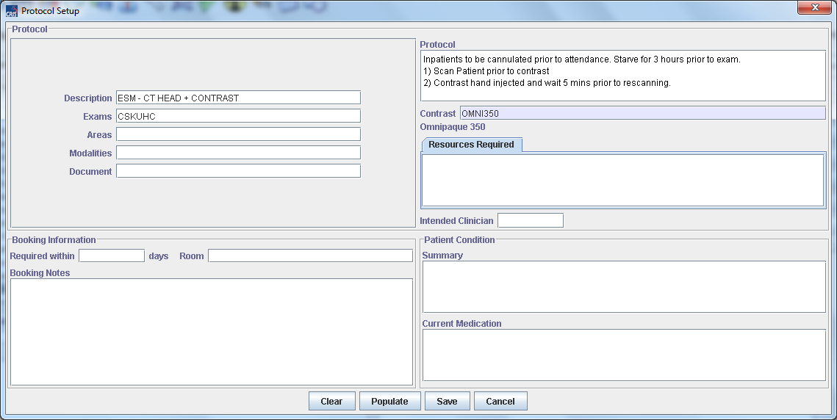

- Having saved new Template, save the Request as ‘Justified’ and [Completed].

TRAINER DEMO

- Once completed explain / demonstrate the use EDIT PROTOCOL, DELETE PROTOCOL and DELETE CATEGORY.

- DISCUSS BEST PRACTICE - HSS recommend prefixing any SITE SPECIFIC PROTOCOLS with NACS Code and USER SPECIFIC with C code or registration number. This is because Protocols are TRUST, EXAM, MODALITY and AOB specific. It is also possible to combine Exam Protocols where this is commonly the case – otherwise you will be presented with both exam protocols individually and should use [Lock text] after selecting the first exam.

- Explain how you can remove the EXAM, AOB and Modality details on a Protocol in the ZZ_Archive to stop it been in active use.

SYSTEM CONFIGURATION – TRAINER DEMO

Depending on the audience System Configuration may not be applicable to the session – i.e. End Users only. Where possible we will aim to schedule an AM session with RIS Admin and Department Superintendents, Clerical Leads who will want to consider setting up the system, and piloting / introducing full vetting. PM session may only contain End Users who do not need to know about set-up.

Vetting Module Table Configuration

CRIS LICENSES

A valid trust license will be required for the CRIS Vetting Module. You can check if a valid ‘VETTING’ Module Code has already been applied to the system via TABLES > SYSTEM TABLES > LICENSES. In the event that the license is not present and you have purchased the ‘Vetting Module’ or the module is ‘Inclusive’ to your CRIS deployment this can be requested via your Client Manager or the Helpdesk.

XR SETTINGS

The following XR setting are designed for use with the Vetting Module. These settings can be applied at XRTR (Trust), XRS (Site) or XRT (Terminal) Level as applicable via TABLES > SYSTEM TABLES > XR SETTINGS.

Setting | Description
VETTING.ModuleAvailable | Specifies if the vetting module is available on a terminal.
RECEPT.RefreshVettingList | This setting will allow the vetting list to automatically refresh every time the screen is cleared.
GENERAL.EditVetText | This setting prevents users from editing the text associated with events via the Vetting screen.
VETTING.TimeframeDays | This setting allows system managers to specify the number of days an event should be vetted before the breach date.
Optional Breach Date Settings
GENERAL.BreachDateCalculation | Enables the display of the breach date on patient events and hover help over date fields.
GENERAL.BreachDateCalculation Type | Allows users to specify which breach date calculation to display. i.e. English or Scottish styles.
STATS.WaitingTimeClockStartDate | The date used when starting the waiting time either Request made or Request received.
EVENTLIST.Vetting | This setting will allow system managers to specify which columns of information to be displayed on any of the CRIS work lists (if required).  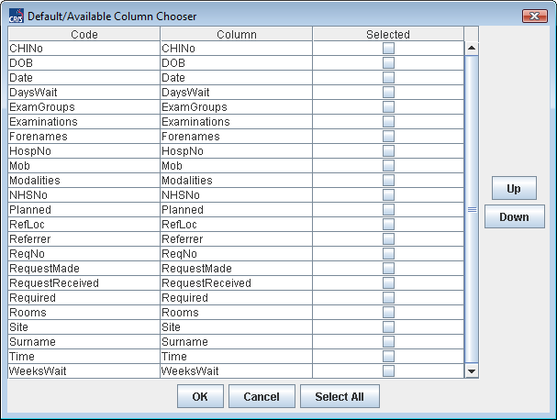  To add an additional column to an existing work list, tick the selected box for the item you wish to display.

SECURITY SETTINGS

The following security settings are required to access the Vetting Module. HSS recommend that the Trust create a new ACTIVITY Group called MODVET = Vetting and Protocoling Module and new ROLES called RADIOGV, and RADIOLV which have RADIOG and RADIOL as their parent groups. You should then assign MODVET Activities to both new ROLES. This can be undertaken via TABLES > PEOPLE > SECURITY SETTINGS.

In this way during a pilot phase of the Vetting Module each individual user can just have the MODVET Activity assigned to their existing Userids via Staff Tables and [Edit Group]. Then when the Trust / Site are ready to go live with the Vetting Module the relevant users can be assigned RADIOGV or RADIOLV instead of their old roles.

The use of Activities rather than simply adding security settings to each role makes it much easier update the Vetting Module with any new security settings which are associated with future module development – i.e. The scheduled development of security settings which will in future restrict who can and cannot create, edit and delete Protocol templates.

Section | Item | Description
The following settings apply to the new Vetting Protocol Set-up Table:
GENERAL | MANAGE_VET_GRP | Vetting List Management – Allows users to edit protocols assigned to a specific Resource Vetting Group via the Protocol Set-up Table.
GENERAL | MANAGE_VET_STE | Vetting List Management – Allows users to edit protocols assigned to a specific the Site / Hospital via the Protocol Set-up Table.
GENERAL | MANAGE_VET_SYS | Vetting List Management – System Wide – This setting will override all others, giving access to edit all levels via Protocol Set-up Table.
GENERAL | MANAGE_VET_TR | Vetting List Management – Allows users to edit protocols assigned to a specific Trust via the Protocol Set-up Table.
When creating a protocol the default ownership will be the highest level to which the user has permission to manage. A user may change ownership of a protocol, or category to any of the levels which that user also has permission to manage. It is only possible to create or delete Categories (Folders) at Trust or System level, however lower levels (Site and Group) can still assign and remove protocols within the categories just not manage the categories themselves.

The below settings are applicable to the CRIS Vetting Module itself:
GENERAL | MANAGE_VETTING | Allows users to manage the Vetting list – i.e. Assign events etc.
GENERAL | CHANGE_VETTING | Allows users to make amendments to previously vetted events.
GENERAL | JUSTIFY | Allows users to Justify an event from the applicable tick boxes.
GENERAL | EDIT_VET_TEXT | Allows users to edit anyone’s free text – This is not recommended except for System Managers.
VIEWS | VETTING | Allows users to view the vetting information throughout the system.

SPECIFYING WHICH MODALITIES REQUIRE JUSTIFICATION

It will also be necessary to specify WHICH MODALITIES REQUIRE JUSTIFICATION based on IRMER regulations and those that do not via TABLES > SYSTEM > NORMAL TABLES > CRISMODL.

You should enter Y or N via the ‘Requires Justify’ field for each relevant modality. If the Modality is left blank or set to N – any associated examinations are automatically marked as ready to proceed using the same icon as a Vetted request – i.e. if the event has a vetted icon you can proceed to book an appointment or perform the examination.
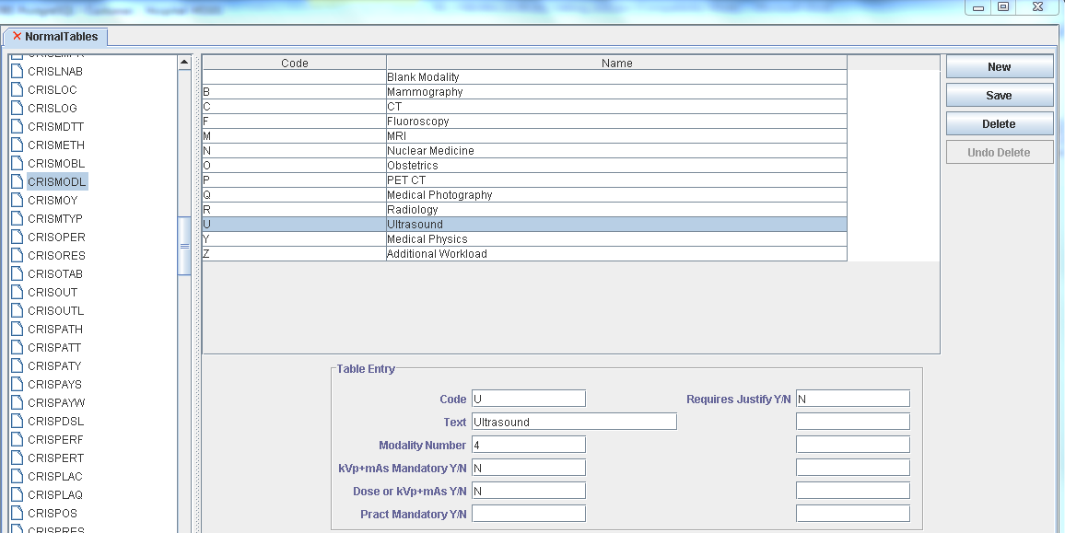

ASSIGNING MODALITIES / EXAMS WHICH REQUIRE VETTING

It will be also necessary to specify WHICH MODALITIES REQUIRE VETTING via TABLES > OTHER > APPOINTMENTS > EXAMS PER HOSPITAL as this will control which exams are outstanding for vetting.

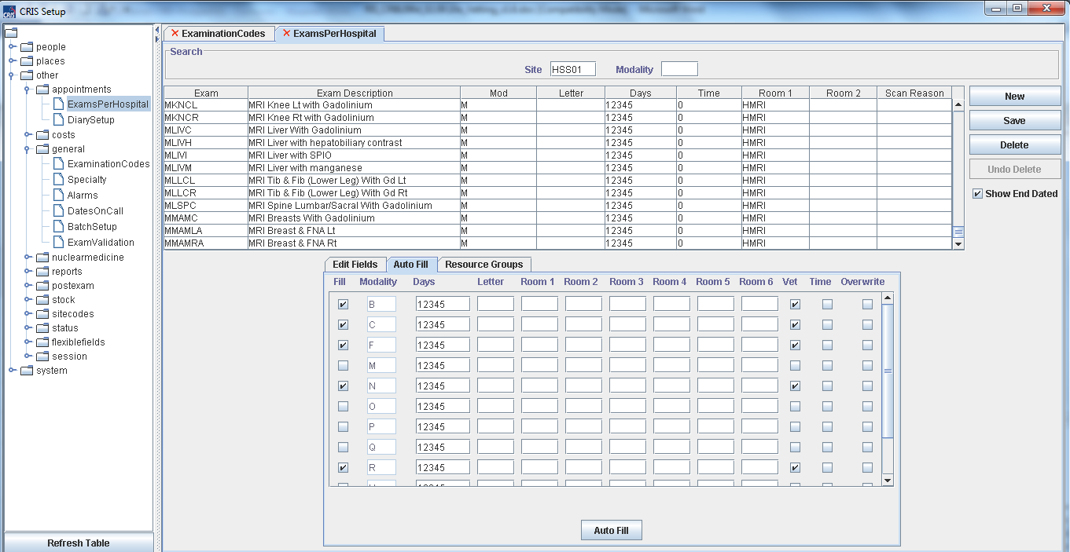

Selecting the ‘Autofill’ tab will allow you to tick all modalities which require vetting, then click [Auto Fill] to action this followed by [Save] to commit the changes. You should not use Overwrite unless you genuinely wish to overwrite all other details, without overwrite ticked any changes are just appended to existing values.

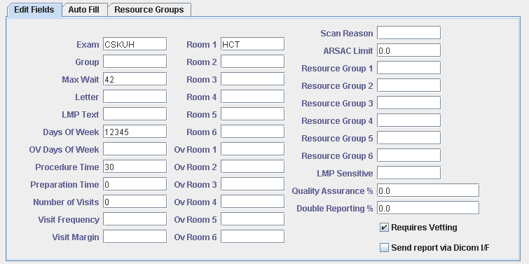
Depending on the circumstances you can also mark individual exams as requires vetting, by ticking the field for all relevant exams if vetting would not be applicable to the majority of exams in a given modality. Alternatively, you could untick ‘Requires Vetting’ if the majority of exams do require vetting but a handful of examinations in a given modality do not.

Any exams flagged as not applicable to vetting are automatically marked as ready to proceed using the same icon as a Vetted request – i.e. if the event has a vetted icon you can proceed to book an appointment or perform the examination.

VETTING STATUS CODES

The CRIS Status Codes Table via TABLES > OTHER TABLES > STATUS allows customised Status codes with associated text on Buttons and via Hover help. This is particularly useful to the VETTING Status codes and HSS recommends that the following Status Codes are in place prior to deploying the Vetting Module.

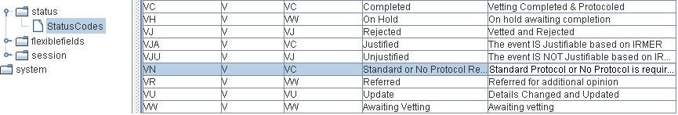

This can be undertaken via TABLES > OTHER TABLES > STATUS and editing the VN Code from ‘Not Required’ to ‘Standard / No Protocol Req.’ as follows:
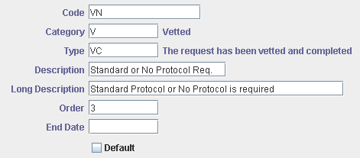

The other statuses ‘long description’ can be amended if required to customise the hover help seen by users when via relevant function buttons.
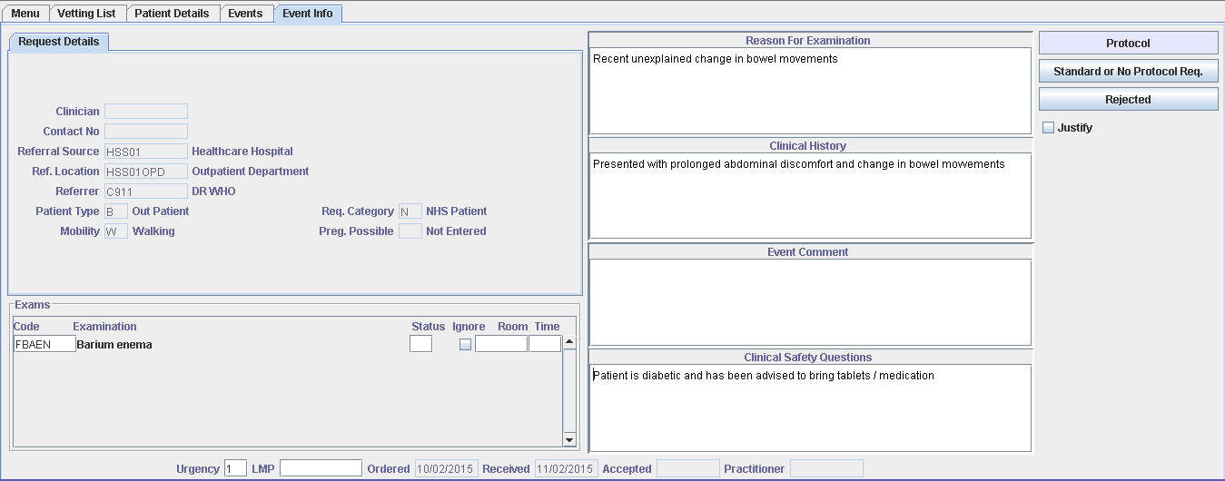

Please note: The Status Codes Tables is System Wide so it will be necessary to agree any changes with all Trusts in Consortium deployments.

Creating Custom Protocols
The CRIS Vetting Module has been designed to allow system administrators and vetting clinicians to create and maintain vetting protocols covering all elements pertinent to performing procedures – i.e. Preparations and contrasts, required resources, specific booking information and patient conditions. Where applicable all the above elements can be created as combined protocols, in addition to individual items which can then be selected as required using the [Ctrl] key which will enable you to multi select any required elements.

New – Creating Protocols have now been moved from the event level Vetting Screen to a new Protocols Set-up Table via TABLES > OTHER TABLES > VETTING to facilitate more effective deployment and management of vetting protocols.

In Consortium models enabling GENERAL.MANAGE_VET_SYS = Y will display the ‘Show Trusts’ filtering and to view all Protocols throughout the Consortium, however if GENERAL.MANAGE_VET_SYS = N the filter will not be displayed and you will only be able to view / edit protocols relevant to your own Trust.

Creating Categories and Protocols
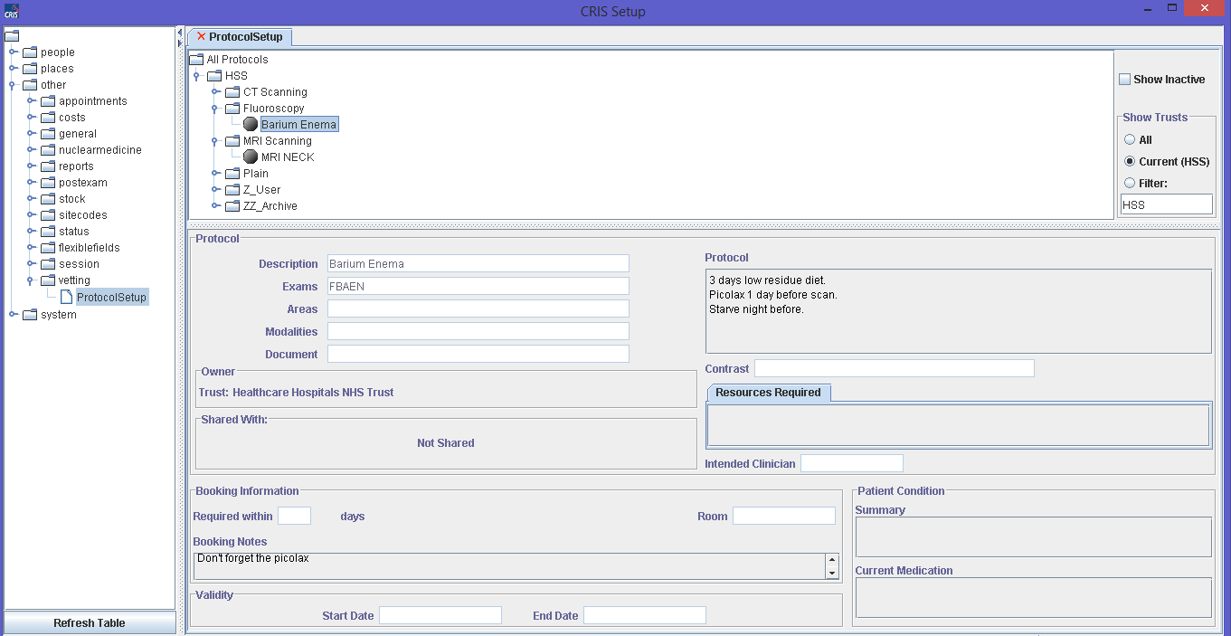

CREATING PROTOCOL CATEGORIES

Begin by creating any required new Categories, and Subcategories. Categories are effectively folders used to classify types of ‘Protocols’ (i.e. CT, MRI, US etc.) both for generic use and for individual use (i.e. ESM Protocols).

Once a category exists, it is then also possible to create subcategories within the parent category, ahead of generating protocol items or to add categories to existing ones. It is also possible to drag and drop protocol into alternative categories as required.

Please note: If creating User specific categories, it is recommended that you prefix the parent category name with your reporting code (i.e. C12345_Dr Savage-Mady Protocols).

To create a category right click either the Trust folder or ‘All Protocols’ and select ‘Add Category’.
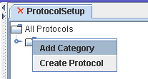
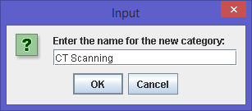

CREATING PROTOCOLS

Having identified a destination category right-click and choose ‘Create Protocol’ from the resulting menu.
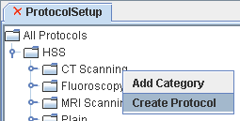

This will display the ‘Protocol Set-up’ function as follows, and you should complete the template as required:
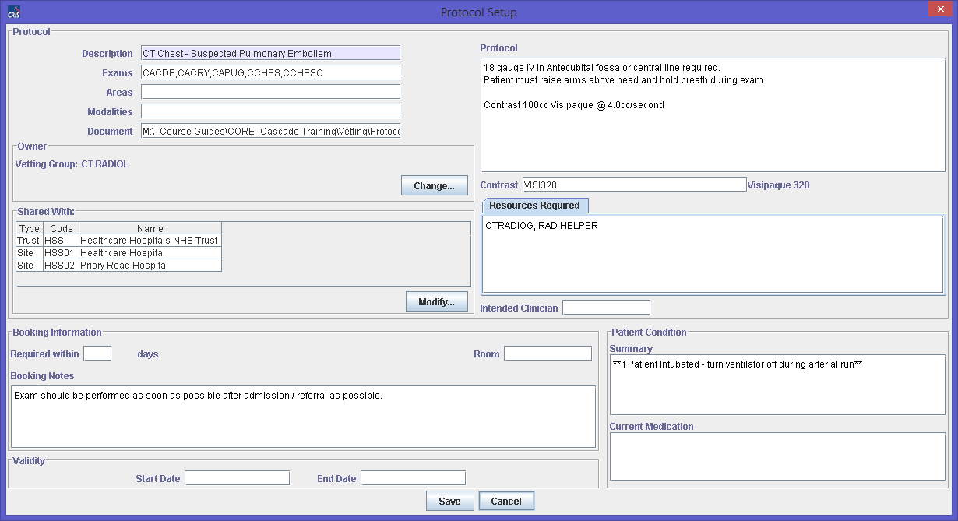

Protocol Setup
Description | Enter an appropriate description to identify the type of protocol being created – (i.e. CT Chest – Pulmonary Embolism). This field is obligatory.  Please note: HSS recommend prefixing any SITE SPECIFIC PROTOCOLS with NACS Code and USER SPECIFIC with C code or registration number for ease of identification in lists.
Exams | Enter any examinations applicable to the protocol. This can be entered by typing the examination codes separated by commas, or by pressing the [F4] prompt key and selecting from a list of available exams. Completing this field ensures that the protocol is displayed accordingly when a valid examination is being vetted, but it is not obligatory.
Areas | Enter the relevant area of the body for the exam / protocol if applicable. Press [F4] to choose from a list of available options. Completing this field ensures that this protocol is associated with the ‘relevant to Body Parts’ folder, but it is not obligatory.
Modalities | Enter the modality associated with the protocol as applicable. Completing this field ensures the protocol is displayed in the appropriate modality folder, but it is not obligatory.
Document | Press [F4] or double click this field to browse for any supporting documentation which should be associated with the protocols. This field is not obligatory.
Owner - New | 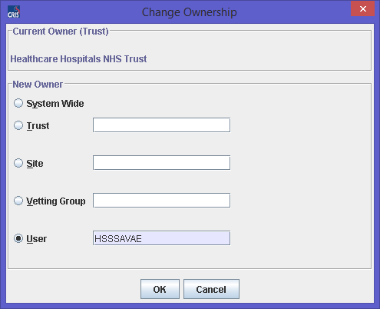  The Vetting module has been enhanced to allow system managers to define the owner of protocols to determine the order in which protocols appear and are prioritised.
Owner - New | System Wide | This option is only available if GENERAL.MANAGE_VET_SYS = Y is enabled. This option allows protocols to be created and shared System Wide (i.e. Consortium wide as applicable)
Owner - New | Trust | Use this function to enable Trust wide protocols only viewable within the current Trust except if the protocol is also ‘Shared’.
Owner - New | Site | This option allows the system manager to create site specific protocols which will only be displayed when vetting at each relevant Hospital except if the protocol is also ‘Shared’.
Owner - New | Vetting Group | This function enables protocols to be shared with a group of Vetting Clinicians except if the protocol is also ‘Shared’.  Please note: This option requires use of the Resources Module.
Owner - New | User | This option allows system managers to create user specific protocols which will take priority over other protocols presented to the user via the Vetting screen except if the protocol is also ‘Shared’.
Shared with - New | The ‘Shared with’ function enable RIS system managers to share protocol templates with other Trusts, Sites, Vetting Groups or Users as applicable. This may be useful if the Resource Module is not deployed and the system manager would like to share a protocol template with several users (i.e. All CT Radiologists – C12345,C12346,C12347,C12348 etc.) or for ‘Consortiums User groups’ to create central protocols which can be shared with specific Trusts, or sites.  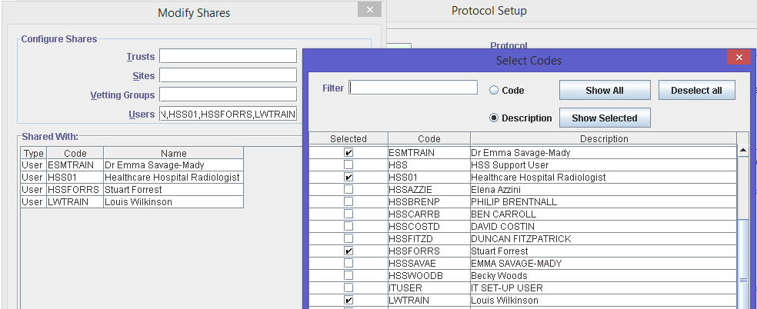  When vetting an event, only those protocol templates which are in the events Trust, Site and logged in User hierarchy will be available to be assigned.
Required Within – Days | Enter the number of days from the date of the vetting the examination should be performed. This will then auto complete the ‘Required By’ field in the Vetting screen and be amended as necessary. This field is not obligatory.
Room | Room the examination should be performed in. This can be amended via the Vetting screen if required. This field is not obligatory.
Booking Notes | Enter any relevant booking notes, or items such as preferred session days, follow up appointment dates etc. This field is not obligatory.
Preparation | Enter any specific preparation, protocols or instructions for performing the procedure. This field is not obligatory.
Contrast | Enter the contrast(s) required for the examination by pressing [F4] and selecting one or more contrast drugs. Please note: Clinicians should check against alarms before specifying contrast when vetting patient requests.
Resources Required | Used to specify staff required for the scan – i.e. Anaesthetist, Nurse etc. This field is not obligatory.
Intended Clinician | Used to identify a specific clinician for reporting after the images have been generated. If this field is left blank the request will be unallocated. This field is not obligatory.
Patient Condition Summary | Unlikely to be used as a generic protocol more typically for use on a patient by patient basis to specify any issues relevant to health or status of the patient. This field is not obligatory.
Current Medication | Used to specify any issues relevant to medication – (i.e. If patient is diabetic please bring tablets or insulin).
Start Date - New | These new functions enable system managers to activate protocols from a particular date and retire (End Date) protocols when no longer required. Leaving both fields blank will immediately activate the new protocol.  Please note: If you enter dates into either field the protocols will no longer be visible in the set-up table by default. To display inactive protocols tick ‘Show Inactive’ via the Protocol Set-up table.
End Date - New
[Save] function button | Saves the new protocol or any changes made to an existing protocol.
[Cancel] function button | Closes the ‘Protocol Setup’ screen without saving.

EDITING CATEGORIES & PROTOCOLS
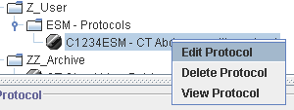
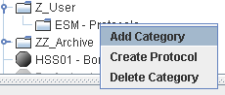

Protocol Options
Add Category | This will allow the user to create a custom categories and subcategories as which will then be available to all users.
Create Protocol | This will open a new window allowing the user to create a custom protocol that will be added to the main list once it has been saved.
Delete Category | Housekeeping tool to clear any unwanted protocols.
Edit Protocol | Utility to facilitate amendments to existing protocols.
View Protocol | This option is only available if the protocol has a document associated with it. If so then the associated document will be opened for viewing.

Document Control

Title |  | Vetting Module Course Teaching Script
Author |  | Emma Savage-Mady |  |  | Date Created | 11/01/2013
File Ref. |  | input.doc
Change History
Issue | Date |  | Author / Editor | Details of Change
0.1 | 11/01/2013 |  | Emma Savage-Mady | First Draft Issue
0.2 | 05/02/2013 |  | Emma Savage-Mady | Draft release for review
0.3 | 17/02/2013 |  | Emma Savage-Mady | Amendments based on delivery
0.4 | 26/02/2013 |  | Emma Savage-Mady | Amendments based on review / editing – clarified Exercise 1, and corrected error on reference to TABLES > OTHER rather than SYSTEM for CRISMODL.
0.5 | 10/09/2013 |  | Emma Savage-Mady | Removal of guidance which recommends enabling Vetting at Terminal Level. Addition of XR setting GENERAL.EditVetText.
1.0 | 28/10/2013 |  | Emma Savage-Mady | Amendments to Security Settings MODVET for Activity instead of VETPRO, and amendment to Status codes ‘Standard or No Protocol Req.’ instead of ‘No Protocol Required.
2.0 | 03/08/2015 |  | Emma Savage-Mady | Amendments in line for 2.09.10r1 onwards
2.1 | 22/02/2016 |  | Emma Savage-Mady | Edited to include XR and Security settings.
Review Date |  |  | 22/02/2018

