

Cris Release Notes (External)

v2.11.00

4th December 2018

**Ian Baker – Product Owner (Core products)**

**Copyright**

Wellbeing Software 2018. All Rights Reserved.

Registered Office: 3rd Floor i2 Mansfield, Hamilton Court, Oakham Business Park, Mansfield, NG18 5FB

These materials are or comprise restricted and proprietary confidential information of Healthcare Software Solutions. Disclosure to or use by the recipient shall not convey any intellectual property rights in these materials. The right to use these materials by the recipient is subject to restrictions and limitations contained in the Provision of Integrated Care Record System and Associated Services Agreement and related agreements.

**Confidentiality**

All information in this document is provided in confidence for the sole purpose of adjudication of the document and shall not be used for any other purpose and shall not be published or disclosed wholly or in part to any other party without HSS prior permission in writing and shall be held in safe custody. These obligations shall not apply to information which is published or becomes known legitimately from some source other than HSS. Many of the product, service and company names referred to in this document are trademarks or registered trademarks. They are all hereby acknowledged.

**Document Control**

|  |  |  |  |  |  |  |
| --- | --- | --- | --- | --- | --- | --- |
| Title | | Cris Release Notes (External) v2.11.00 | | | | |
|  | |  | | | | |
| Author | | Ian Baker | | | Date Created | 04/12/2018 |
| File Ref. | | Cris External Release Notes v2.11.00.docx | | | | |
| Version | | 2.11.00 | | | | |
| Change History | | | | | | |
| Issue | Date | | Author / Editor | Details of Change | | |
| 0.1 | 04/12/2018 | | Ian Baker | Created from GG Internal Release Notes | | |
|  |  | |  |  | | |
|  |  | |  |  | | |
|  |  | |  |  | | |
|  |  | |  |  | | |
| Review Date | | |  | | | |

**Contents**

1 Introduction 5

1.1 Purpose 5

1.2 Audience 5

1.3 Previous Releases 5

2 New/Improved Functionality in this release 6

2.1 Referral Source to have email field 6

2.2 Ability to configure slots to be able to hold multiple modality Types 6

2.3 Reduce excessive query calls for the same query in the lists 7

2.4 Ability to configure slots to be able to hold multiple Patient Types 7

2.5 Allow differing referrer and patient type mapping to be allowed 8

2.6 NHS number ‘alert’ on CRIS if an NHS number already exists in CRIS 9

2.7 Recording Accessibility Information Standards. 9

2.8 OCS Request Urgency does not change Default Report Urgency 9

2.9 Font appears blurred in CRIS 10

2.10 Refine "flashing" busy overlay to something more subdued 10

2.11 Workaround.ExmsPerHospitalCacheUpdatePeriod 10

2.12 Providing default 'Assigning Authority' to McKesson DTI 10

2.13 Exception when using 'link to trust' option 11

2.14 Line Border on Status table tool tip not coloured. 11

2.15 Java version logging 11

2.16 Validating an order when selecting from orders or event list 12

2.17 Use of REPORT.AutoRefreshUnreportedList with AutoSelectNextEvent on UnreportedTab 12

2.18 SQL duplication on backend staff table 13

2.19 Connection controller rework 13

2.20 MFN (Master File notifications) 13

2.20.1 Referral source email MFN^M02 ZRS segment 13

2.20.2 Log for MFN messages 14

2.20.3 PRA segment - Not allow Groups inbound or outbound 14

2.20.4 Referral source Trust versus Site 14

2.20.5 Attribute to be added for MFN^M05 14

2.20.6 Referrer links not to be received or sent outbound 14

2.21 Printed appointment letters and request card scanned icon on all lists 15

2.22 Enhancement to error dialog 15

2.23 Print preview appointments sending to AVDATA and status table 15

2.24 Reduce network traffic for various tables (Staff table) 15

3 Fixes to existing functionality in this release 16

3.1 Unable to verify reports in Advanced Billing 16

3.2 Fees Table - 'Site' column contents removed on passing/selecting 'Fee type' column 16

3.3 ‘CANCEL’ triggers for orders not being generated 16

3.4 Exception thrown when adding excess cost in Billing page 17

3.5 Report workflow in reporting mode is blocked when billing is on 17

3.6 Quantity value on large invoices does not match the Great Plains Finance system. 17

3.7 Linking system provides incorrect potential matches 17

3.8 Change site popup no longer works at event level 18

3.9 Nuclear med activity incorrectly calculated 18

3.10 Obstetric field not big enough for date text 18

3.11 Stat selection not displayed correctly when added to selected fields 18

3.12 Illegal Component Exception 19

3.13 Vetting symbol missing on certain modes and workflows 19

3.14 Letters batch printed from diary missing 19

3.15 Event Date and Status Start Date corruptions. 19

3.16 Incorrect practice of creating duplicates due to not undertaking a demographics check on PAS records. 20

3.17 Auto Load Next Event fails if REPORT.AutoRefreshUnreportedList’ setting is enabled. 20

3.18 Error when adding appointment to diary. 20

3.19 Blank exam details when loading event details for new event request. 21

3.20 Batch Printing Reporting Auto Commit Error. 21

3.21 Date change cross threading issue. 21

3.22 In Health performance. 21

3.23 Hospnos entry not being created via inbound PACS interface. 22

3.24 The 'Restricted' option is shown in a different font in the Report Editor’s right click menu 22

3.25 A Null Pointer Exception is thrown when trying to save a dictation. 22

3.26 Date fields in lists too narrow. 22

3.27 Protocol text duplicated when locked 23

3.28 Username & Passwords Visible In Java Log 23

3.29 Show selected and Show unallocated not working together on report info list 23

3.30 Order can be added to Diary 'Scratch Pad' 23

3.31 Columns are not aligned with headers in ExamsPerHospital 24

3.32 ExamsPerHospital Showing Other Sites Exams 24

3.33 Breach dates not calculated when 'show completed' is set to ‘Y’. 24

3.34 Suspended and unverified tabs need time colon 24

3.35 The ‘DTIHub’ implementation in CRIS is not fit-for-purpose 25

3.36 Report Info List - profile not setting order by colour correctly. 25

3.37 Date is not shown properly in Report Properties 25

3.38 Referrer to write to database 25

3.39 Java exception in vetting list when adding status and not category 26

3.40 [Reference#0057460] RFC - Addendum data not saved when report suspended. 26

3.41 Using the ‘Auto Select Next Event’ option from within the Report Info List – when using Speech MIC is skipping events 26

3.42 [Reference#0072797] Merge patient issue with RRO, TMC style interfaces 27

3.43 Report lock icon not displayed on Day list or Unprocessed list when another user is in the report screen & the report is not verified 27

3.44 Email status is not created when emailing an appointment letter 27

3.45 Cancelling underlying order(s) while event is on the Diary 28

3.46 Warning message for patient type with mismatch referrer type is confusing 28

4 Known issues 29

4.1 Report info list (auto load filter) Cache issue 29

4.2 User cannot tell the difference between disabled fields and enabled fields in setup 29

4.3 Porter list - cancelled attendances cannot request additional portering 29

4.4 Ability to save an appointment with no time or room 30

4.5 CRIS Create Dummy Patients no longer works 30

4.6 NullpointerException when selecting a row in the View Log screen. 30

4.7 XR Setting RECEPT.PrintRequestCard is not working properly 30

4.8 NullPointerException in ContractCosts table when creating a New Contract. 30

4.9 Improve report lock icons on work lists for ALL modes. 30

5 Supported Platforms 31

# Introduction

## Purpose

This document will outline the functional changes made to this release of Cris. It will detail any new features, enhancements to existing functionality and list changes made due to existing functionality not working as expected. It will list all deliverable artefacts and release procedures.

## Audience

This document is primarily for external stakeholders, so they have a clear understanding of the application's new/improved functionality, resolved and known issues for this release.

## Previous Releases

Cris v2.10.09 - 18th October 2018

# New/Improved Functionality in this release

Referral Source to have email field

OTRS Reference: [0053365](http://service.hssnet.com/otrs/index.pl?Action=AgentTicketZoom;TicketID=53492)

A dedicated field is required for the email address of a referral source. This can be sent and received using Master File Notifications.

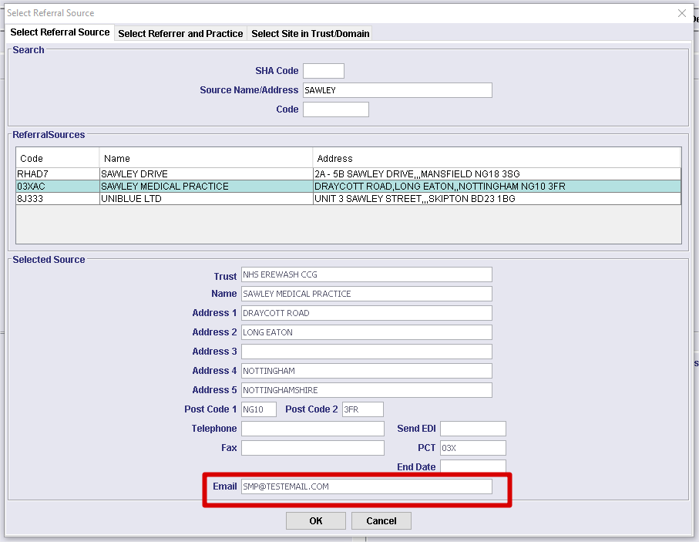

Ability to configure slots to be able to hold multiple modality Types

OTRS Reference: N/A

Within the diary slots you can now implement up to 5 modalities which allow appointments to be booked into the diary within one room for multiple modalities. For example, a common dual room Fluoroscopic and Xray. By editing diary slots to hold both F and R type and adding the room to the exams per hospital table for the exams, you can now book both modality types into the same room whilst not allowing other types of modalities.

If no modality is set, this is a wild card accept.

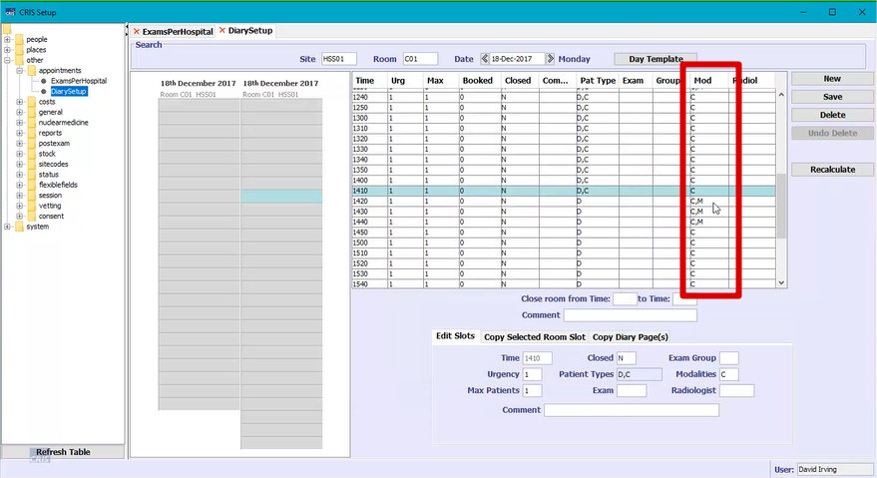

Reduce excessive query calls for the same query in the lists

OTRS Reference: N/A

To avoid unnecessary queries to the database, if the lists are refreshed within 10 seconds of having previously been refreshed, we ignore the call for the refresh. After 10 seconds we allow the refresh. The 10 second time limit is hard-coded and cannot be configured.

Ability to configure slots to be able to hold multiple Patient Types

OTRS Reference: [0083990](http://service.hssnet.com/otrs/index.pl?Action=AgentTicketZoom;TicketID=84464)

Within the diary slots you can now implement up to 5 patient types which allow appointments to be booked into the diary within one room for multiple patient types. For example, a room may be used for walk-in outpatient appointments and inpatient appointments. By editing diary slots to hold different patient types, you can now book both patient types into the same room, whilst not allowing other types of patients to be booked into those slots.

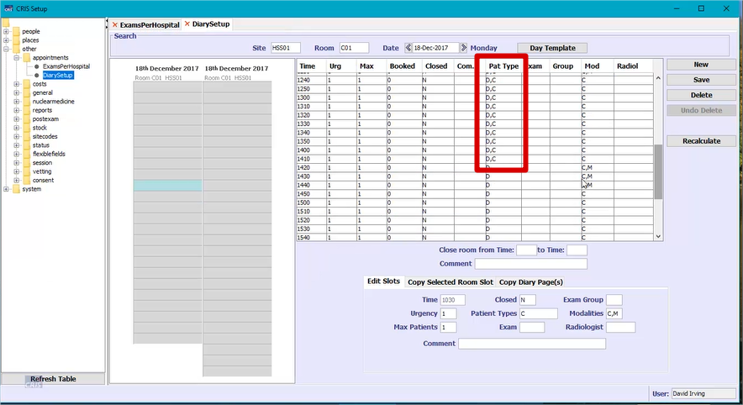

Allow differing referrer and patient type mapping to be allowed

OTRS Reference: N/A

This configurable change allows for orders and requests to be made where the referrer type differs from the patient type e.g. Referrer Type G (GP) and Patient Type C (A & E Attender).

**Additional Information**

This functionality is controlled by the XR setting ‘**SECURITY.Event_ValidatePatientTypeOnNewEvent’**.

The default is ‘yes’, so validation will be performed by default. Set to ‘No’ to turn validation off.

If validation is off, the following warning message will **not** be displayed:

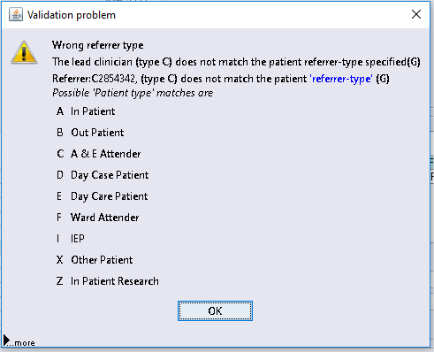

NHS number ‘alert’ on CRIS if an NHS number already exists in CRIS

OTRS Reference: [0026978](http://service.hssnet.com/otrs/index.pl?Action=AgentTicketZoom;TicketID=27022)

When patient demographics arrive from PAS/OCS, if the NHS number for a known patient is changed, it is now noted in the log, under ‘WARN’>'Interface'>'PAS'>‘NHS Number Change’ with all the relevant details pertaining to the change.

If PAS/OCS sends the same NHS number and the patient is validated by patient number, then if the patient details such as DOB are different it will log this information, under ‘WARN’>'Interface'> ‘PAS' > NHS Number matched’ as there may now be a possibility that there are 2 patients with the same NHS number within the PAS.

Recording Accessibility Information Standards.

OTRS Reference: [0053127](http://service.hssnet.com/otrs/index.pl?Action=AgentTicketZoom;TicketID=53254)

Within the patient details screen there is a new ‘Sensory Disability’ checkbox. A tick signifies that the patient has a sensory disability and a cross states they don't have a sensory disability. The blank option is available if they haven't been asked. The sensory disability should be noted in the alarms table. A stat can then be used to see patients with a sensory disability with an appointment made. Further stats can be used to identify the sensory disability from the alarms table.

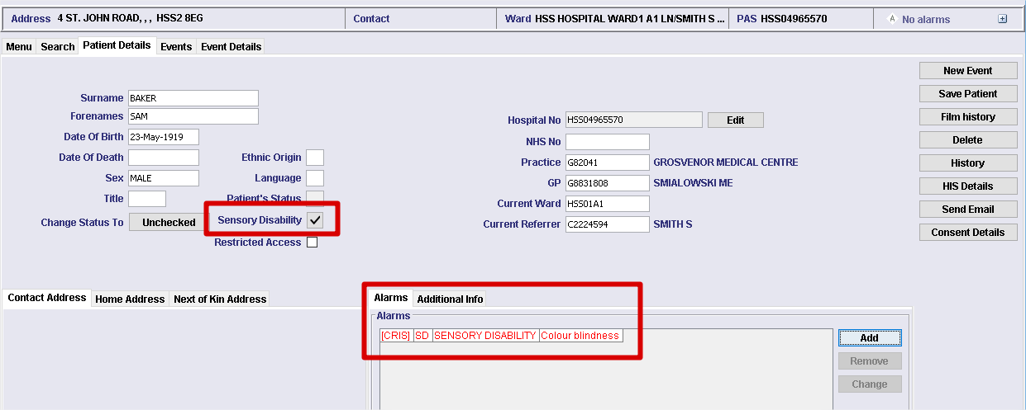

OCS Request Urgency does not change Default Report Urgency

OTRS Reference: [0037418](http://service.hssnet.com/otrs/index.pl?Action=AgentTicketZoom;TicketID=37462)

Previously within CRIS if you created a request with an event urgency of 'urgent' this would implement a reporting urgency of 'urgent' based on the CRISURG table set up. However, this was not the case for incoming orders with an event urgency matched to reporting urgency in the CRISURG table.

The change made means that orders with an event urgency of 'urgent', and a reporting urgency of 'urgent' within the CRISURG table, now implements the reporting urgency.

Font appears blurred in CRIS

OTRS Reference: N/A

Font appeared blurred in CRIS. Anti-aliasing will be turned off by default to prevent bluring.

Refine "flashing" busy overlay to something more subdued

OTRS Reference: N/A

When the worklists are refreshed, sometimes it ‘flashers’ before the list is displayed. This is because the ‘busy’ overlay is about to be displayed but then the list finishers refreshing. This ‘flashing’ is a little annoying to some people, so a different approach has been requested.

The display has been altered to show rotating set of circles, and the display SLOWLY darkens as a query takes longer. Max darkness is after 30 seconds.

Workaround.ExmsPerHospitalCacheUpdatePeriod

OTRS Reference: N/A

The XR setting contains the ‘WORKAROUND’ segment. This indicates that the setting isn’t necessarily permanent or of any usefulness. The setting is used to control how often the ‘ExamsPerHospital’ cache gets refreshed.

The ‘GENERAL’ segment has replaced the ‘WORKAROUND segment and added to this release.

Providing default 'Assigning Authority' to McKesson DTI

OTRS Reference: N/A

The McKesson PACS at RNOH cannot distinguish between images from separate sites. There are two sites involved with this integration, RAN01 and RAN02. The PACS uses the single context of RAN01 when storing/receiving images from both sites. CRIS, on the other hand, uses both RAN01 and RAN02 when sending PACS messages.

The 'Assigning Authority' parameter on all outgoing PACS messages can now be configured to the appropriate value using a dedicated XR setting.

**Additional Information**

New XR setting - **REPORT.PACSWORKSTATION.SiteCodeDefault’**.

Currently, if this setting is not used or blank, the default will be 'RAN01'.

Exception when using 'link to trust' option

OTRS Reference: N/A

When selecting a SHA referrer, it allows you to link to a trust. However, if this trust is not inputted into the background table there will now be an error message describing the issue.

Line Border on Status table tool tip not coloured.

OTRS Reference: N/A

When hovering over the status table, previously the border of the tool tip was coloured as per the text in the Category column. Since the introduction of Java 8, this colouring had disappeared. The hover in the status table now appears in a bold line colour.

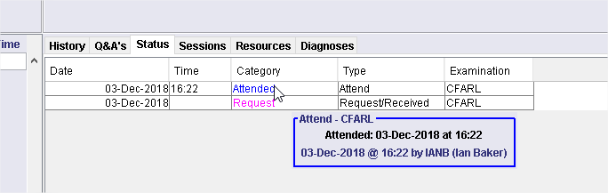

Java version logging

OTRS Reference: [0064695](http://service.hssnet.com/otrs/index.pl?Action=AgentTicketZoom;TicketID=65078)

The Java version is now visible in the 'About' menu within CRIS.

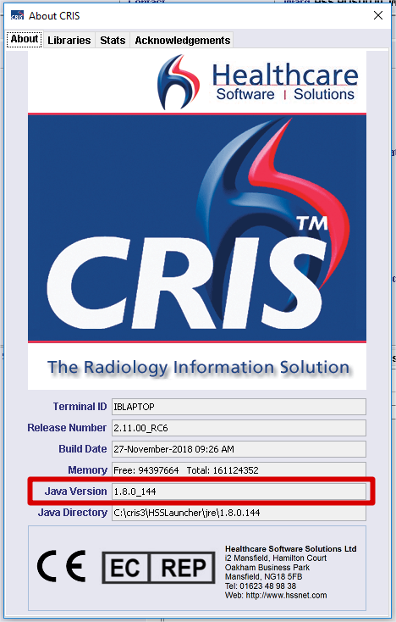

Validating an order when selecting from orders or event list

OTRS Reference: N/A

Previously as a user, it was possible to pick an order off the orders list, or off the patients event list, that had been cancelled by ordercomms.

There are now various stages throughout the CRIS workflow where the cancellation of the underlying order is checked. When this condition is trapped, a warning dialog is displayed with an appropriate message and a log of the event is created.

Depending on the scenario, the underlying list will be refreshed, or the patient's workflow will be cleared.

Use of REPORT.AutoRefreshUnreportedList with AutoSelectNextEvent on UnreportedTab

OTRS Reference: N/A

Previously, if the XR setting for auto refresh was set and 'Auto select next event' in options is set, when we started verifying reports, we would get the list shown again, rather than just pulling in the next report.

It now runs the query in the events thread rather than background thread. It may take a little longer, but it will automatically get the next available event to report, rather than revert back to the list.

SQL duplication on backend staff table

OTRS Reference: [0058734](http://service.hssnet.com/otrs/index.pl?Action=AgentTicketZoom;TicketID=58957)

Performance improvements have been made when loading the staff table in the setup page.

Connection controller rework

OTRS Reference: N/A

The underlying problem here was that multiple threads were trying to access the same database connection simultaneously. This issue manifested itself throughout the application in a number of different ways. For example:

* Exam dates getting corrupted when retrieving data from the database, e.g. the relative position of a urgent request date for an exam being listed much farther down a list ordered by urgency and thus not getting booked in quickly.
* Dates changing when you hover over them, due to data corruptions.
* Letters/Reports not being printed and not flagged as having failed. Thus urgent reports to a   
  G.P / Clinican affecting a patient might not get printed.
* Data being pulled from the database spuriously disappear and throw errors.

Several different solutions were considered but it was decided to have a pool of only two database connections. If possible, client side data is cached from the connection which allows the connection to be released sooner. Various manager classes have been altered slightly to allow release of the connection sooner.

MFN (Master File notifications)

OTRS Reference: N/A

This change relates to keeping the referrers, referral sources, and referral locations synchronised with the PAS. The PAS will become the master record of the content.

A range of changes were made to support MFN^M02 and MFN^M05 HL7 messages, both for incoming messages, assumed to be from a PAS system, and for outgoing messages to a related PACS system.

MAD (Master Add) and MUP (Master Update) messages are supported, but MDL (Master Delete) messages merely result in an acknowledgement in the log, fulfilling the decision that deletion should remain a manual process.

Additional logging has been introduced to facilitate the tracking of issues.

Referral source email MFN^M02 ZRS segment

OTRS Reference: N/A

The referral source now has an email address which can be created/updated via an inbound MFN02 message and changes made are sent outbound.

Log for MFN messages

OTRS Reference: N/A

MFN02 and MFN 05 logging is now implemented.

A log is made whenever an MFN incoming messages creates/updates the CRIS database.

PRA segment - Not allow Groups inbound or outbound

OTRS Reference: N/A

The 'Practitioner Group' field is no longer updated by an MUP type MFN02 message. The new value is ignored, and the existing value is used.

The 'practitioner group' field will reflect the current value in CRIS's database and sent downstream. So, effectively, only a change via the CRIS GUI will be reflected in any 'outgoing' message.

Referral source Trust versus Site

OTRS Reference: N/A

As a system admin user I currently use the trust code ( 3 digits ) and add 2 0's to the end of the referral trust code, I need the MFN messages to automate these 2 extra 0's or allow the referral source to be 3 or 5 digits in length, to accommodate trust and site.

A referral source of <trustcode>00 is created when a MFN02 message is received with a ZRS segment. This 'default' referral source will be created once and only once, for each unique trust code.

Attribute to be added for MFN^M05

OTRS Reference: N/A

A new attribute has been added to determine whether MFN^M05 messages populate the referral location. The 'default' is set to 'true' to suppress any MFN05 messages.

Referrer links not to be received or sent outbound

OTRS Reference: N/A

A new attribute has been added to determine whether referrer link messages are suppressed.

Printed appointment letters and request card scanned icon on all lists

OTRS Reference: [0041092](http://service.hssnet.com/otrs/index.pl?Action=AgentTicketZoom;TicketID=41136)

Previously only one icon covered both scanned documents AND printed documents and you can’t tell which it is by looking at the list.

Within the lists there are now 2 new icons; a scanner icon to represent a scanned request card and a printer icon to represent a printed appointment letter or emailed appointment letter.

Enhancement to error dialog

OTRS Reference: N/A

Error dialogs now have a clearer interface and a ‘cut-and-paste’ facility to supply error logs externally.

Print preview appointments sending to AVDATA and status table

OTRS Reference: N/A

When printing appointment letters to print preview, CRIS no longer marks the letter as printed or adds a printed status or uploads AVDATA.

Reduce network traffic for various tables (Staff table)

OTRS Reference: N/A

Performance enhancements have been made for requests to the staff table ensuring that the same request is not made multiple times within a short space of time.

# Fixes to existing functionality in this release

The following fixes are included in this release:

Unable to verify reports in Advanced Billing

OTRS Reference: [00110022](http://service.hssnet.com/otrs/index.pl?Action=AgentTicketZoom;TicketID=110627)

When a reporting fee was being calculated for un-even multiple exam events, an Arithmetic exception was being thrown – ‘Non-terminating decimal expansion’. This was caused by BIGDECIMAL divisions, which had no decimal precision in place.

All BIGDECIMAL divisions now have a suitable precision scaling for reporting fee calculations.

Fees Table - 'Site' column contents removed on passing/selecting 'Fee type' column

OTRS Reference: N/A

When you create a new Fee in the Fees tab of the setup tables, upon tabbing past or entering a value into the ‘Fee Type’ field, the contents of the ‘Site’ field are removed/deleted.

Whenever the contents of the 'Fee Type' or 'Party Type' columns are changed, the 'Party' column is cleared, and the content of the 'Sites' column remains.

This issue has been resolved.

‘CANCEL’ triggers for orders not being generated

OTRS Reference: [00109430](http://service.hssnet.com/otrs/index.pl?Action=AgentTicketZoom;TicketID=110035)

When an event is cancelled in CRIS, an appropriate ‘CANCEL’ trigger is generated and the ‘downstream’ PACS is notified. It was seen that this trigger was only being created when a ‘pure’ CRIS event was cancelled. Therefore, with any ‘cancelled’ CRIS events that contained underlying orders, no ‘CANCEL’ triggers were generated, therefore PACS had no idea of the current status of these events.

All events cancelled in CRIS now send a 'CANCEL' trigger outbounds to the PACS.

Exception thrown when adding excess cost in Billing page

OTRS Reference: N/A

When a user trys to add excess cost in the Billing screen an Arithmetic Exception is shown and the excess cannot be added.

This is a similar issue to 3.1 and and relates to BigDecimal division. Excess cost can now be added without error.

Report workflow in reporting mode is blocked when billing is on

OTRS Reference: N/A

With ‘Advanced Billing’ enabled and CRIS in ‘reporting’ mode, on creation of a new event, there is a focus loss problem between pages.

The workflow presents the user with the ‘Attend/Report’ option on the ‘Attend Event’ page. When this is selected, the ‘Billing’ page should be presented and the ‘Continue’ button enabled. What is seen, however, is a combination of the ‘billing’ page and the ‘Report’ page, with the ‘Finished’ button from the ‘report’ page, visible.

This particular workflow has now been bought into line with other ‘modes’ workflow whereby the ‘Billing’ page is removed once the ‘Continue’ button is selected.

Quantity value on large invoices does not match the Great Plains Finance system.

OTRS Reference: N/A

Cancelled ‘Procedure Costs’ are still being counted alongside the quantity of charged procedure costs.  
Thus the quantity is incorrect on the invoice but the total value is correct.

Problem was related to the comparison of two BigDecimal numbers that were both set to zero but not seen as being equal. We now use a BigDecimal utility that just compares the value and doesn't take the precision into account which resolves this issue.

Linking system provides incorrect potential matches

OTRS Reference: [00103619](http://service.hssnet.com/otrs/index.pl?Action=AgentTicketZoom;TicketID=104192)

CRIS now allows matching to take place between PAS records and already linked patient records for the  
same trust. This results in multiple PAS records for the same trust being linked to the same patient record (CRIS number).

The application no longer presents a match screen if a CRIS patient is already linked to a PAS patient for that trust. If a PAS patient exists from another trust, the match screen will be presented.

Change site popup no longer works at event level

OTRS Reference: [00103640](http://service.hssnet.com/otrs/index.pl?Action=AgentTicketZoom;TicketID=104213)

The ‘Change site’ popup box appears to only show and work correctly when first picking up  
an order for a different site and no longer works when saving an event for any other scenario

The ‘Change site’ popup now appears for all appropriate scenarios.

Nuclear med activity incorrectly calculated

OTRS Reference: [00103745](http://service.hssnet.com/otrs/index.pl?Action=AgentTicketZoom;TicketID=104318)

When creating a syringe, the data format was being saved as ‘HH:MM’ but the database field width is only 4, thus the second minute value was being lost.

The colon between the hours and minutes values is now removed before storing to the database and the activity is now calculated correctly.

Obstetric field not big enough for date text

OTRS Reference: [00103652](http://service.hssnet.com/otrs/index.pl?Action=AgentTicketZoom;TicketID=104225)

When looking at the anatomy (FASP) scan form within CRIS, the date field doesn’t display the full date as it appears the date text is too large for the field.

Adjusted the field columns width from '7' to '11' which allows for the full date (dd-mmm-yyyy) in the GUI.

Stat selection not displayed correctly when added to selected fields

OTRS Reference: [00103761](http://service.hssnet.com/otrs/index.pl?Action=AgentTicketZoom;TicketID=104334)

When adding a new selection by double clicking it within the list or highlighting and selecting the ‘>’ arrow, the selection is moved across to the right, but a scrollbar appears at the bottom of the screen and the first 2-3 characters of the selection are cut off. This occurs each time a new selection is added to the selected fields section. Ideally, the scrollbar would not appear and the whole selection would be visible by default.

When rows were added to the selected fields scroll pane, no account of the width of the 'tree root' was taken. This meant that the row added was sized with the full width of the scroll pane which subsequently caused the component to 'hang' over the edge of the scroll pane and forced the horizontal scroll bar to appear. This has now been rectified.

Illegal Component Exception

OTRS Reference: N/A

An ‘IllegalComponentStateException’ is shown to the user when the report editor is opened, and the user navigates back to the event list.

This was an intermittent fault so we have added exceptions of this type to the error handling routines.

Vetting symbol missing on certain modes and workflows

OTRS Reference: [0096047](http://service.hssnet.com/otrs/index.pl?Action=AgentTicketZoom;TicketID=96620)

The vetting symbol (thumbs up) is not displayed when vetting in certain modes and workflows.

Each exam has a flag that indicates whether it requires vetting or not, but the 'vetting status' is applied to the event. So, if one exam of a multi-exam event, requires vetting, then the event requires vetting, so it's initial status should be 'awaiting vetting' with no icon present. If none of the exams require vetting, then the event does not require vetting and should have a 'thumbs-up' icon.  
Now if a single exam event, that requires vetting, is changed to an exam that does not require vetting and vice versa, then the vetting status should be changed accordingly. The 'awaiting vetting' status should only apply to an event that requires vetting but has yet to be vetted, once vetted, the appropriate vetting status, plus icon should be seen.

Appropriate validation has been added to ensure that the expected vetting status displays the correct icon, if applicable.

Letters batch printed from diary missing

OTRS Reference: [0095938](http://service.hssnet.com/otrs/index.pl?Action=AgentTicketZoom;TicketID=96511)

Batch printing from the diary intermittently fails to print all the letters. Consequently, patients will not receive their appointment letter.

The underlying problem here is that the same database connection is trying to be accessed by two different processes simultaneously. To mitigate this issue, the printing process is run to completion and the user is prevented from doing anything else in the meantime.

This problem has now been addressed. See section 2.19 for further details.

Event Date and Status Start Date corruptions.

OTRS Reference: [0096078](http://service.hssnet.com/otrs/index.pl?Action=AgentTicketZoom;TicketID=96651)

Intermittently, the event date and status start date are set to a random date. This appears to occur when either the event is being reported or a new intended clinician is assigned.

Again, this issue is related to the multiple access of the same database connection simultaneously. This problem has now been addressed. See section 2.19 for further details.

Incorrect practice of creating duplicates due to not undertaking a demographics check on PAS records.

OTRS Reference: [0031771](http://service.hssnet.com/otrs/index.pl?Action=AgentTicketZoom;TicketID=31815)

If patients are loaded using a Patient Identifier – i.e. Hospital Number or an order is loaded via a Worklist, CRIS does not check using Surname, Forename and DOB to see if an existing CRIS records exists to enable the unlinked PAS record to be linked to an existing CRIS record.

CRIS should now offer CRIS patients from other trusts as matches for patients at the current trust.

This works from patient search panel, and from the Vetting page when you vet an event or try and assign a practitioner/group to the event.

Auto Load Next Event fails if REPORT.AutoRefreshUnreportedList’ setting is enabled.

OTRS Reference: [0090301](http://service.hssnet.com/otrs/index.pl?Action=AgentTicketZoom;TicketID=90811)

It has been discovered that if the ‘Auto Select Next Event’ tick box on the unreported list no longer works if the XR setting ‘REPORT.AutoRefreshUnreportedList’ is set to ‘Yes’ for your workstation. If this setting is set to ‘No’, this function works as expected.

Changes to the thread in which this runs mean the interface will now lock until the query has finished and then update the screen.

Error when adding appointment to diary.

OTRS Reference: [0093358](http://service.hssnet.com/otrs/index.pl?Action=AgentTicketZoom;TicketID=93868)

A ‘NullPointerException’ error is being displayed when adding an appointment to the  
diary (from scratchpad to diary slot).

There was a previous fix that allowed the addition of a 2nd exam post vetting. This took the status history of the 1st exam and copied the Status history to the new exam. However, it made all the Status entries all have the current status set to false which was incorrect. The Status History for the 2nd exam now copies the history from the 1st exam including the ‘currentStatus’ flags.

Blank exam details when loading event details for new event request.

OTRS Reference: N/A

When an order is received into CRIS that has an exam code that is not in the ‘Exams Code’ table, when the user tries to create an event from the order, the ‘Exam Editor’ within the ‘Events Details’ page is missing. The user is now prevented from moving on or clearing down and the application must be shut down using the ‘task Manager’.

Validation has been inserted to prevent this happening and now allows the user to enter a valid examination and proceed with creating the event.

Batch Printing Reporting Auto Commit Error.

OTRS Reference: [0081677](http://service.hssnet.com/otrs/index.pl?Action=AgentTicketZoom;TicketID=82119)

When printing via batch print, some users report an error that appears stating ‘Could not save report, cannot commit when auto commit is enabled. Initial feedback from the sites suggest that the reports are printed once the  
user clicks ok on this message however this cannot be confirmed as we are unable to replicate on demand.

The underlying problem, once again, is the fact that the single database connection is being accessed by multiple processes simultaneously. Initially, all printing processes will be carried out before the user is given back control, eliminating any cross-processing problems.

This problem has now been addressed. See section 2.19 for further details.

Date change cross threading issue.

OTRS Reference: N/A

The underlying problem here, is that a single database connection is being accessed by multiple processing threads simultaneously. Initially, a new, bespoke ‘postgresql’ driver was developed to solve this problem.

The underlying problem has now been addressed in 2.11.00. Further details can be found at section 2.19

In Health performance.

OTRS Reference: [0095930](http://service.hssnet.com/otrs/index.pl?Action=AgentTicketZoom;TicketID=96503)

When attempting to create commission/fees invoices at month end it is taking an excessive amount of time because it appears to be looping doing the same database call.

The storage component which is used to hold the 'fees' from the 'fees' database table, is now checked to see if it exists or is empty before all the fees are reloaded. This loading will happen once and once only unless this vector is cleared deliberately.

Hospnos entry not being created via inbound PACS interface.

OTRS Reference: [0098875](http://service.hssnet.com/otrs/index.pl?Action=AgentTicketZoom;TicketID=99448)

When creating a new patient via the inbound PACS interface the associated 'hospnos' entry is not being created.

Hospital number is now stored prior to a new CRIS record being created then it is restored straight after.

The 'Restricted' option is shown in a different font in the Report Editor’s right click menu

OTRS Reference: N/A

When right-clicking in the report editor, an options menu is displayed. The ‘Restricted’ option is displayed in a different font to all the other options.

The GUI ‘look-and-feel’ was displaying this option using the wrong graphical components. The correct components are now present, and the option is displayed as all the others in the list.

A Null Pointer Exception is thrown when trying to save a dictation.

OTRS Reference: N/A

When a user attempts to save a dictation for an attendance, a null pointer exception is thrown and the user cannot progress further.

This ‘null’ condition is now trapped when it occurs and the user can progress and save the dictation.

Date fields in lists too narrow.

OTRS Reference: N/A

In some lists the preferred width of the Date columns is not wide enough. Under analysis, the width of these fields is caused by a formatted string of the form 99/99/9999, yet the field contains dd/mmm/yyyy. i.e. 1 character more.

Date fields now have minimum width and will maintain their visibility.

Protocol text duplicated when locked

OTRS Reference: [0053929](http://service.hssnet.com/otrs/index.pl?Action=AgentTicketZoom;TicketID=54056)

When locking text within the Vetting protocol screen, the text gets duplicated.

A check is now made to see if any selected protocols are locked. If they are, they are no longer added to the list.

Username & Passwords Visible In Java Log

OTRS Reference: [00103897](http://service.hssnet.com/otrs/index.pl?Action=AgentTicketZoom;TicketID=104470)

Various DTI’s display the login credentials in the Java Console and/or system logs. This also includes the password. This is, obviously, not recommended, so the password log should either be removed or encrypted.

The password has been removed from the logs.

Show selected and Show unallocated not working together on report info list

OTRS Reference: [00103644](http://service.hssnet.com/otrs/index.pl?Action=AgentTicketZoom;TicketID=104217)

When on the unreported report info list, the tick boxes for ‘show selected’ and ‘show unallocated’ do not work when used together when refreshing the items on the list. With both selected, only the unallocated reports are  
listed, any reports assigned to the code in the reported field are not displayed in the list as they should be.

These checkboxes now work in line with the Acceptance Criteria.

Order can be added to Diary 'Scratch Pad'

OTRS Reference: [0087211](http://service.hssnet.com/otrs/index.pl?Action=AgentTicketZoom;TicketID=87685)

An OCS order is created then sent to the 'Diary'. A message is sent from OCS to cancel this order.  
The order is cleared from patient 'Events' list, as expected, but it remains on the diary’s scratch-pad and can still be dragged and dropped into a timeslot. If the patient is re-loaded then the event is displayed as an appointment.

If the cancelled order is moved from the scratch-pad to a timeslot, a warning dialog is presented to the user stating that the order has been cancelled. If the diary is then refreshed, the cancelled order is removed from the scratch-pad.

Columns are not aligned with headers in ExamsPerHospital

OTRS Reference: N/A

The columns within the ‘Auto Fill’ tab are not aligned with the column headers within the ‘ExamsPerHospital’ setup table.

Headers and column data are now aligned.

ExamsPerHospital Showing Other Sites Exams

OTRS Reference: [0092489](http://service.hssnet.com/otrs/index.pl?Action=AgentTicketZoom;TicketID=92999)

The ‘Site’ filtering within the ‘ExamsPerHospital’ setup table isn’t working correctly, it returns exam codes from other sites irrespective of the ‘Site’ filter value.

Fixed so that it now only pulls back exams with the matching site code.

Breach dates not calculated when 'show completed' is set to ‘Y’.

OTRS Reference: [0092343](http://service.hssnet.com/otrs/index.pl?Action=AgentTicketZoom;TicketID=92853)

When using the [Vetting List] events are highlighted in pink to indicate waiting time breaches via the breach date option. However, this only works when the ‘Show Completed’ field is set to ‘N’, not when set to ‘Y’. This doesn’t make any sense as Clerical staff looking at completed events are the ones who really need to know about Waiting Time breaches rather than Clinicians Vetting requests.

‘Completed’ events are now included within the breach date validation.

Suspended and unverified tabs need time colon

OTRS Reference: N/A

The ‘:’ is missing between the ‘HH (hours)’ and the ‘MM (minutes) in the ‘Time’ column on both the ‘Suspended’ and ‘Unverified’ tabs on the Report Info Lists. Should display HH:MM but displays HHMM.

The value within the ‘Time’ column now has a ‘:’ between the hours and minutes.

The ‘DTIHub’ implementation in CRIS is not fit-for-purpose

OTRS Reference: N/A

The ‘DTIHub’ is a desktop integration package that allows the CRIS application to communicate with the Context Manager application. However, the current implementation has several limitations.   
It doesn't report errors, provide any response information or anything - it just returns a HTTP 200 (OK) in every case. As a result, the CRIS Adapter (within the Context Manager), cannot respond to error conditions, or rejections of "clear" requests.

The integration code is now fit for purpose; Errors are reported at appropriate times.

Report Info List - profile not setting order by colour correctly.

OTRS Reference: N/A

If you start with no-profile, and ‘Unreported’ is selected. Ensure the ‘Options’ dialog has all options off. Now pick a profile where the Options for the ‘Unreported’ tab are set to order by urgency and colour by urgency. If auto-load is set, the table updates when the profile is selected. However, the options get set, but the table does not pick up the sort immediately. If you now turn off then on the options for order by colour, the sort is now corrected.

The colour sorting is now established as soon as the profile is loaded.

Date is not shown properly in Report Properties

OTRS Reference: N/A

The ‘Date’ field in the ‘Properties’ tab of the ‘Report Properties’ dialog, is too narrow to display the date as dd/mmm/yyyy.

Column width increased to accommodate required date format.

Referrer to write to database

OTRS Reference: N/A

When the user selects the referral source for a new event, they are given the option to 'Select referrer and practice'. They search for referrer such as 'Brown', select and click the relevant referral source code/practice.  
Selecting Ok it inputs into the new event referral source and referrer code is present.  
At this point the user uses the mouse to select referral location and selects a location.  
If the user then doesn't navigate through the fields, or use the mouse into the referrer field, the referrer doesn't commit to the database. So, if you try and attend it throws an error until you select the field.

Now, when the user populates the referral location field, the validation checks are re-applied and the appropriate fields are populated, allowing the user to attend the event at this stage.

To help the user further, the ‘Referrer Type’ to ‘Patient Type’ validation can be turned off by setting the new XR setting - **SECURITY.Event_ValidatePatientTypeOnNewEvent** to ‘No’. It’s default value is set to ‘Yes/true’ so this validation will be present initially.

Java exception in vetting list when adding status and not category

OTRS Reference: N/A

When adding a status and not a category in the vetting list, a java exception is thrown.

This issue has now been resolved.

[Reference#0057460] RFC - Addendum data not saved when report suspended.

OTRS Reference: [0057460](http://service.hssnet.com/otrs/index.pl?Action=AgentTicketZoom;TicketID=57683)

While ‘Batch’ verifying several reports, it was seen that the user could verify one part of the report, add an addendum, then suspend the report for further viewing. However, when looking at the properties for this report, no addendum details were recorded. All the addendum fields were null.

Reports with a status of ‘Suspended Addendum (R) can now be seen in the ‘Suspended’ tab even if no addendum details are present. This enables the report to be processed as required.

Using the ‘Auto Select Next Event’ option from within the Report Info List – when using Speech MIC is skipping events

OTRS Reference: [0045479](http://service.hssnet.com/otrs/index.pl?Action=AgentTicketZoom;TicketID=45523)

With the following XR settings set to ‘yes’;

REPORT.AutoRefreshUnreportedList

GENERAL.ForceReloadOnListSelect

The user enters the ‘Report Info List’ page. They then select the ‘Unreported’ tab and ensure the ‘Auto Select Next Event’ option is ticked in the ‘Options’ dialog.

The user now propagates through the list using the SpeechMike.

However, events are not presented in order and events are missed.

The list is now better maintained to ensure the event order is correct.

[Reference#0072797] Merge patient issue with RRO, TMC style interfaces

OTRS Reference: [0072797](http://service.hssnet.com/otrs/index.pl?Action=AgentTicketZoom;TicketID=73240)

In the TMC/RRO interfaces we do not send out any demographic updates or merges. If a patient record is sent for reporting and then the patient is merged and becomes the child record before a result is sent back into CRIS this will cause an issue. The inbound result will now have the CRIS number of the child record rather than the CRIS number in use and the result will be rejected.

Report messages sent to the merged (minor) patient are no longer rejected and directed to the merged (active) patient. The incoming PACS interface attribute 'CheckPatient' **MUST** be set to **'true'**.

## Report lock icon not displayed on Day list or Unprocessed list when another user is in the report screen & the report is not verified

OTRS Reference: N/A

When user 1 is viewing an unverified report and user 2, on another terminal, is in the day list or unprocessed list, the lock icon does not display against the event in the list. If user 2 selects the event from the list they do get presented with the message about the event being processed by another user but until this message appears they are not aware that the event is locked already.

The lock is now set for a newly created report, or a report re-opened when provisional.

## Email status is not created when emailing an appointment letter

OTRS Reference:

When an appointment letter is emailed, the ‘status’ table for the event is not updated to indicate that the letter has been emailed.

When an appointment letter is emailed a status of email created will be added to the exam but the exam will NOT be marked as printed in the database, regardless of whether Print Preview has been set as the printer for letters.

## Cancelling underlying order(s) while event is on the Diary

OTRS Reference: N/A

An event, containing multiple orders, has been appointed and appears within a diary slot. The underlying orders are now cancelled by OCS. This results in the event being removed from the diary. Appointed events should not be allowed to be cancelled by OCS.

When an attempt is made to cancel the underlying orders, via an incoming OMG^O19 message, of a multi-order appointment, the message is rejected and the appointment remains in the diary and the patient's event list.

## Warning message for patient type with mismatch referrer type is confusing

OTRS Reference: N/A

When creating a CRIS event, it will validate the patient type against referrer type. If the referrer type does not match with that of patient type in the event, users will get a warning message. For example,

‘This referrer (type C) does not match the patient type specified(G).’

Message amended to give a clearer answer and possible options.

# Known issues

The following issues have been identified during testing of this release.

These issues have been risk-assessed and have been accepted within this release. They may be addressed in a future release of the product.

## Report info list (auto load filter) Cache issue

Jira Reference: [CRIS-2528](http://jira.hssnet.com/browse/CRIS-2528)

Potential bug/issue regarding filters and the auto load filter option.

Steps to reproduce:

1. Ensure you have multiple filter profiles set up for various tabs in the report info list (at least 2 for each).
2. Select the first filter (nothing should load) Click refresh (the data is loaded)
3. Select the next filter for the same tab. (nothing should load)
4. Select back to the previous filter (the information is cached/ loaded from before.
5. Different variations of this can yeild strange results such as selecting a filter from the unreported tab, then the unverified tab, press refresh.
6. Reload the first unreported tab then the 2nd filter for the unverified tab will load the data cached for the first filter.

This could be a potential clinical risk as it appears the filter is loaded with the required filters however it is showing filters for a different search.)

## User cannot tell the difference between disabled fields and enabled fields in setup

Jira Reference: [CRIS-2649](http://jira.hssnet.com/browse/CRIS-2649)

After CRIS has been updated with the new look and feel, some fields in the setup table, especially those tables related to Advanced Billing, look the same whether enabled or disabled. This is happening in 2.10.02 but working on 2.10.t1g1

## Porter list - cancelled attendances cannot request additional portering

Jira Reference: [CRIS-3043](http://jira.hssnet.com/browse/CRIS-3043)

When requesting a porter on an attendence in the events tab and cancelling that request from the porter list you are unable to then request any more portering and can only return despite it being cancelled.

Steps to reproduce:

1. Create an attendance.
2. From the event tab Right click the attendance and select request porter.
3. Assign the time and room and save.
4. Load the Porter list.
5. Right click and cancel the request.
6. Reload the event tab.
7. Right click the attendance.

The option to request porter is not available; only the option to return is seen (even though the patient was never moved).

## Ability to save an appointment with no time or room

Jira Reference: [CRIS-3152](http://jira.hssnet.com/browse/CRIS-3152)

Users are able to save an appointment without inputting a Room or time.

This stops letters from being printed.

## CRIS Create Dummy Patients no longer works

Jira Reference: [CRIS-3168](http://jira.hssnet.com/browse/CRIS-3168)

Note: This only affects the creation of dummy data.

## NullpointerException when selecting a row in the View Log screen.

Jira Reference: [CRIS-3214](http://jira.hssnet.com/browse/CRIS-3214)

NullpointerException is displayed in the View Log screen when a patient unlinked row is selected.

## XR Setting RECEPT.PrintRequestCard is not working properly

Jira Reference: [CRIS-3235](http://jira.hssnet.com/browse/CRIS-3235)

Scanned Documents can be Printed if your trust/site/local terminal has XR Setting RECEPT.PrintRequestCard = Yes. Then select the scanned image and right click to choose print option or choose [Print Document] button.

When RECEPT.PrintRequestCard = No, the user should not be able to print the scanned request card. In fact, the 'Print Document' button has disappeared, but the user can still choose the right click option 'Print Image Document' while selecting the request card.

## NullPointerException in ContractCosts table when creating a New Contract.

Jira Reference: [CRIS-3262](http://jira.hssnet.com/browse/CRIS-3262)

NullpointerException message is displayed when creating a new Contract ID in the ContractCosts TablesSetup.

## Improve report lock icons on work lists for ALL modes.

Jira Reference: [CRIS-3291](http://jira.hssnet.com/browse/CRIS-3291)

Currently the 'report lock' icon only appears when a report is open for edit, and is currently being created, or editing a provisional report.

For any other status the lock icon does not appear. i.e. being edited for a addendum.

The lock should appear when a report is open for edit in ANY mode and be visible to any other user on refreshing a work list.

# Supported Platforms

See warranted environment specification.