CRIS

Release 2.11.03

Release Notes (External)

Copyright

© Wellbeing Software 2019

Registered Office: 3rd Floor i2 Mansfield, Hamilton Court, Oakham Business Park, Mansfield, NG18 5FB

These materials are or comprise restricted and proprietary confidential information of Wellbeing Software. Disclosure to or use by the recipient shall not convey any intellectual property rights in these materials. The right to use these materials by the recipient is subject to restrictions and limitations contained in the Provision of Integrated Care Record System and Associated Services Agreement and related agreements.

Confidentiality

All information in this document is provided in confidence for the sole purpose of adjudication of the document and shall not be used for any other purpose and shall not be published or disclosed wholly or in part to any other party without HSS prior permission in writing and shall be held in safe custody. These obligations shall not apply to information which is published or becomes known legitimately from some source other than HSS. Many of the product, service and company names referred to in this document are trademarks or registered trademarks. They are all hereby acknowledged.

Document Control

|  |  |  |  |  |  |  |
| --- | --- | --- | --- | --- | --- | --- |
| Title | | CRIS | | | | |
| Author | | Ian Baker | | | Date Created | 11.03.2020 |
| File Ref. | | Cris Release Notes v2.11.03.docx | | | | |
| Version | | Release 2.11.03 | | | | |
| Change History | | | | | | |
| Issue | Date | | Author / Editor | Details of Change | | |
| 0.1 | 11.03.2020 | | Ian Baker | First draft | | |
| 1.0 | 12.03.2020 | | Bazil Caygill | Release | | |
|  |  | |  |  | | |
|  |  | |  |  | | |
|  |  | |  |  | | |
|  |  | |  |  | | |
|  |  | |  |  | | |
| Review Date | | |  | | | |

|  |  |  |  |
| --- | --- | --- | --- |
| Approval Sign-off | | | |
| Owner | Role | Date | Issue |
| Ian BakerGary Glover | Product Owner | 11.03.2020 |  |
| Approver | Role | Date | Issue |
| Bazil Caygill | Release Train | 12.03.2020 | 1.0 |

Contents

Copyright 2

Confidentiality 2

Document Control 2

Contents 3

1 Introduction 4

1.1 Purpose 4

1.2 Audience 4

1.3 Previous Release 4

2 Functionality added in this release 5

2.1 Dragon 15 Implementation 5

2.2 Dragon – Dictation Source Change 6

2.3 Dragon 13 Local Profile Implementation 7

3 Fixes to existing functionality in this release 8

3.1 ‘Suppress Multi Episodes’ – XR setting missing 8

3.2 Extra characters appearing in Report screen when pressing ALT-E in Clinical History 9

3.3 Report text obscured by request box in editor 10

3.4 Patient loaded from CRIS list is not the correct patient 11

3.5 Database Connections not always closed correctly 12

3.6 Focus set to first exam following Insert All Titles (ALT+A) 13

4 Known issues 14

5 Supported Platforms 15

# Introduction

## Purpose

This document will outline the functional changes made to this release. It will detail any new features, enhancements to existing functionality and list changes made due to existing functionality not working as expected.

## Audience

This document is primarily for external stakeholders, so they have a clear understanding of the application's new/improved functionality, resolved and known issues for this release.

## Previous Release

The previous release of this product was as follows:

Version: 2.11.02

Date: 05/Nov/2019

# Functionality added in this release

The following features and enhancements are included in this release:

## Dragon 15 Implementation

The Dragon 15 Voice Recognition application is now integrated with CRIS 2.11.03. Dragon 15 includes a number of improvements over earlier versions including better profile management and improved recognition quality.

The Nuance Dragon 15 – Medical Practice Edition Webpage

<https://www.nuance.com/healthcare/provider-solutions/speech-recognition/dragon-medical-practice-edition.html>

Nuance Dragon 15 – Medical Practice Edition Release Notes

<https://www.nuance.com/products/help/dragon15/dragon-for-pc/enx/dmpe/Content/ReleaseNotes/DMPE_relnotes.htm>

Note. Nuance has removed the system tray menu from this version. We have recreated the commonly used items from this list within Cris itself.

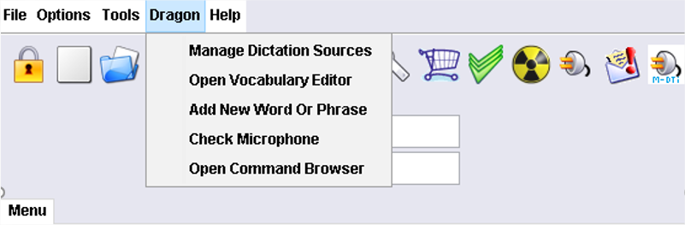

## Dragon – Dictation Source Change

When a CRIS user has multiple dictation sources in Dragon they are presented with a list of them in CRIS when they log in. The list is displayed but there is no way to tell the user which dictation source is which. It would be useful if the dictation sources could be better identified to stop the user from selecting the wrong one.

Resolution:

If an unrecognised audio source is present CRIS will display the Dragon audio source dialog:

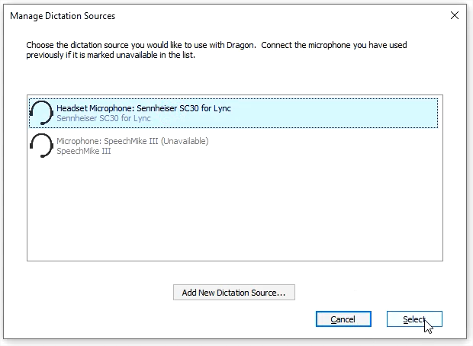

These changes have been implemented against Dragon 13 and also against Dragon 15.

## Dragon 13 Local Profile Implementation

As a user I can continue to use Dragon VR, even when the network drive containing my main profile is not available, so I can continue to work when we are experiencing network issues.

Resolution:

Dragon has the option for multiple locations for the roaming profile. This is just a network directory location and Dragon can be configured for more than one of these.

We create 2 entries, 1 for the master location, and a 2nd one as a failover location that is not backed up - i.e. master at J:\Dragon, and the 2nd one is at C:\Dragon (i.e. the local machine).

If IT Admin then copies over the users who will want this failover facility from J: to C, CRIS can check for the 1st one failing, and tell the user they are going to get the failover profile. This will not however be backed up by CRIS and will only be used if the network share to the master share fails.

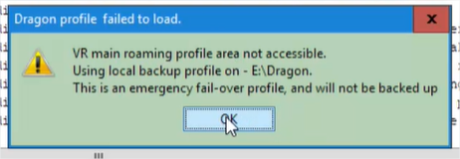

**Note: Only supported for Dragon13**

# Fixes to existing functionality in this release

The following fixes are included in this release:

## ‘Suppress Multi Episodes’ – XR setting missing

Between previous versions of the CRIS application, the ‘Suppress Multi Episodes’ XR setting has been partially removed. The impact of not having this setting is that customers with incompatible OCS interfaces cannot merge exams into one event – i.e. two separate HL7 exams which need to be merged into one overall event via CRIS.

Resolution

The XR setting has now been fully restored allowing customers to use it as designed.

.

## Extra characters appearing in Report screen when pressing ALT-E in Clinical History

As a user, when I add Clinical History into a summary report using ALT-E, I do not want to see the string "on *date* at *time*" erroneously entered into the report. And when using VR with multiple exams the command "Insert all titles" does not insert the Clinical History's signature twice in summary report and skip the first exam title.

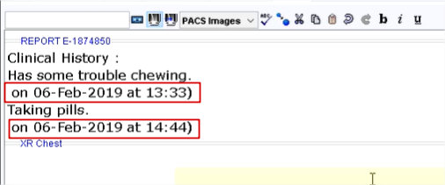

Hovering over an event on the scratch pad or within a diary slot any comment text is shown followed by the "on date at time)”. The entire signature should be removed from the display.

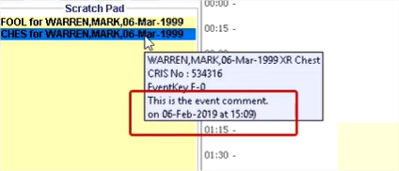

Resolution:

The incorrect clinical history and missing exam descriptions when using VR command "Insert All Titles" in the report editor have been corrected.

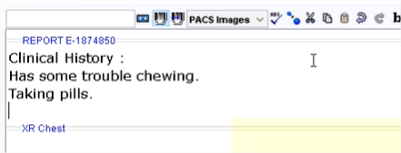

## Report text obscured by request box in editor

OTRS Reference: [00136720](http://service.hssnet.com/otrs/index.pl?Action=AgentTicketZoom;TicketID=137359)

It has been reported that when users click the "<< Request" button on the report editor screen, to show the scanned documents and event details, when you type multiple lines in the report or use VR to insert multiple lines, the cursor is staying behind the event info box in the report. This then means that at least one line of text is half obscured by the box.

Resolution:

Changes have been made to ensure that the words that are being typed or dictated do not go behind the Request Details box.

## Patient loaded from CRIS list is not the correct patient

OTRS Reference: [00150484](http://service.hssnet.com/otrs/index.pl?Action=AgentTicketZoom;TicketID=151155)

Users reported that, intermittently, while working in CRIS, a patient would be opened from a list, however the patient which loads on screen is the patient at the top of the list and not the patient the user selected.

Full replication steps for recreating the issue

------------------------------------------------------------

1. Login to 2.11.XX version of CRIS
2. Ensure you have RECEPT.RefreshOrdersList XR setting set to blank or Yes (the blank default is yes).
3. Open orders list.
4. Open request list.
5. Return to orders list.
6. Pick any patient and open the record on screen.
7. Decide you don't want this patient, so clear down the patient. You are returned to the open orders list.
8. Open the same patient again, from the orders list, by double clicking the already highlighted record, this should load the patient at the top of the list and not the patient you just clicked on.

Resolution:

Changes have been made to ensure that the list selection is refreshed correctly and that the correct patient is opened.

## Database Connections not always closed correctly

OTRS Reference [00149739](http://service.hssnet.com/otrs/index.pl?Action=AgentTicketZoom;TicketID=150410)

It has been found when you log out of Cris, it doesn't always kill the connections or use the same two connections when the user logs back in. This means users get more and more connections left open as they

logout.

Resolution:

A code change has been made to ensure that database connections are managed correctly when logging out and in to Cris.

## Focus set to first exam following Insert All Titles (ALT+A)

When using the ‘Insert All titles’ command, the focus would remain in the summary section rather than being set to just after the title of the first exam.

Resolution:

The focus is now set correctly and, following ‘Insert All Titles’ (ALT+A), the cursor is placed after the first exam title.

# Known issues

There were no new issues identified during testing of this release.

# Supported Platforms

See Warranted Environment Specification v1.12