Core Cris

2.12.00

Release Notes

Copyright

© Wellbeing Software 2019

Registered Office: 3rd Floor i2 Mansfield, Hamilton Court, Oakham Business Park, Mansfield, NG18 5FB

These materials are or comprise restricted and proprietary confidential information of Wellbeing Software. Disclosure to or use by the recipient shall not convey any intellectual property rights in these materials. The right to use these materials by the recipient is subject to restrictions and limitations contained in the Provision of Integrated Care Record System and Associated Services Agreement and related agreements.

Confidentiality

All information in this document is provided in confidence for the sole purpose of adjudication of the document and shall not be used for any other purpose and shall not be published or disclosed wholly or in part to any other party without HSS prior permission in writing and shall be held in safe custody. These obligations shall not apply to information which is published or becomes known legitimately from some source other than HSS. Many of the product, service and company names referred to in this document are trademarks or registered trademarks. They are all hereby acknowledged.

Document Control

|  |  |  |  |  |  |  |
| --- | --- | --- | --- | --- | --- | --- |
| Title | | Core Cris | | | | |
| Author | | Ian Baker | | | Date Created | 16.09.2019 |
| File Ref. | |  | | | | |
| Version | | 2.12.00 | | | | |
| Change History | | | | | | |
| Issue | Date | | Author / Editor | Details of Change | | |
| 0.1 | 16.09.2019 | | Ian Baker | First draft | | |
| 0.2 | 17.09.2019 | | Ian Baker | Updates after review | | |
| 0.3 | 24.09.2019 | | Ian Baker | Additions to section 3 | | |
| 1.0 | 24.09.2019 | | Bazil Caygill | Release | | |
| 1.1 | 07.10.2019 | | Ian Baker | Additions after testing | | |
| 2.0 | 07.10.2019 | | Ian Baker | Release | | |
| 2.1 | 18.10.2019 | | Ian Baker | Update following stakeholder review | | |
| Review Date | | |  | | | |

|  |  |  |  |
| --- | --- | --- | --- |
| Approval Sign-off | | | |
| Owner | Role | Date | Issue |
| Ian Baker | Product Owner | 18.10.2019 | 2.1 |
| Approver | Role | Date | Issue |
| Bazil Caygill | Release Train | 24.09.2019 | 1.0 |

Contents

Copyright 2

Confidentiality 2

Document Control 2

Contents 3

1 Introduction 5

1.1 Purpose 5

1.2 Audience 5

1.3 Previous Release 5

2 Functionality added in this release 6

2.1 UniqueByEvent attribute to send one report out for one event with multiple exams. 6

2.2 Ability to copy text from non-selectable parts of the interface. i.e. NHS number label 7

2.3 Add an hourly option to scheduled stats 8

2.4 Show warning when PACS not connected 9

2.5 Stop opening and closing all images in sequence with multiple exams 10

2.6 OCS Cancellation warning message not clear 11

2.7 MFN Audit - Add "Extra Detail" for Referral Sources, RefLinks and Referral Locations. 12

2.8 To enable CRIS to automatically change the status of an electronic order into a request 13

2.9 Process CATEGORY OBX Segment in Ultragenda Interface 14

2.10 Core Cris Rebrand 15

2.11 Extra pop up box when clicking the padlock icon 16

2.12 Insert all titles command 17

2.13 QuickEventSummary flag stops data being written to database. 18

2.14 Dragon 13 - Dictation source change 19

2.15 Provide a way to identify the default (blank) value of an XR setting 20

2.16 Implement Receipt Printing in 'Advanced' billing 21

2.17 Font appears blurred in Cris following link to windows font size 22

2.18 XR filter option 23

2.19 ‘Hospital Number’ column to Porters list and Dictation list 24

2.20 Vetting Workflow Default Button 25

2.21 Vetting List - Assigning of orders/events to a practitioner/group 26

2.22 Insignia DTI no longer working as expected post 2.10 upgrade 27

2.23 Improve Exam Validation for age check 28

2.24 Disable ‘intlog’ functionality 29

2.25 Billing - Invoices missing CRIS number 30

2.26 F12 Viewer to display same drop-down menu as Reporting and Post-processing 31

2.27 Dragon local profile implementation 32

3 Fixes to existing functionality in this release 33

3.1 Two exam validation rules not working as expected 33

3.2 Date values not fully visible 34

3.3 Interface Error - Couldn't create Message object 35

3.4 OriginatingOCS Bug 36

3.5 NullpointerException when selecting a row in the View Log screen. 37

3.6 XR Setting RECEPT.PrintRequestCard is not working properly 38

3.7 NullPointerException in ContractCosts table when creating a New Contract. 39

3.8 Post processing failure - old event with billing enabled. 40

3.9 Merging OCS Orders for Episodes - XR setting disappeared between 2.09.10t1e and 2.10 41

3.10 CRIS locks up completely when selecting multiple reports for printing. 42

3.11 Request Card icon not shown in CRIS when sent with HL7 Order message. 43

3.12 Events showing as deleted after patient records merged together 44

3.13 FASP printout - missing ‘see comments’ option 45

3.14 RFC Bug - Stat Scheduler stops when terminal missing 46

3.15 Extra characters appearing in Report screen when pressing ALT-E in Clinical History 47

3.16 IVSITEHAND form not displaying 48

3.17 VR - Icon grey while active 49

3.18 RFC Bug - Unable to assign practitioner to multiple events 50

3.19 RFC Bug - EFW cut off on screen 51

3.20 RFC Bug - Text not wrapping within print content editor for Java 1.8 52

3.21 RFC Bug - Fetch PASid method causing list slowness 53

3.22 Null content in warning message when failing ‘Warning On Patient Type’ exam validation 54

3.23 Exception thrown while no XRT highlighted 55

3.24 Exam column headers do not line up with corresponding fields 56

3.25 Adding new text to existing templates causes next paragraph text to change 57

3.26 Billing allows different currencies but still shows £ sign 58

3.27 Cannot print all request card when there are multiple images 59

3.28 Fail to cancel attendance with multiple exams 60

3.29 Break point is not working for procedure cost 61

3.30 RFC Bug - Site and room filters combined but not remembered 62

3.31 [Refresh] porter list would clear the filtered result 63

3.32 Word wrap and moving text issues in report editor 64

3.33 RFC Bug - Multiple notes not displayed against event 65

3.34 Assign Order(s) to Practitioner/Group for PAS patient. 66

3.35 Assign Order(s) to Practitioner/Group for matching CRIS/PAS patient. 67

3.36 Patient demographics check when a PAS patient order is assigned to a Practitioner/Group. 68

3.37 ‘stripTildeNew’ Function Fails to Remove Duplicate Tilde Symbols 69

3.38 Create CRIS Patient record while 'Vetting' an Order. 70

3.39 Dual OCS reflex messages suppressed due to race condition 71

3.40 Cannot stop event note from popping up 72

3.41 Removal of Intended clinician not recorded in ‘View log’ 73

3.42 'Group' field in the 'Vetting List' 74

3.43 CRIS: Med Photo bug when saving Consent details in Post Processing mode (2.11.00) 75

3.44 Problem: CRIS overriding Report Urgency from AI 76

3.45 Appointments with date of 01/01/2099 77

3.46 Unable to link notes to event keys longer than 9 characters-message module. 78

3.47 Warning message for patient type with mismatch referrer type is confusing. 79

3.48 Exception throw when open/close patient panel in merge patient screen 80

3.49 Buttons on Select Referral Source Screen is cropped 81

3.50 Spellcheck squiggles following correction of a misspelt word 82

3.51 Assign to Group for an order with end-dated referrer, will change the colour of the order. 83

4 Known issues 84

4.1 Configurable Age and AttdAge columns problem 84

4.2 Can’t download the existing document for a patient 85

4.3 Warning message displayed twice when referring invalid order to a group in the Vetting List 86

5 Supported Platforms 87

# Introduction

## Purpose

This document will outline the functional changes made to this release. It will detail any new features, enhancements to existing functionality and list changes made due to existing functionality not working as expected.

## Audience

This document is primarily for external stakeholders, so they have a clear understanding of the application's new/improved functionality, resolved and known issues for this release.

## Previous Release

The previous release of this product was as follows:

Version: 2.11.01

Date: 09/Jul/19

## 

# Functionality added in this release

The following features and enhancements are included in this release:

## UniqueByEvent attribute to send one report out for one event with multiple exams.

As a user when I am sending out a report with multiple exams

I want to be able to send out the multiple report and summary as it does in PACS outbound interface

So that OCS doesn't receive more than one report for all the exams merged in CRIS

Resolution:

New attribute created - 'UniqueByEvent' which must be configured in the ‘OutgoingMessages’ section of the ‘pasocs’ interface configuration files.

## Ability to copy text from non-selectable parts of the interface. i.e. NHS number label

Allow the user to cut text from the interface to save the user having to copy the CRIS no, or NHS no etc by hand. Allow them to get the text be it in a table, or a text box, or a label.

Resolution:

Tool created to allow the user to copy text from the main application window area, plus includes ability to include screenshot of the application. Designed to allow secretaries etc. to lift the text from labels (like NHS No.)

Relies upon enabling XR setting General.MiddleMouseButtonCopyToClipboard option. You can now copy using the Middle Mouse Button (MMB). This applies to text boxes, labels, selected rows in tables.

For basic textboxes you can also copy the tooltip using Ctrl+MMB. This generally does not apply to tables.

You can trim the text in the clipboard using the Trim Button in the Clipboard viewer, prior to pasting somewhere else.

You can copy the application image to the clipboard using Shift + MMB. This will not apply for dialogs.

For text, a 'clipboard viewer' opens to show the copied text, which can be trimmed within the clipboard, and then pasted elsewhere as required.

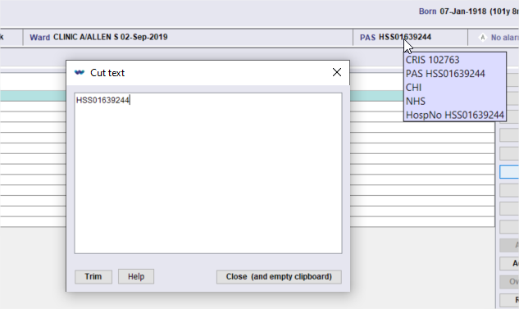

## Add an hourly option to scheduled stats

As user I can schedule regular stats every hour so I can add this to the existing ability to schedule them every 5 minutes and every day, to allow the department to supply and submit better information to trust management and reduce the level and number of scheduled stats that need to be run.

Resolution:

Option added to the database NORMAL table CRISSRPT.

Option added to StatsScheduler code to recognise the option.

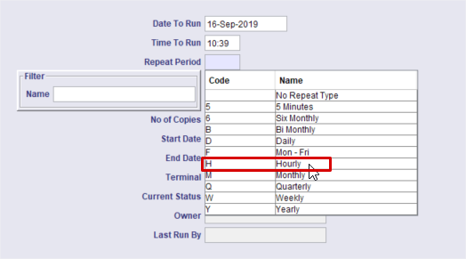

## Show warning when PACS not connected

eRC – eRadCockpit – GE web-based reporting platform

UV – Universal Viewer for Centricity PACS

As a vetting user within EMRAD, when I try to launch a PACS image, without first closing existing UVs in eRC (by clicking the 'Cris Vetting' button), or if there are no images associated with the accession number, I want to see a suitable warning message advising that the PACS is not connected or no accession exists within PACS, so that I can quickly identify and resolve the issue.

Resolution:

Created a new XR setting - REPORT.PACSWORKSTATION.EMRAD_GE.WarningMessageEnable -

which, when set, will display a warning message in the above scenario.

## Stop opening and closing all images in sequence with multiple exams

As a user using GE PACS, when the DTI is enabled in post processing it performs the DTI call twice causing the images to load and unload twice and PACS to steal focus, which interrupts entry of post processing details in CRIS

Resolution:

The call to 'displayImagesForExam' is no longer issued when the first exam's tab gains focus in the Post Processing screen.

## OCS Cancellation warning message not clear

A previous change in 2.11 added a warning message when the user tried to process an order or request that had been cancelled by the order comms (OCS). It was raised that the message could be clearer, in that some users may not know what the abbreviation OCS means.

Old Message (2.11) - "This event has been cancelled by OCS"

Resolution:

New Message (2.11.01+) - "This event has been cancelled by Order Comms"

Replaced all occurrences of 'OCS' with 'Order Comms' in warning messages within the workflow GUI.

## MFN Audit - Add "Extra Detail" for Referral Sources, RefLinks and Referral Locations.

MFN messages are outputted into the View Log Table, but this is at consortium level and there is currently only “Extra detail” (used in EXCEL export) for Referrers. Extra detail should be added for Referral Sources, Referral Links and Referral Locations as customers will want to know what MFN messages have been processed and some may require remedial configuration – i.e. Blank SHA’s.

Resolution:

All MFN related logging now contains meaningful 'extra data' outlining was has changed. Each MFN05 addition/update now has its own log entry

## To enable CRIS to automatically change the status of an electronic order into a request

OTRS Reference: [0066288](http://service.hssnet.com/otrs/index.pl?Action=AgentTicketZoom;TicketID=66671)

As a Cris User I want all Orders to be automatically converted into Requests so that workloads can be better managed as Requests go into silos.

Resolution:

Orders sent into the CRIS PASOCS interface can now be converted automatically to requests and appear on appropriate lists.

Orders failing validation will go directly onto orders list for further processing.

Two new interface attributes created:

1. OrderToAppointment set to ‘true’ will generate appointments directly from orders.
2. OrderToRequest set to ‘true’ will generate requests directly from orders.

The ‘CreateOrder’ attribute has been copied over from the ‘UltraGenda’ interface. This is only used when interface is simulating the old ‘UltraGenda’ functionality. So, if the ‘OrderToAppointment’ is set to ‘true’, this attribute must also be ‘true’.

## Process CATEGORY OBX Segment in Ultragenda Interface

OTRS Reference: [0076757](http://service.hssnet.com/otrs/index.pl?Action=AgentTicketZoom;TicketID=77199)

There exists, for a specific customer, a bespoke OCS interface which doesn’t contain all of the functionality of the primary Cris OCS interface. We need to switch this customer’s interface to our standard OCS interface whilst maintaining their bespoke functionality.

Enable setting of the Request Category field in CRIS events via values in an

OBX segment in inbound order messages from Ultragenda.

In the version of CRIS currently in use (2.09.19.t1e), CRIS only detects and processes three OBX:3 values, “PREGNANT”, “LMP” and “SITE” in Ultragenda messages.

Resolution:

Orders sent in on the PASOCS interface can now be changed to appointments/attendances automatically. As such, their processing will comply to our PASOCS interfaces and all OBX segments will be processed.

## Core Cris Rebrand

As a Core Cris user I can see the new wellbeing Software branding on the Splash Screen, Login Screen and the Help/About screen so that the latest wellbeing branding is reflected within the Cris product.

Resolution:

Branding updated as required.

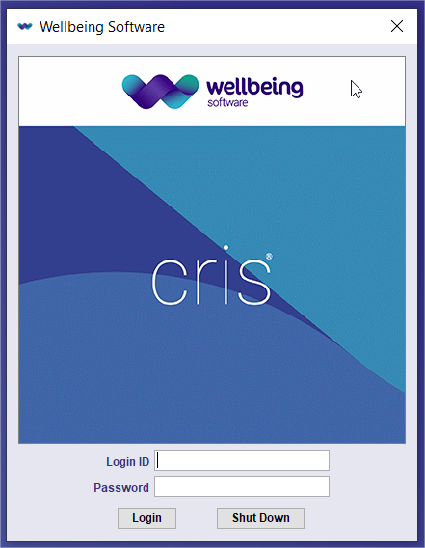 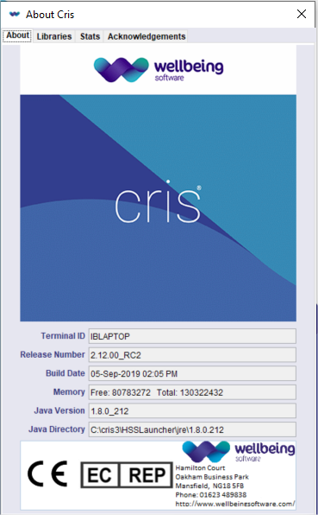

## Extra pop up box when clicking the padlock icon

Users are accidentally clicking the log out button when attempting to use the clear screen button. We require a pop up box which asks the user are they sure they wish to log out, Yes or No?

Resolution:

A dialog is now displayed when the user presses the padlock icon. This dialog asks the user if they are sure they want to log out. The user can then log out, cancel the action and stay logged in and they can select a check box if they don't want to be asked again.

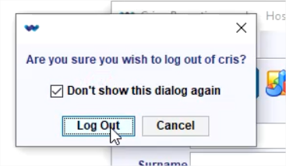

## Insert all titles command

When the ‘Insert all titles’ is issued, the expected behaviour is that the titles are added to each section of the report with the focus placed in the first exam after the exam title.

The actual behaviour is that the Titles are added to each section of the report however the focus is placed in the Clinical history section of the report.

Resolution:

‘Insert all titles’ command now positions cursor at the end of the first exam.

## QuickEventSummary flag stops data being written to database.

The XR setting GENERAL.UseQuickEventSummary is used to indicate how work lists should refresh.

Unfortunately, this flag also acts to stop data being written to the ExamSummary table in the database if it is turned off. Thus, if someone switches the state of this for a period, the data will be corrupted.

Resolution:

Code modified to ensure data is saved to the ExamSummary table when GENERAL.UseQuickEventSummary XR setting is set to false.

## Dragon 13 - Dictation source change

In Dragon 13 a change was made to how multiple dictation sources are created in Dragon.

The impact for CRIS is when a user has multiple dictation sources in Dragon they are presented with a list of them in CRIS when they log in. The list is displayed but there is no way to tell the user which dictation source is which. It would be useful if the dictation sources could be better identified to stop the user from selecting the wrong one.

Resolution:

If an unrecognised audio source is present CRIS will display the Dragon audio source dialog:

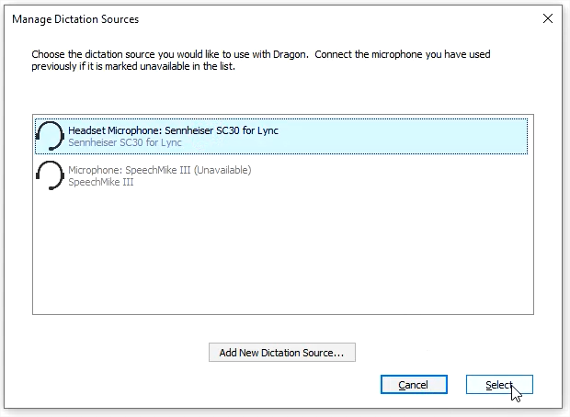

## Provide a way to identify the default (blank) value of an XR setting

Currently, when looking at the XR settings screen, there is no clear indication of the ‘default’ value of a setting should it be blank.

Resolution:

The XR settings panel has been amended by adding the default state into the settings area, for those settings that have a fixed default in the source code. If you pick a setting from the XR-settings panel, and there is nothing set by a user, AND it has a default against the setting, the default is displayed in the value panel in grey, and {default} is appended to the value on screen.

i.e.

No {default}

6 {default}

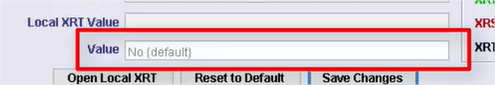

Keys with a known default also feature an asterisk at the start of the description:

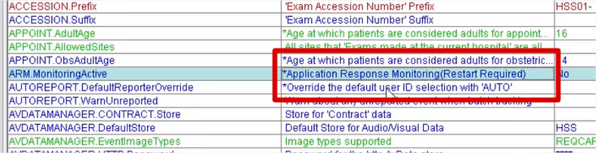

## Implement Receipt Printing in 'Advanced' billing

We need the ability to print a ‘receipt’ for all ‘self-payer’ contracts.

Resolution:

The printing features have been amended to provide 'receipt' printing for ‘self-payer’ patients.

## Font appears blurred in Cris following link to windows font size

As a user, when I am viewing the Cris interface, I want the font to appear without blurring, as it did prior to the link to windows font size, so I can clearly see the text on screen.

Resolution:

Application adjusted to correct a problematic value in the settings for the look-n-feel. Also added a capability to adjust 3 flavours of font/font-size-style from the ‘.jnlp’ file. Some of the field look-n-feel settings were not being updated on start-up.

In addition, there is also a registry setting that resolves a Java issue that incorrectly reports High DPI abilities of monitors in windows 10. This registry setting can be provided on request.

## XR filter option

A filter to add an ability to search XR terminal IDs to find specific terminals is required. This will allow the user to quickly identify a particular terminal within a long list. Customers will also find this beneficial when performing normal sys admin tasks.

Resolution:

A filter has been added to the XR settings setup page to allow the terminal id to be filtered.

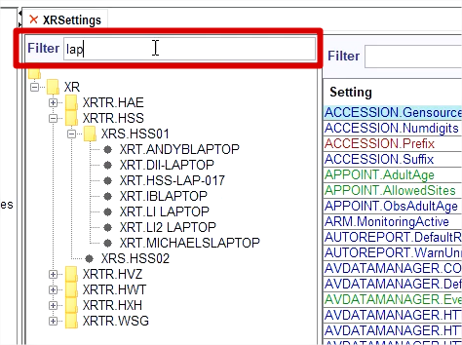

## ‘Hospital Number’ column to Porters list and Dictation list

OTRS Reference: [0031956](http://service.hssnet.com/otrs/index.pl?Action=AgentTicketZoom;TicketID=32000)

As a user I want to see hospital number as a column on the Porter and Dictation lists so that I have easy access to this reference number.

Resolution:

The 'HospNo' column has been added to both the 'Dictation' and 'Porters' lists.

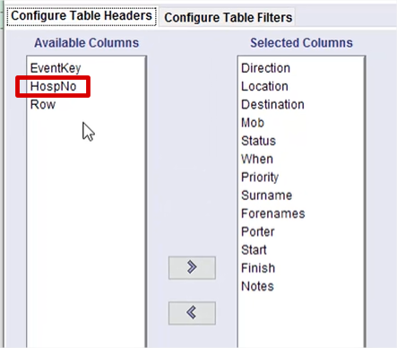

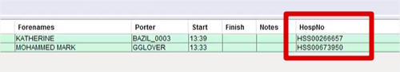

## Vetting Workflow Default Button

As a user in Vetting Mode, when I first go through the vetting process and enter the Protocol screen, the default button should be 'Completed', so I can complete the process rather than update it.

When I revisit the vetting process for a previously vetted event, the default button should be 'Update'.

It's currently set to 'Update' regardless of whether it’s a new vetting session or an update.

Resolution:

Application now recognises if the events status contained a "vetting complete" state and sets the correct default button accordingly.

## Vetting List - Assigning of orders/events to a practitioner/group

As a vetting list or Orders list user, when I try to assign multiple orders/events, I want to see a warning if there are multiple orders within the selection for the same patient, so that the user is aware that the orders may need to be combined into a single event/request before assignment.

The existing message that warns about orders and events is incorrect and should be removed. The only time a warning should be displayed is when there are multiple order rows in the selection for a single patient.

Resolution:

Message now displayed when a user tries to Assign multiple orders for a single patient:

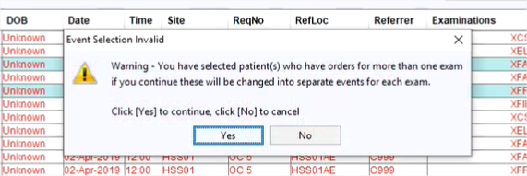

## Insignia DTI no longer working as expected post 2.10 upgrade

OTRS Reference: [00124803](http://service.hssnet.com/otrs/index.pl?Action=AgentTicketZoom;TicketID=125408)

The mismatch occurs because the current DTI can only interrogate local trust entries in the ‘PACSID’ table, so when a patient/event comes from a different trust, it cannot be found in the table and a ‘mis-match’ warning is displayed.

Resolution:

If the 'pascid' table is interrogated, and a patient/event mismatch occurs, the trust code from the event is obtained and used to interrogate the pacsid table again. This then returns the correct 'pacs patient'. If this second check fails, a warning message will be displayed.

## Improve Exam Validation for age check

As a user, when I configure age validation against an exam, I want the first two parameters to be used as the lower and upper thresholds to validate against

Resolution:

A new exam validation rule has been added based on the age of the patient at exam creation.

The rule has two parameters, LOWER LIMIT and UPPER LIMIT and the patient's age must fall between these two values to validate. The message displayed is now a 'warning' message and as such allows the user to proceed even if the age is invalid.

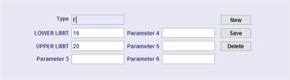

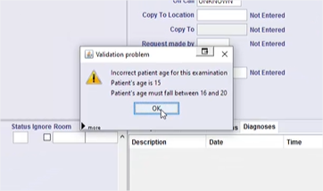

## Disable ‘intlog’ functionality

The ‘hss/interfaces/hl7pas/IncomingMessages’ interface contains a piece of functionality which creates log entries in the database for every HL7 message received, it is not possible to disable this functionality without a code change.

After reviewing the CRIS code this functionality is redundant as the information stored is of very little value.

As this functionality creates log entries for every inbound message it causes huge tables to build within the live crisprod databases, especially on large sites/consortiums:

Resolution:

Log messages to ‘intlog’ in hl7pas interface will no longer be made.

## Billing - Invoices missing CRIS number

OTRS Reference [00128108](http://service.hssnet.com/otrs/index.pl?Action=AgentTicketZoom;TicketID=128745)

As a billing user I want to see the CRIS number on invoices, regardless of the contract type so that I can easily link back to the CRIS record from an invoice

Resolution:

The functionality is now available to display the CRIS number for a patient associated with an invoice irrespective of the contact type.

Amended code to ONLY display the CRIS number for 'AD HOC' contracts. The invoices for these contracts are printed by event, so the patient's CRIS number will be available.

## F12 Viewer to display same drop-down menu as Reporting and Post-processing

As a user, when I open the report viewer (F12 viewer) in Core Cris I can see a drop-down menu, the same as I can see in post processing and reporting. This is so I can select and open individual images in the F12 viewer in the same way as I can in reporting and post processing.

Resolution:

Combo for DTI added to report viewer.

## Dragon local profile implementation

As a user I can continue to use Dragon VR, even when the network drive containing my main profile is not available, so I can continue to work when we are experiencing network issues.

Resolution:

Dragon has the option for multiple locations for the roaming profile. This is just a network directory location and Dragon can be configured for more than 1 of these.

We create 2 entries, 1 for the master location, and a 2nd one is a failover location that is not backed up - i.e. master at J:\Dragon, and the 2nd one is at C:\Dragon (i.e. the local machine).

If admin then copies over the users who will want this failover facility from J: to C, CRIS can check for the 1st one failing, and tell the user they are going to get the failover profile. This will not however be backed up by CRIS and will only be used if the network share to the master share fails.

Only supports Dragon13, not Dragon 11 or 12.

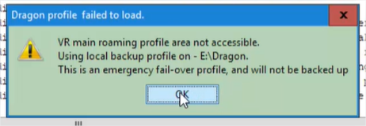

# Fixes to existing functionality in this release

The following fixes are included in this release:

## Two exam validation rules not working as expected

OTRS Reference: [0072847](http://service.hssnet.com/otrs/index.pl?Action=AgentTicketZoom;TicketID=73290)

An issue has been found where two exam validation rules, when implemented, are not working as expected. The two rules in question are ‘Incorrect age for exam’ and ‘display warning based on patient type’.

Incorrect age for exam = Warning message displays even when correct age is used (meets min & max requirements).

Display warning based on patient type = Warning displays If patient type selected however pop up box is blank.

Resolution:

Incorrect age for exam = Warning message displays only when incorrect age is used (does not meet min & max requirements).

Display warning based on patient type = Warning displays If patient type selected, pop up box displays text along the lines of ‘Incorrect patient type for this examination’.

Normal table ‘EXAMVGRP’ has been updated accordingly.

## Date values not fully visible

OTRS Reference: [0056742](http://service.hssnet.com/otrs/index.pl?Action=AgentTicketZoom;TicketID=56933)

Since the changes to the date formatting within CRIS, some fields within the application are not large enough to display the full date.

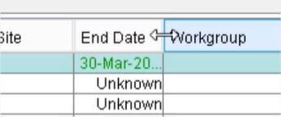

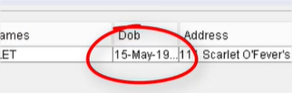

Resolution:

Some intelligence has been built into the date/time fields to calculate the space required to show the date/time format in question.

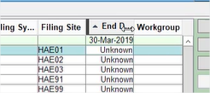

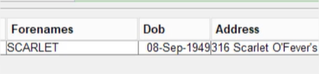

## Interface Error - Couldn't create Message object

OTRS Reference: [0076694](http://service.hssnet.com/otrs/index.pl?Action=AgentTicketZoom;TicketID=77136)

An issue has been found whereby certain messages are failing immediately after the scheduled interface restart. Messages will continue to be lost; this poses a potential clinical risk. The issue has only been seen to affect consortiums so far.

Resolution:

Two related parsing classes (small variations on the original classes) were added into the codebase alongside the hapi library, with adjustments to ensure that the NullPointerException issue could no longer arise. Changes were then made to the CRIS Interfaces code to ensure that those classes are now invoked appropriately.

## OriginatingOCS Bug

OTRS Reference: [0094507](http://service.hssnet.com/otrs/index.pl?Action=AgentTicketZoom;TicketID=95048)

It's been found that when an order is sent to CRIS via an OCS interface with the ‘OriginatingOCS’ attribute set. Any reflex orders created that are linked to the original order are created with no value in the 'originating_ocs' column of the orders table. This means that the resulting messages outbound from CRIS are not restricted to sending back to the original OCS only.

Resolution:

Now when 'reflex' orders are created, the 'originating_ocs' value from the original order is copied to the 'reflex' order. This can then be validated, and the 'reflex' order can be sent back to the same Order Comms System it originally came from.

Also, if the attribute is ever unset or doesn't exist, the 'reflex' order will be sent outbound.

## NullpointerException when selecting a row in the View Log screen.

A NullpointerException (NPE) is displayed in the View Log screen when a patient unlinked row is selected.

Resolution:

Now there are no NPE’s when selecting PATIENTLINK or PATIENTUNLINK log entries

## XR Setting RECEPT.PrintRequestCard is not working properly

Scanned Documents can be Printed if your trust/site/local terminal has XR Setting RECEPT.PrintRequestCard = Yes. Then select the scanned image and right click to choose print option or choose the [Print Document] button.

When RECEPT.PrintRequestCard = No, the user should not be able to print the scanned request card. The 'Print Document' button is hidden, but the user can still choose right click option 'Print Image Document' while I am selecting the request card.

Resolution:

Wherever the option to print the request card exists, its availability is now controlled via the 'RECEPT.PrintRequestCard' XR setting.

## NullPointerException in ContractCosts table when creating a New Contract.

A NullpointerException message is displayed when creating a new Contract ID in the ContractCosts Tables Setup.

Resolution:

This was caused by a thread timing issue relating to the updating of the ‘progress bar’ while the new contract cost was being created. This timing issue has now been removed and the contract cost is created without error.

## Post processing failure - old event with billing enabled.

When billing is enabled, and the user attempts to process an event that was created before billing was enabled (no contract), an error occurs, and the user is unable to progress to the post processing screen.

Resolution:

The error is now trapped when the event has no associated contract. Post processing can now continue.

## Merging OCS Orders for Episodes - XR setting disappeared between 2.09.10t1e and 2.10

There is an XR Setting which is crucial to a piece of functionality that is needed to disable the Episodes functionality if the 3rd party order comms system can’t support episodes in the expected way. It was developed in 2.09.10t1e but has disappeared in 2.10 and there is nothing in the release notes to say why.

The impact of not having this setting is that customers with incompatible OCS interfaces cannot merge exams into one event – i.e. two separate HL7 exams which need to be merged into one overall event via CRIS.

Resolution:

XR setting was only partially implemented. The complete setting is now available.

## CRIS locks up completely when selecting multiple reports for printing.

From the events list, pick a list of events with multiple reports on each. Right click and select Print Report. If printing for reports is set to "Print Preview", the interface may lock up completely after about 4 repetitions.

Resolution:

The threading synchronisation around this functionality has been amended to allow this workflow to proceed without stalling the application.

## Request Card icon not shown in CRIS when sent with HL7 Order message.

When an Order is received via OrderComms and it has an attached Request Card, the Scanned REQCARD icon is not shown for CRIS events if it’s saved as a Request/Waiting.

Resolution:

When an order, which contains a request card, is converted into a CRIS event, the request card icon is now present against the event in the patient's event list.

## Events showing as deleted after patient records merged together

OTRS Reference: [00110950](http://service.hssnet.com/otrs/index.pl?Action=AgentTicketZoom;TicketID=111555)

An issue has occurred when two users are amending the same patient simultaneously.

User A creates an event for Patient 1 while vetting an order.

User B merges Patient 1 with Patient 2

User A finishes and save the event for Patient A.

Now when the event is searched against Patient A, it cannot not be found.

Resolution:

Prior to saving the event, the application now checks that the patient in the database does not have an alias. If so, the event is updated to the new master patient.

## FASP printout - missing ‘see comments’ option

OTRS Reference: [00108581](http://service.hssnet.com/otrs/index.pl?Action=AgentTicketZoom;TicketID=109186)

When an obs fasp report form is completed, users have the option to select several values for each body part scanned (Normal Variant, Not examined, Not seen, Abnormal, Seen, Normal, Other see comments). It has been found that the printed reports for fasp reports did not include text for each section when the user selected a particular body part as ‘Other see comments’ as it should. If you select ‘Stomach’ for example as ‘Other see comments’, the printed report states that ‘No abnormalities were seen in the following: ABDOMEN: stomach’ which is obviously incorrect, and it should state ‘see comments’.

Resolution:

The screenshot below highlights the changes needed.

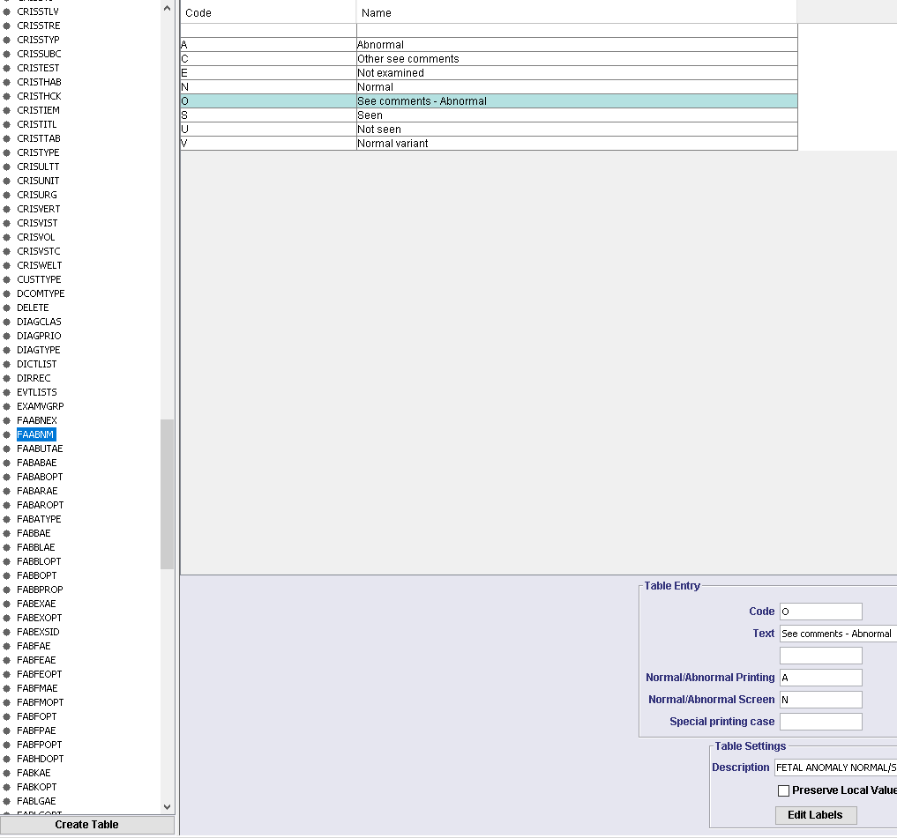

## RFC Bug - Stat Scheduler stops when terminal missing

OTRS Reference: [0095591](http://service.hssnet.com/otrs/index.pl?Action=AgentTicketZoom;TicketID=96164)

If a stat has been scheduled to run, using a terminal ID which no longer exists at the time of running, the stat scheduler should just ‘skip’ running this stat instead of stopping on this stat and therefore queueing other, genuine stats behind it.

Resolution:

The exceptions are now trapped if we have NO terminal ID set against the Stat and the missing terminal is skipped.

## Extra characters appearing in Report screen when pressing ALT-E in Clinical History

As a user, when I add Clinical History into a summary report using ALT-E, I do not want to see the string "on *date* at *time*" erroneously entered into the report. And when using VR with multiple exams the command "Insert all titles" does not insert the Clinical History's signature twice in summary report and skip the first exam title.

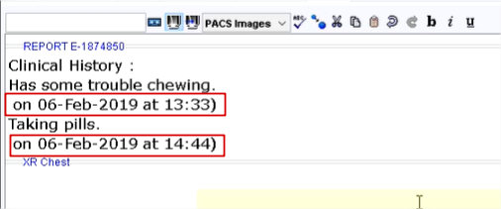

Hovering over an event on the scratch pad or within a diary slot any comment text is shown followed by the "on date at time)”. The entire signature should be removed from the display.

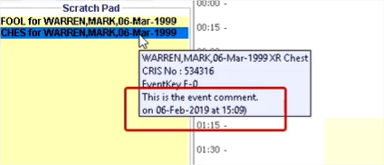

Resolution:

The incorrect clinical history and missing exam descriptions when using VR command "Insert All Titles" in the report editor have been corrected.

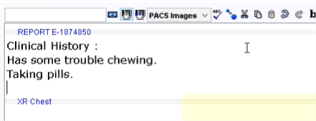

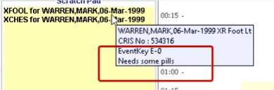

## IVSITEHAND form not displaying

When I run Cris 2.11.01, the IVSITEHAND form doesn’t display and I see several errors:

Resolution:

Internal libraries changed from Sun/Oracle specific image libraries to libraries that are compatible with the ‘OpenJDK’ environment.

The Softform now displays without errors.

## VR - Icon grey while active

The dragon icon in CRIS remains grey even when the mic is active and working in a report.

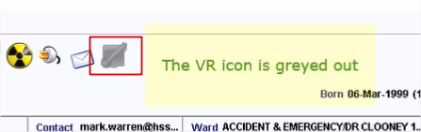

There are two XR Settings

VOICE.DragonReportingStartState_AutoON

and

VOICE.DragonReportingStartState_AutoOFF

If these are not set to a value, then the code throws a suppressed exception that causes the activation of the VR Icon to be skipped.

Resolution:

The application now contains a default of 3 (Mic sleeping) for both of these values in code so that it will work if not set up properly.

The site setup guidelines do stress that these should be set, so this fix is precautionary only.

## RFC Bug - Unable to assign practitioner to multiple events

OTRS Reference: [00113979](http://service.hssnet.com/otrs/index.pl?Action=AgentTicketZoom;TicketID=114584)

Up until recently, you were able to load the vetting list, hold down ‘ctrl’ on the keyboard and left click multiple events on the list and then assign a practitioner in the right-hand bottom corner by clicking assign.

However, this functionality no longer works. You cannot assign a practitioner to multiple events because an error is shown on screen. The error doesn’t help as the events selected are all CRIS events and not orders.

Resolution:

A check has been added for all events in selection, fixed initial multi-select failure and added checking to right click 'Vetting -> Referred'.

## RFC Bug - EFW cut off on screen

OTRS Reference: [00116974](http://service.hssnet.com/otrs/index.pl?Action=AgentTicketZoom;TicketID=117578)

We have had an issue raised with a couple of sites after upgrading to 2.10 where on the UOFG, the fetal weight is being cut off in the report.

This is happening for users no matter the screen resolution they are using.

Resolution:

We have adjusted the width of the field from 6 characters to 9 characters.

## RFC Bug - Text not wrapping within print content editor for Java 1.8

OTRS Reference: [00121272](http://service.hssnet.com/otrs/index.pl?Action=AgentTicketZoom;TicketID=121876)

A problem has been identified where if you have a Cris system using java version 1.8 (which all 2.10 sites will use), text wrapping does not work within the print content editor if there is a really long line of text within a template.

If you were to load the exact same template using a java 1.6 version, the word wrapping within the template is enabled as expected.

Resolution:

Changes were made to reset the break points for the editor screen so that they break correctly on word boundaries. This was caused by a Swing bug introduced into Java in version 1.7.

## RFC Bug - Fetch PASid method causing list slowness

OTRS Reference: [00124647](http://service.hssnet.com/otrs/index.pl?Action=AgentTicketZoom;TicketID=125251)

When XR setting RECEPT*RESTRICT*NEW*EVENT*PAT_PAS is set to ‘yes’ on a workstation, this slows down the speed of the lists significantly.

This issue is most apparent on the appointments, waiting and request lists.

The problem is that the ‘PAS ID’ for a patient is called for EVERY event on the list, even if the list contains events for the same patient. This is obviously unnecessary and slows things down.

Resolution:

The application will now get the PAS ID for each patient once, and only once, prior to loading the list, thus speeding up the list creation.

## Null content in warning message when failing ‘Warning On Patient Type’ exam validation

Given that a 'Display warning based on pat type' validation rule exists for an exam for a certain patient type, when a new Event is created for that exam, that breaches the validation, then the appropriate warning message should be displayed.

The warning message should mention the validation details.

In fact, it shows as 'null null' in the message.

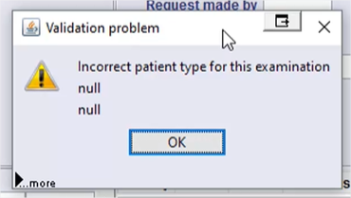

Resolution:

Parameters with no content are no longer displayed in validation warning messages.

The warning message has been amended to include more detail.

## Exception thrown while no XRT highlighted

When the user opens the XR setting, the user's local XRT is highlighted in the XR setting tree as expected.  
In the left hand ‘Filter’ field, enter a word, e.g. HSS. The XR tree is filtered appropriately but nothing is highlighted. Now when the user selects the ‘Setting’ or ‘Description’ checkbox, an error is shown.

Resolution:

The ‘Filter’ panel, which includes the ‘Setting’ and ‘Description’ checkboxes, is disabled until something is selected in the terminal node tree on the left.

## Exam column headers do not line up with corresponding fields

The headers on the Event Details page for Exams do not line up with their corresponding fields.

Resolution:

Titles now line up with columns in the exam editor.

## Adding new text to existing templates causes next paragraph text to change

When you try and add new text to existing templates within the print content editor, as you type, the text in the paragraph below moves for no reason and cuts off some words on the end.

Resolution:

Changes were made to reset the break points for the editor screen so that they break correctly on word boundaries. This was a Swing bug introduced into Java in version 1.7.

## Billing allows different currencies but still shows £ sign

OTRS Reference: [00113774](http://service.hssnet.com/otrs/index.pl?Action=AgentTicketZoom;TicketID=114379)

Currently, the currency symbol (£) is hard-coded into the printing templates. If this is not the location’s currency, it will need to be changed manually wherever it exists within the printing configuration system.

Resolution:

Existing templates will need amending to access new a new currency object, but once this is done, the currency symbol will depict the currency of the locality.  
  


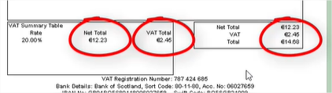

## Cannot print all request card when there are multiple images

When a CRIS event has more than 1 request card scanned, the user can right click on the event to 'Print All' request cards. Currently, after the user chooses this option, it only prints the first request card. This only appears to be an issue with Print Preview.

Resolution:

Added pages to print-preview for when printing when we have multiple images. Previously we only created 1 page but now we create multi-page output for the print.

## Fail to cancel attendance with multiple exams

When there is a contract set up with a procedure cost and a cancellation cost (e.g. Hospital Cancel £10), if we create an attendance with 3 exams, using this contract, and then cancel the attendance by using the same cancellation reason, the user won't be able to cancel this event, and an error is shown when the billing screen is loaded.

Resolution:

Multiple exam events can now be cancelled without error.

## Break point is not working for procedure cost

A break point can be added to a procedure cost, which is used when calculating discounts. The calculated cost with the discount included is incorrect.

Resolution:

Event breakpoints are now being calculated correctly when the Discount Type' is 'P' for percentage.

## RFC Bug - Site and room filters combined but not remembered

OTRS Reference: [00124993](http://service.hssnet.com/otrs/index.pl?Action=AgentTicketZoom;TicketID=125598)

When loading the day list or appointment list for another site within your trust, and you combine the site + room filters on the list, if you then click [list], the results will show for the desired site/room.

If you then close the list fully and reload it by clicking [day list], an error appears stating “cannot set value ‘XXXXX’ in the field as this is not valid”.

It appears that CRIS tries to combine the room filter for the other site and apply this to your logged in site, as such the room code is not valid and therefore catches the exception. The site filter in the site filter field currently still shows as the other site however CRIS isn’t filtering on this because if you f4 in the room field, the rooms available are for your logged in site.

Resolution:

We now check, and if the room is not valid for the site chosen, when the Lists are displayed, the room field is set to blank.

## [Refresh] porter list would clear the filtered result

The filtered column is not working when user press [Refresh].

Resolution:

When the porter list has been filtered in some way, pressing the [REFRESH] button no longer removes the filter and the contents of the list remain unchanged.

Filtered entries are maintained within the Porter list when any column is sorted and the [REFRESH] button is applied.

## Word wrap and moving text issues in report editor

Strange word-wrap and moving text behaviour has been observed in the report editor, similar to that raised in issues 3.20 and 3.25.

Resolution:

Fixed word wrapping by resetting break points.

## RFC Bug - Multiple notes not displayed against event

OTRS Reference: [00126368](http://service.hssnet.com/otrs/index.pl?Action=AgentTicketZoom;TicketID=126973)

As found in versions of CRIS 2.10 (using windows 10 OS), when multiple notes are added to one event, upon loading the event, only the latest note added is visible. Please note that windows 7 and CRIS 2.10 does not produce this issue.

One pop up note box appears for each comment, which if you have more than one message, only the latest message text is displayed.

The expectation is that all messages should be visible once the event is loaded.

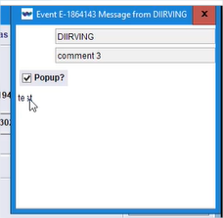

Resolution:

Popup notes now tile from top right, column by column until full. Any extra notes beyond this stack on the top right one. Notes are now post-it note colour.

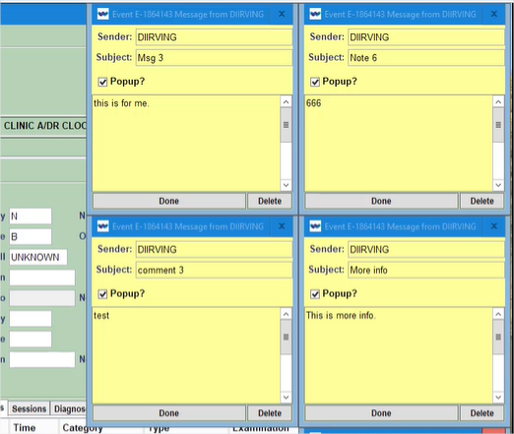

## Assign Order(s) to Practitioner/Group for PAS patient.

1. If an order in the 'Vetting List' (for PAS patient) is highlighted and Assigned to Practitioner, the HIS patient is saved with a CRIS no and assigned to the 'Practitioner
2. If multiple orders in the 'Vetting List (for PAS patient) are highlighted and Assigned to Practitioner, the 'Event Selection Invalid' dialogue is displayed.

Resolution:

If a selection of ‘pure’ orders is selected from the vetting list, and a Practitioner or Group is assigned to that order, the following validation is applied:

* Multiple orders for the same patient – Warning that each order will be converted to a single event.
* Multiple orders, multiple patients – Error message indicating that Orders for multiple patients will not be processed, reselect your orders.

.

## Assign Order(s) to Practitioner/Group for matching CRIS/PAS patient.

1. If an order in the 'Vetting List (for PAS patient) is highlighted and Assigned to a Practitioner/Group then the 'Match Patient' screen is displayed with CRIS patient.
2. If multiple orders in the 'Vetting List (for same PAS patient) is highlighted and Assigned to a Practitioner/Group then the 'Event Selection Invalid' dialog is displayed.

Resolution:

If a selection of ‘pure’ orders is selected from the vetting list, and a Practitioner or Group is assigned to that order, the following validation is applied

* Multiple orders for the same patient – Warning that each order will be converted to a single event.
* Multiple orders, multiple patients – Error message indicating that Orders for multiple patients will not be processed, reselect your orders.
* Multiple order for the same patient BUT a CRIS patient already exists within the Trust, then a MATCH screen will be presented to the user prior to assignment. Please note, choosing the ‘Do Not Match’ option, may result in duplicate patients.

## Patient demographics check when a PAS patient order is assigned to a Practitioner/Group.

1. If an order in the 'Vetting List (for PAS patient) is highlighted and Assigned to a Practitioner/Group then the 'Match Patient' screen is displayed with CRIS patient.
2. If multiple orders in the 'Vetting List (for same PAS patient) are highlighted and Assigned to a Practitioner/Group then the 'Event Selection Invalid' dialog is displayed.

Resolution:

If a selection of ‘pure’ orders AND existing events is selected from the vetting list, and a Practitioner or Group is assigned to that order, the following validation is applied:

* Multiple orders for the same patient – Warning, each order will be converted to a single event.
* Multiple orders, multiple patients – Error message indicating that Orders for multiple patients will not be processed, reselect your orders.
* Multiple order for the same patient BUT a CRIS patient already exists within the Trust, then a MATCH screen will be presented to the user prior to assignment. Please notes, choosing the ‘Do Not Match’ option, may result in duplicate patients.
* Multiple order for the same patient BUT a CRIS patient already exists within ANY Trust, then a MATCH screen will be presented to the user prior to assignment. Please notes, choosing the ‘Do Not Match’ option, may result in duplicate patients.

Existing events will be amended to include the newly assigned Practitioner or Group.

## ‘stripTildeNew’ Function Fails to Remove Duplicate Tilde Symbols

OTRS Reference: [00127080](http://service.hssnet.com/otrs/index.pl?Action=AgentTicketZoom;TicketID=127717)

An issue has been identified whereby duplicate tilde values sent in outbound messages are not removed.

Resolution:

The function that strips duplicate tilde characters from the outbound messages has been fixed to work correctly.

## Create CRIS Patient record while 'Vetting' an Order.

When vetting an order from the PAS patient’s event list, the order list or the vetting list, no 'Create CRIS Patient' option dialog is presented to the user, even if the PAS.PromptNewCrisPatient XR setting is set to ‘Yes’

Resolution:

Now, when 'vetting' an order, if the patient has no PAS matches and no CRIS number, an appropriate dialog is presented asking the user if they would like to create a new CRIS patient. If the user selects 'Yes’, the vetting process continues as expected and a new CRIS patient is created. If the user selects 'No', the user stays on the Events page.

## Dual OCS reflex messages suppressed due to race condition

OTRS Reference: [00127989](http://service.hssnet.com/otrs/index.pl?Action=AgentTicketZoom;TicketID=128626)

In circumstances where two OCS interfaces exist linked to the same PAS mirror it's possible for reflex messages to fail to send due to a race condition that occurs between the two message generators. This results in:

* The OCS will occasionally not be informed when a new exam is added to an existing order.
* The OCS will not know about certain exams that have been added to orders. This also means that status updates are not kept in line with CRIS and reports for these exams will be unsolicited.

Resolution:

With dual OCS interfaces, we now only see ONE 'reflex' order being sent back to the originating Order Comms System.

## Cannot stop event note from popping up

For pop-up event notes, the User should be able to un-tick the ‘pop-up’ checkbox and click [Done] in order to prevent the message popping up again. However, the message still pops up when the event is loaded.

Resolution:

Following the fix, if you untick the popup and then press Done, the popup will cease to re-show. It will however still be accessible via the Messages panel.

## Removal of Intended clinician not recorded in ‘View log’

OTRS Reference: [00126899](http://service.hssnet.com/otrs/index.pl?Action=AgentTicketZoom;TicketID=127504)

When blanking/removing a clinician from the ‘Intended Clinician’ field, the action is not logged within the view log, meaning the user cannot audit to see who removed the clinician code.

Resolution:

The removal of the intended clinician from an event is now recorded in the logs. A new log type of REPORTUNASSIGN has been created to capture this occurrence. This new log type must be inserted into the CRISLGTP normal table.

## 'Group' field in the 'Vetting List'

The 'Group' field should only be available in the 'Vetting List' if the 'Resource Module' is available.

Resolution:

The resource 'Group' field on the vetting list is only displayed when the resource module is enabled and the 'GENERAL.SingleResourceGroupPerEvent' setting is set to 'yes'.

## CRIS: Med Photo bug when saving Consent details in Post Processing mode (2.11.00)

OTRS Reference: [00128990](http://service.hssnet.com/otrs/index.pl?Action=AgentTicketZoom;TicketID=129627)

When a user enters consent details in post-processing mode in CRIS, finishing and saving does not record the saved consent details when reloading the patient. However, image data is stored successfully.

When using any other mode (reception, vetting etc), then saving the med consent, the radio consent buttons are saved successfully upon reloading the patient/event.

It is very likely that users using this module will be using post processing mode since their main work will be to post process patients.

Resolution:

Changes made to allow Attend and PostProcess buttons to behave properly by saving the signature before opening the panel to show the signature in the post processing screen.

## Problem: CRIS overriding Report Urgency from AI

OTRS Reference: [00130303](http://service.hssnet.com/otrs/index.pl?Action=AgentTicketZoom;TicketID=130940)

When An Event is updated by the AI Interface it updates the report urgency to a new value (R,N).

In release 2.11, this is being changed to the urgency derived from the event urgency and displaying a warning message that the report urgency has changed.

Resolution:

Changes made to only change the report urgency value if the value was already either an empty string, null or 'S'. Any other values like 'U', 'R', or 'N' will not cause a change when the event is opened in CRIS.

## Appointments with date of 01/01/2099

OTRS Reference [00130605](http://service.hssnet.com/otrs/index.pl?Action=AgentTicketZoom;TicketID=131242)

There is an issue where two users are updating an event at the same time. One user has the event opened in the Diary and the other user has it opened in the ‘Event Details’ page. The user in the diary adds the event into a valid slot. The user in the ‘Event Details’ page has no idea of this change but makes changes to the event and saves. This subsequently changes the event date to 01-Jan-2099 and overwrites the appointment date in the diary.

Resolution:

Validation checks are now made whenever the user applies an action to the event, e.g. save, change, attend etc. If the event and/or exam(s) have changed, the user is notified of this fact and asked to store any changes made before the workflow is cleared.

## Unable to link notes to event keys longer than 9 characters-message module.

OTRS Reference [00130605](http://service.hssnet.com/otrs/index.pl?Action=AgentTicketZoom;TicketID=131886)

The messaging module allows you to assign notes to specific events. When attempting to link a note to an event, where the event key is longer than 9 digits, the linking fails.

Resolution:

The database column width for the field has been increased to support longer event keys.

## Warning message for patient type with mismatch referrer type is confusing.

When an order is received into CRIS, where the referrer is unknown, when opening the order to process the application this originally produced a message stating that the referrer was unknown. Now a message that just states ‘Press F4 to see the list’ is produced, which is a little vague and doesn’t outline the cause of the problem.

Resolution:

The exception messaging has been amended to use the original message description. Now all such exceptions will give a more detailed message outlining the real cause of the problem.

## Exception throw when open/close patient panel in merge patient screen

When merging two patients, the ‘Merge Patient’ panel contains the ‘Patient Banner’ component. When this component is expanded or closed, an error is shown.

Resolution

Now when the ‘Patient Banner’ is expanded/contracted within the ‘Merge Patient’ panel, no errors occur.

## Buttons on Select Referral Source Screen is cropped

When viewing the 'Select Referral Source' window, the buttons [OK] and [Cancel] at the bottom are cropped. This is happening in the 'Select Referral Source' tab and the 'Select Site in Trust/Domain' tab. The window cannot be enlarged to enable the user to see the buttons properly.

Resolution:

The dimensions of the dialog have now been amended to show the button correctly and to ensure the buttons are displayed when the dialog is resized.

## Spellcheck squiggles following correction of a misspelt word

OTRS Reference [00136345](http://service.hssnet.com/otrs/index.pl?Action=AgentTicketZoom;TicketID=136984)

When reporting, if a word is misspelt and then corrected, any words that are subsequently typed are also marked as spelling errors until a space is typed to signify the end of the word.

Resolution:

Report attributes and ‘insert’ mark-up have been amended to ensure correct spellcheck functionality.

## Assign to Group for an order with end-dated referrer, will change the colour of the order.

When a ‘Group’ is assigned to an order, a warning message is displayed indicating that the referrer is end-dated, and the assignment process will be stalled. Once the warning dialog is acknowledged, the order in the list is not refreshed and the order is displayed in green text. In similar scenarios, the list is refreshed, but not immediately, so it displays with a green colour momentarily. Refreshing the list returns the order to the correct colour.

Resolution:

The order is validated a little earlier in the process, so any errors are reported prior to the status of the event changing. This prevents the colour changes seen above.

# Known issues

The following issues have been identified during testing of this release.

These issues have been risk-assessed and have been accepted within this release. They may be addressed in a future release of the product.

## Configurable Age and AttdAge columns problem

*Current status: Open*

2 new configurable columns have been added to report info list and events list.

But there are some problems:

1. Report info List:

- Open any tab, e.g. Unverified Tab.

- Ensure no-profile is selected.

- Ensure there is no age columns, if so, reset the list with default columns.

- Add 2 new ages columns, press [Refresh]

The list is displayed.

- Select another tab, e.g. Suspended.

- Select Unverified tab again.

Expected: 2 new ages columns are displayed.

Result: both columns have disappeared.

2. Report info List:

- Open any tab, e.g. Unverified Tab.

- Add Ages columns, press [Refresh]

- Choose Table Filter, set Age Contains 'xx', (E.g. 69). Apply it.

The list is filtered on patients aged ‘xx’

Press [Refresh]

Expected: The list is filtered on Age Contains 'xx'.

Result: the list returns patients that do not match 'xx' (e.g. 69)

3. Event List

Waiting List for example.

After adding both new age columns, press [List].

Check java console, there are some exceptions thrown with erro hss.utils.ConfigurableTableModel getValueAt 101 - Error interpreting configurable column script

## Can’t download the existing document for a patient

*Current status: Open*

*Fix version:*

When a user tries to upload, and then download a patient document it displays an error message.

## Warning message displayed twice when referring invalid order to a group in the Vetting List

*Current status: Open*

*Fix version:*

When a user tries to refer an order to a group from the vetting list, and the order referrer code does not match the patient referrer type, a warning message is displayed. On closing the message, the same message is shown again and must be closed again.

# Supported Platforms

See Warranted Environment Specification v1.12