CRIS

Release 2.12.01

Release Notes (External)

Copyright

© Wellbeing Software 2020

Registered Office: 3rd Floor i2 Mansfield, Hamilton Court, Oakham Business Park, Mansfield, NG18 5FB

These materials are or comprise restricted and proprietary confidential information of Wellbeing Software. Disclosure to or use by the recipient shall not convey any intellectual property rights in these materials. The right to use these materials by the recipient is subject to restrictions and limitations contained in the Provision of Integrated Care Record System and Associated Services Agreement and related agreements.

Confidentiality

All information in this document is provided in confidence for the sole purpose of adjudication of the document and shall not be used for any other purpose and shall not be published or disclosed wholly or in part to any other party without HSS prior permission in writing and shall be held in safe custody. These obligations shall not apply to information which is published or becomes known legitimately from some source other than HSS. Many of the product, service and company names referred to in this document are trademarks or registered trademarks. They are all hereby acknowledged.

Document Control

|  |  |  |  |  |  |  |
| --- | --- | --- | --- | --- | --- | --- |
| Title | | CRIS | | | | |
| Author | | Ian Baker | | | Date Created | 14.04.2020 |
| File Ref. | |  | | | | |
| Version | | Release 2.12.01 | | | | |
| Change History | | | | | | |
| Issue | Date | | Author / Editor | Details of Change | | |
| 0.1 | 14.04.2020 | | Ian Baker | First draft | | |
| 1.0 | 21.04.2020 | | Bazil Caygill | Rebrand, release | | |
|  |  | |  |  | | |
|  |  | |  |  | | |
|  |  | |  |  | | |
|  |  | |  |  | | |
|  |  | |  |  | | |
| Review Date | | |  | | | |

|  |  |  |  |
| --- | --- | --- | --- |
| Approval Sign-off | | | |
| Owner | Role | Date | Issue |
| Ian Baker | Product Owner | 14.04.2020 |  |
| Approver | Role | Date | Issue |
| Bazil Caygill | Release Train | 21.04.2020 | 1.0 |

Contents

Copyright 2

Confidentiality 2

Document Control 2

Contents 3

1 Introduction 4

1.1 Purpose 4

1.2 Audience 4

1.3 Previous Release 4

2 Functionality added in this release 5

2.1 Support 2-digit urgency values 5

2.2 Allow image compression from IMAGEIO Function in CRIS (Medical Photography) to be configurable 6

2.3 Cannot save image files of type ‘TIFF’ for MedPhoto modality 7

2.4 CRIS does not report when email client sub-system not setup correctly. 8

2.5 Warning in diary if wait times breached 9

2.6 Dragon 15 Implementation 10

3 Fixes to existing functionality in this release 11

3.1 Intouch Kiosk changing appts in CRIS diary 11

3.2 Post exam defaults not populating the post processing with 4 decimal places 12

3.3 Addendum data not saved when report suspended. 13

3.4 Cannot book appointment by 'search forward' with a batch of exams in Diary Viewer 14

3.5 Two Warning messages show when referring invalid order to group in Vetting list 15

3.6 Post exam defaults not populating the post processing screen 16

3.7 Create CRIS Patient warning is not displayed when multiple selecting CRIS event and order during assigning 17

3.8 Filtering on worklists is corrupted when columns are sorted, and the list refreshed 18

3.9 Editing Stats field entries causes lockup of database connection 19

3.10 Creating new connections when logging back on. 20

3.11 Incorrect images loaded on PACs causing mismatch 21

3.12 Patient loaded from CRIS list is not the correct patient. 22

3.13 Unable to end-date values within the CRIS setup tables 23

4 Known Issues 24

5 System Requirements and Supported Platforms 25

# Introduction

## Purpose

This document will outline the functional changes made to this release. It will detail any new features, enhancements to existing functionality and list changes made due to existing functionality not working as expected.

## Audience

This document is primarily for external stakeholders, so they have a clear understanding of the application's new/improved functionality, resolved and known issues for this release.

## Previous Release

The previous release of this product was as follows:

Version: 2.12.00

Date: 09/09/2019

# Functionality added in this release

The following feature(s) has been added to this release.

## Support 2-digit urgency values

When I set an urgency against an event, I want to be able to choose from a list of more than 9 urgencies. Currently the setup screens allow you to have 2-digit urgency codes but when trying to save an event with an urgency code with two digits there is an error.

*Resolution*:

Cris has been modified to allow the configuration and usage of 2-digit urgency codes.

All incoming/outgoing interfaces now process 2-digit urgency values without error.

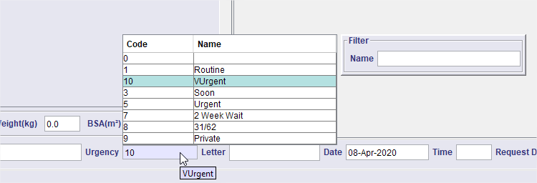

## Allow image compression from IMAGEIO Function in CRIS (Medical Photography) to be configurable

OTRS Reference: [00145580](http://service.hssnet.com/otrs/index.pl?Action=AgentTicketZoom;TicketID=146251)

An issue was identified whereby applying compression to already compressed images was causing image quality to drop below acceptable levels in the Med Photo Module.

*Resolution*:

We have allowed the user to adjust the compression between 0 and 100%. This is done via a new XR setting – AVDataManager.PHOTO.Quality.

If the quality is > 1 then this is classed as a percentage of 1-100%. (100% should be lossless).

If less than or equal to 1 and > 0, this is a 0-1 range and is effectively multiplied by 100 to give a percentage.

If set to '0', this is 'as-is' and will store the file exactly as presented. This may therefore cause a large data storage requirement.

In addition, improvements have been made in the memory management and user feedback when loading large images into Cris.

## Cannot save image files of type ‘TIFF’ for MedPhoto modality

Med Photo module did not support the saving of TIFF images.

*Resolution*

TIFF images are now supported.

## CRIS does not report when email client sub-system not setup correctly.

An issue was reported whereby a customer was unable to send email messages from CRIS.

This was because when CRIS checked for a valid MAPI system it did not find one, so it gave up on the email. It did not tell the user or log the error.

*Resolution*:

Code added to display an appropriate message if the sub-system check fails.

## Warning in diary if wait times breached

When I add an appointment to the diary that breaches the wait times, I want to see a warning message so I can help avoid the trust breaching its targets.

*Resolution*:

We have implemented a check, using the existing breach date calculations within CRIS, to warn the user if the event being added to the diary exceeds the basic breach date.

This only is used if we have:

1. a single exam in the ScratchPad on the diary and drag it into the diary, or
2. we use SearchForward with only 1 exam selected.

In case a) the message details the date; the appointment is trying to be set to.

In case b) it states that we are searching beyond the breach date for an appointment we might not have found yet. (i.e. don't waste time looking for something we might not want).

If we get a warning, we are given the option to abort, or proceed even though we know the appointment date is beyond the breach date.

**Note: If we have multiple exams selected, no warnings are given.**

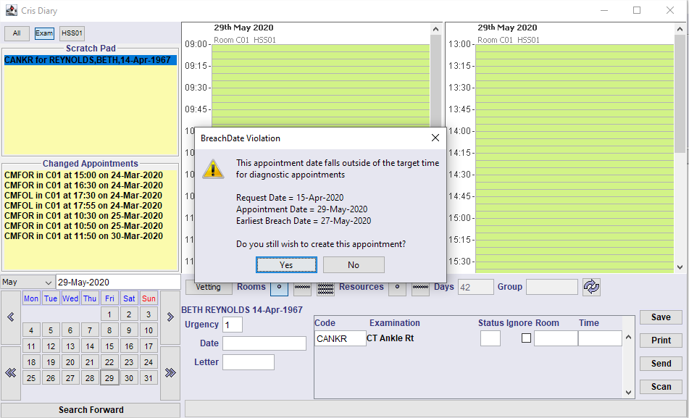

## Dragon 15 Implementation

The Dragon 15 Voice Recognition application is now integrated with CRIS 2.11.03. Dragon 15 includes a number of improvements over earlier versions including better profile management and improved recognition quality.

The Nuance Dragon 15 – Medical Practice Edition Webpage

<https://www.nuance.com/healthcare/provider-solutions/speech-recognition/dragon-medical-practice-edition.html>

Nuance Dragon 15 – Medical Practice Edition Release Notes

<https://www.nuance.com/products/help/dragon15/dragon-for-pc/enx/dmpe/Content/ReleaseNotes/DMPE_relnotes.htm>

Note. Nuance has removed the system tray menu from this version. We have recreated the commonly used items from this list within Cris itself.

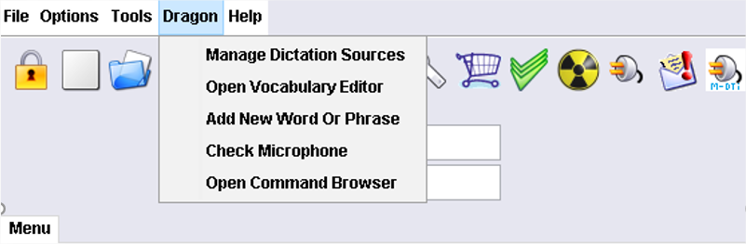

# Fixes to existing functionality in this release

The following fixes are included in this release:

## Intouch Kiosk changing appts in CRIS diary

OTRS Reference [00110771](http://service.hssnet.com/otrs/index.pl?Action=AgentTicketZoom;TicketID=111376)

When an InTouch attendance kiosk is used, the attendance date and time is sent via the incoming PACS interface. The 'booked_date' and 'booked_time' is updated in the 'exams' table, resulting in the event moving in the diary.

Resolution:

A new interface attribute was created to separate the required functionality.

The attribute ‘KioskEnable’ must be set to ‘true’ to enable the new functionality and configured in any incoming PACS interface file.

The booked_date and booked_time are no longer modified so the appointment does not move in the diary.

## Post exam defaults not populating the post processing with 4 decimal places

OTRS Reference [00133960](http://service.hssnet.com/otrs/index.pl?Action=AgentTicketZoom;TicketID=134597)

The ‘seconds, mAs and dosage’ fields within the ‘postExam’ table, have previously had their validation adjusted to allow 4 digits before the decimal place, and 4 places after. i.e. 9999.9999 or 0.0010

However, there is a postexam default table in CRIS which was not changed.

Resolution

The post exam table now supports the same format as elsewhere in Cris.

## Addendum data not saved when report suspended.

OTRS Reference [0057460](http://service.hssnet.com/otrs/index.pl?Action=AgentTicketZoom;TicketID=57683)

It was discovered that, dependent on workflow, whenever a report was suspended, its status went to a ‘suspended addendum’ as expected but the report wasn’t visible within the ‘Suspended’ tab in the report info lists.

Resolution

Now ANY suspended addendum (if the suspended date is unknown) will be reported in the suspended tab. This may lead to very old reports initially being reported.

## Cannot book appointment by 'search forward' with a batch of exams in Diary Viewer

If you select a batch of exams from the scratch pad and click the [Search Forward] button, it will only appoint one of the exams. The right-click option 'Search Forward' functionality is working.

*Resolution*:

Changes made to ensure the same code is used whether the right-click ‘Search Forward’ or ‘Search Forward’ button is clicked. Both now work as expected.

## Two Warning messages show when referring invalid order to group in Vetting list

When referring to a group within the Vetting list, if the referrer has been end dated then the same warning message was being displayed twice.

*Resolution*:

When trying to refer an invalid referrer, only one message is produced outlining who the referrer is and the reason the validation has failed.

## Post exam defaults not populating the post processing screen

OTRS Reference: [00133960](http://service.hssnet.com/otrs/index.pl?Action=AgentTicketZoom;TicketID=134597)

The format of post exam values was recently changed from numeric (6,2) to numeric (12,4) for the columns ‘dosage’ and ‘mas’, and the ‘seconds’ column was changed from numeric (6,2) to numeric (8,4).

However, the post exam default projections table was not changed this is causing two errors

1. When attempting to open post exam defaults you receive a null pointer exception

2. Where there is a post exam default set up if you create an event for that exam and room you get an error message.

*Resolution*:

Post exam default projections table changed to reflect earlier database changes elsewhere in Cris.

## Create CRIS Patient warning is not displayed when multiple selecting CRIS event and order during assigning

When creating a Cris patient from a HIS patient as part of a multi-select assignment on the Vetting list, the ‘Create Cris Patient’ dialogue should be displayed. It isn’t.

The order is assigned, and the HIS patient is saved as CRIS patient. The failure only happens when the chosen event, positioned at the top of the vetting list, is not an order.

*Resolution*:

Added validation to trap all occurrences of CRIS/non-CRIS patients in the selection and display an appropriate message informing the user to make another selection.

## Filtering on worklists is corrupted when columns are sorted, and the list refreshed

A filter is placed on a column in a worklist e.g. the request list. The list is refreshed, and the filter is maintained. However, sort any one of the other columns, refresh the list again, and the filtering is corrupted, i.e. events can be seen that were not part of the original filtered result.

*Resolution*:

Sorting a set of filtered events and refreshing the list, does not corrupt the filtered list

## Editing Stats field entries causes lockup of database connection

If you change a Stat field, and click Save, this does not free up the background database connection. The next time you click save the system will lock up.

1. Open Setup / system / stats / StatsDataFields
2. Highlight the 1st row in the table.
3. Press Save.
4. Try to open the Vetting list and the system will sit buffering.

*Resolution*:

Ensured that the database connections are closed correctly after editing Stats fields.

## Creating new connections when logging back on.

OTRS Reference [00149739](http://service.hssnet.com/otrs/index.pl?Action=AgentTicketZoom;TicketID=150410)

It has been found when you log out of Cris, it doesn't always kill the connections or use the same two connections when the user logs back in. This means users get more and more connections left open as they

logout.

Resolution:

A code change has been made to ensure that database connections are managed correctly when logging out and in to Cris.

## Incorrect images loaded on PACs causing mismatch

OTRS Reference [00145729](http://service.hssnet.com/otrs/index.pl?Action=AgentTicketZoom;TicketID=146400)

Two GE PACS sites have reported issues with images in PACs being mismatched with the report open in CRIS. It is believed that this only occurs with a specific version of the GE software at these two sites.

Resolution

Wellbeing has improved the way it handles exceptions passed by the GE software so that a clearer message can be displayed to the end user advising them of the issue and how to recover to ensure the correct context is maintained.

## Patient loaded from CRIS list is not the correct patient.

OTRS Reference: [00150484](http://service.hssnet.com/otrs/index.pl?Action=AgentTicketZoom;TicketID=151155)

Users reported that, intermittently, while working in CRIS, a patient would be opened from a list, however the patient which loads on screen is the patient at the top of the list and not the patient the user selected.

Full replication steps for recreating the issue

------------------------------------------------------------

1. Login to 2.11.XX version of CRIS
2. Ensure you have RECEPT.RefreshOrdersList XR setting set to blank or Yes (the blank default is yes).
3. Open orders list.
4. Open request list.
5. Return to orders list.
6. Pick any patient and open the record on screen.
7. Decide you don't want this patient, so clear down the patient. You are returned to the open orders list.
8. Open the same patient again, from the orders list, by double clicking the already highlighted record, this should load the patient at the top of the list and not the patient you just clicked on.

Resolution:

Changes have been made to ensure that the list selection is refreshed correctly and that the correct patient is opened.

## Unable to end-date values within the CRIS setup tables

OTRS Reference [00151682](http://service.hssnet.com/otrs/index.pl?Action=AgentTicketZoom;TicketID=152385)

When an attempt is made to remove an existing end-date value from most setup tables, the record isn’t changed, and the end-date remains.

Resolution

Fix applied to ensure that the end date can be removed as expected.

# Known Issues

There were no new issues identified during testing of this release.

# System Requirements and Supported Platforms

See [Warranted Environment Specification v2.0](https://wellbeingsoftware.sharepoint.com/HSS-Development/Releases/Shared%20Documents/Wellbeing%20Warranted%20Environment%20Specification%20v2.0.pdf)