core CRIS

Release 2.12.02

Release Notes (External)

Copyright

© Wellbeing Software 2020, a Citadel Group Company.

Registered Office: 3rd Floor i2 Mansfield, Hamilton Court, Oakham Business Park, Mansfield, NG18 5FB

These materials are or comprise restricted and proprietary confidential information of Wellbeing Software. Disclosure to or use by the recipient shall not convey any intellectual property rights in these materials. The right to use these materials by the recipient is subject to restrictions and limitations contained in the Provision of Integrated Care Record System and Associated Services Agreement and related agreements.

Confidentiality

All information in this document is provided in confidence for the sole purpose of adjudication of the document and shall not be used for any other purpose and shall not be published or disclosed wholly or in part to any other party without Wellbeing Software prior permission in writing and shall be held in safe custody. These obligations shall not apply to information which is published or becomes known legitimately from some source other than Wellbeing Software. Many of the product, service and company names referred to in this document are trademarks or registered trademarks. They are all hereby acknowledged.

Document Control

|  |  |  |  |  |  |  |
| --- | --- | --- | --- | --- | --- | --- |
| Title | | core CRIS | | | | |
| Author | |  | | | Date Created | 02.12.2020 |
| File Ref. | | Cris Release Notes 2.12.02.docx | | | | |
| Version | | Release 2.12.02 | | | | |
| Change History | | | | | | |
| Issue | Date | | Author / Editor | Details of Change | | |
| 0.1 | 02.12.2020 | |  | First draft | | |
| 1.0 | 15.12.2020 | | Bazil Caygill | Review | | |
|  |  | |  |  | | |
|  |  | |  |  | | |
|  |  | |  |  | | |
|  |  | |  |  | | |
|  |  | |  |  | | |
| Review Date | | |  | | | |

|  |  |  |  |
| --- | --- | --- | --- |
| Approval Sign-off | | | |
| Owner | Role | Date | Issue |
|  | Product Owner | 02.12.2020 |  |
| Approver | Role | Date | Issue |
| Bazil Caygill | Release Train | 15.12.2020 | 1.0 |

Contents

Copyright 2

Confidentiality 2

Document Control 2

Contents 3

1 Introduction 4

1.1 Purpose 4

1.2 Audience 4

1.3 Previous Release 4

2 Functionality added in this release 5

2.1 RFC Bug - CRIS SQL queries causing list slowness for cross trust working 5

2.2 Allow Shutdown message to be customised 6

2.3 Waiting List not showing all entries 7

2.4 Allow orders with an invalid referrer code 8

3 Fixes to existing functionality in this release 9

3.1 Changing exam codes on event with a report 9

3.2 Time Reported Field value not set 10

3.3 Overwriting blank codes when using a space 11

3.4 Prevent the blank Clinician Code from being changed 12

3.5 Request cards print to the default printer rather than the selected printer 13

3.6 Unable to load pdfs of version 1.3 as REQCARDS 14

4 Known issues 15

5 Supported Platforms 16

# Introduction

## Purpose

This document will outline the functional changes made to this release. It will detail any new features, enhancements to existing functionality and list changes made due to existing functionality not working as expected.

## Audience

This document is primarily for external stakeholders, so they have a clear understanding of the application's new/improved functionality, resolved and known issues for this release.

## Previous Release

The previous release of this product was as follows:

Version: 2.12.01

Date: 17/Apr/20

# Functionality added in this release

The following features and enhancements are included in this release:

## RFC Bug - CRIS SQL queries causing list slowness for cross trust working

OTRS Reference: 00144292

Jira Reference: CRIS-4824

A customer reported that when they use the application to pick up other trusts events, most of the lists in CRIS are very slow to run queries and display results.

The way in which the customer was hoping to use CRIS for cross trust work was to add multiple trust sites to the site column filter on the request list, for example, but leave the site filter at the bottom of the actual list blank.

This results in the main request list query returning events for any site and then once the result set is returned, the results are filtered down based upon any table column filters which have been added. This can easily be seen in the java console when replicating.

As a user, this significantly impacts the speed of the application. Each time you refresh the list it takes a long time to return data because of the sheer number of events on large consortia lists.

It would be better if CRIS could identify that table filters have been used and therefore apply these into the initial database query.

Resolution:

For this to work SPINE.RestrictToTrust must be set to "No".

A change has been made so that we only request data for the sites included in the site column filter, if this filter is set and the site field is empty.

The user will only see these performance benefits if the site filter operand is ‘Contains’ e.g.

contains HSS01,HSS02.

The list of sites must be separated with commas. No validation of the site codes is performed.

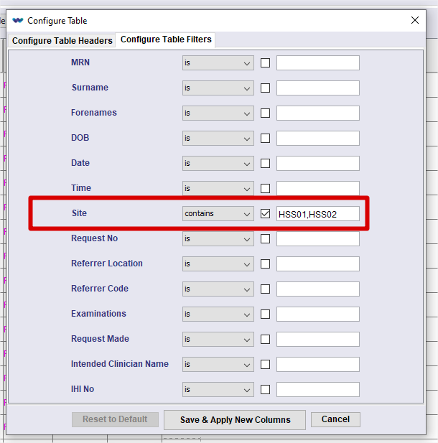

## Allow Shutdown message to be customised

Jira Reference: CRIS-5126

The XR setting **General.Warnshutdown** causes a shutdown message to be displayed. This message should be configurable.

*Resolution*:

A new format - 'SHUTDOWN' has been created to hold the user configurable text. This can be either plain text or HTML.

The dialog is effectively a label, so plain text will always appear on a single line. If you need a more formatted message, use HTML formatting.

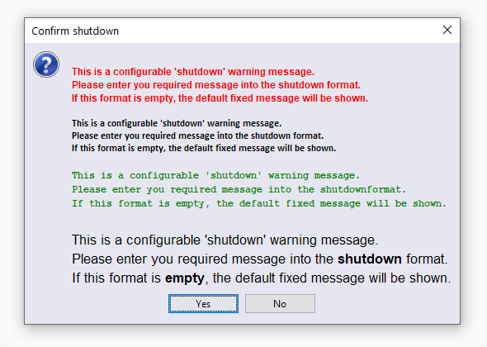

## Waiting List not showing all entries

OTRS Reference: 00154355

Jira Reference: CRIS-5331

If the filters retrieve more than (roughly) 1200 events, it fails to refresh the list.

1. Load waiting list
2. Set filters to retrieve a few events - short date range and modality filter retrieves the events and works correctly. Exam count matches query rows
3. Wait more than 10 seconds
4. Expand the range in the filters

The list does not refresh despite pressing the list button

*Resolution*:

We have adjusted the special sort order used in the waiting list, as it did NOT meet the correct workflow pattern for sorting, and as such threw an exception under certain circumstances.

## Allow orders with an invalid referrer code

Jira Reference: CRIS-5552

A customer is the process of upgrading from 2.09 to 2.12. They noticed that they are no longer able to place orders for unknown referrers. This is a problem for them, and for other users in the South West.

New functionality was added to the ‘Incoming PAS’ interfaces with the 2.12 release. One change was to ‘trap’ invalid referrers and reject the message but at the same time, offer the users a couple of alternatives to prevent this from happening.

The customer in question does not want to use the alternatives and would like the invalid referrer to pass through into CRIS where it can be handled as needed.

*Resolution*:

Added '**ValidateReferrer**' interface attribute to the HL7/PAS interface. This will enable/disable the validation of the referrer code within an OMG^O19 message. The default operation will be that the validation is disabled, and the invalid referrer code will be pass through to CRIS. Tto enable this validation, the attribute must be present and set to ‘true’.

# Fixes to existing functionality in this release

The following fixes are included in this release:

## Changing exam codes on event with a report

OTRS Reference: 00110513

Jira Reference: CRIS-4737

It is currently possible to change, for example, a reported Obstetric exam to a non-Obstetric exam in the event details page, thus hiding the original Obstetric report altogether. Also, if the new exam is consequently reported and verified, downstream systems will see two different reports for the same event. A warning is presented to the user explaining the risk, but the process is not blocked.

*Resolution*:

Validation is now in place that checks to see if the current exam(s) has an associated report. If it does, the user is warned but, more importantly, prevented from proceeding with this workflow.

## Time Reported Field value not set

OTRS Reference: 00141656

Jira Reference CRIS-5669

In some instances, throughout the application, the ‘time_reported’ is NOT populated alongside the ‘date_reported’. This makes the ‘time’ an event was reported unavailable for gathering statistical reporting data.

Resolution

Time reported was not being set for auto-reported reports. This is now set in the same way as the ‘time_typed’ field.

## Overwriting blank codes when using a space

OTRS Reference: 0051668

Jira Reference: CRIS-4901

When creating or changing a staff record within CRIS, it is possible to put a space into the Clinician, Secretary and Radiographer boxes. When this is done, it will overwrite the blank codes setup within CRIS with the staff name and ‘user_id’ values.

*Resolution*:

We have added a check for any ‘whitespace’ characters in the Secretary, Clinician, Radiologist or Clerical fields. Validation takes place when user tries to move out of the field and is prevented from doing so if validation fails and an appropriate warning message is displayed.

## Prevent the blank Clinician Code from being changed

OTRS Reference: 0086260

Jira Reference: CRIS-4920

The ‘blank’ clinician code can currently be changed. If the blank clinician code is changed then reports are then shown with the newly inserted person. This effects downstream systems.

*Resolution*:

Validation checks are made to ensure the ‘blank’ clinician cannot be changed for anything other than a blank clinician.

## Request cards print to the default printer rather than the selected printer

OTRS Reference: 0001151

Jira Reference: CRIS-5047

There is a Request Cards printer open in the Printers Setup page. It works correctly if the currently selected printer is set to either the Windows default printer, Print Preview or No Printer. However, when set to any other valid printer, the output is sent instead to the Windows default printer.

*Resolution*:

The requested print service for request cards was being looked up but then ignored, so the default printer was being used. The requested service is now being set and used.

## Unable to load pdfs of version 1.3 as REQCARDS

OTRS Reference: 00156297

Jira Reference: CRIS-5231

If you load a version 1.3 pdf as an image in scanned documents, it just loads a blank page for each page in the document. You can load it as attached documents fine.

*Resolution*:

Installed the libraries listed below to provide the functionality required.

icepdf-core-6.3.3-SNAPSHOT.jar

icepdf-viewer-6.3.3-SNAPSHOT.jar

jbig2-imageio-3.0.0.jar.

Please note. These jars will be included in the deployment package. Please ensure the ‘cris.jnlp’ references these new jars.

# Known issues

There were no new issues identified during testing of this release.

# Supported Platforms

See Wellbeing Warranted Environment Specification v2.0

