Speech Mike User Guide

This document is designed to be used by any reporting clinicians as a reference when first using digital dictation via a Phillips Speech Mike. This guide covers the layout, functionality and installation information.

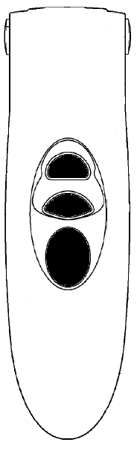
Layout Front / Back
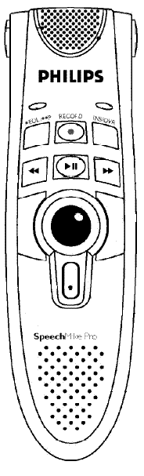

4
11
6
2
1
5
3
9
10
7
12
13
8

1. | Speaker, used for playing back dictations without a sound card and speakers.
2. | Microphone, place the microphone about 2 inches away from your mouth when dictating for best results.
3. | Roller ball, used for controlling the direction of the mouse pointer on screen.
4. | Left Click button, used as a left click on a mouse.
5. | Right click button, used as a right click button on a mouse.
6. | Record button, there are two methods of recording using a Speech Mike. The first one is to hold down the record button whilst talking into the microphone and let go when you have finished. The second is to press the button once to start recording and press it again when you have finished.
7. | Play/Pause, Control for playing back a dictation and pausing a recorded dictation.
8. | Rewind, used to jump to the beginning of a recorded dictation.
9. | Fast forward, used to skip forward when playing a recorded dictation.
10. | Insert / Override, this is used to change the editing mode in the dictation screen. See RIS_CRIB274_Digital_Dictation_v1.0.doc sheet for more information.
11. | End of Line, this button is used to finish a dictation, press it when you have finished your report.
12. | Rear left click, this button is used as a left click on a mouse.
13. | Rear right click, this button is used to launch the ‘Report Viewer’ F12
Installation Notes

Installing a Philips Speech Mike is very easy and will take around two minutes to complete. The First thing that needs to be done is to plug the USB Lead into the computers USB port (either located on the front or back of the computer you are using.
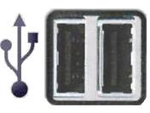
Once you have inserted the USB lead, your computer will start installing the drivers it requires to operate the Speech Mike (these are actually on the Speech Mike itself) You will receive a message stating that the installation has started, at the bottom right of the screen.

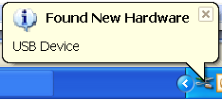

When the message above has been displayed the computer will carry on displaying other messages at the bottom of the screen whilst it installs the different parts of the Speech Mike, there will be one for the pointing device and another for the audio device. The final message that will be displayed will be one saying that your new device is ready to use.

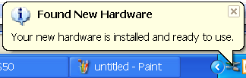

Once the above message has been displayed your Speech Mike is installed, to test this simply move the roller ball to see if the curser moves on your screen. If the curser moves the installation was successful, if not try using a different USB port. When you play your dictation back, there is a chance that the recording level will be too low to hear. If this happens, right click on the speaker icon next to your clock and ‘Open Volume Control’ from there; go to ‘Options’ and choose ‘Properties. From the properties screen you will need to select ‘Speech Mike’ from the ‘Mixer Device’ drop down box. Then select Recording from the options below the box.

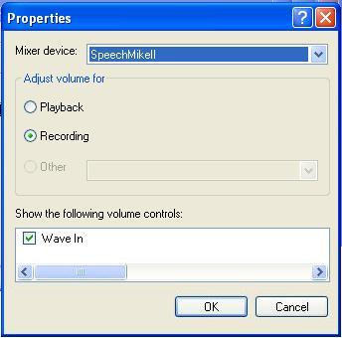

Once you have done the steps above, press ‘OK’, a volume control box will appear on your screen like the image below, all you need to do now is move the control up to about ¼. If this is too loud or quiet, adjust as appropriate. Once you are happy close the box.
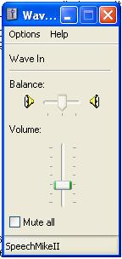

Document Control

Title | input.doc
Author | David Costin | Date Created | 01/09/2009
File Ref. | CRIB289

Approval Sign-off
Owner | Role | Method of approval | Date
David Costin | Trainer/ Application Specialist | Verbal | 01/09/2009
Approver | Role | Method of approval | Date
Helen Richards | Project Lead | Verbal | 01/09/2009

Change History
Issue | Date | Author / Editor | Details of Change
1.0 | 01/09/2009 | DC | First Issue
1.1 | 04/07/2011 | DC | Amendments to version number for 2.09.10e
Review Date |  | 04/07/2011

