

Wellbeing CRIS Launcher Client Installation Instructions

24th July 2019

# Copyright

© Wellbeing Software 2019

Registered Office: 3rd Floor i2 Mansfield, Hamilton Court, Oakham Business Park, Mansfield, NG18 5FB

These materials are or comprise restricted and proprietary confidential information of Wellbeing Software. Disclosure to or use by the recipient shall not convey any intellectual property rights in these materials. The right to use these materials by the recipient is subject to restrictions and limitations contained in the Provision of Integrated Care Record System and Associated Services Agreement and related agreements.

# Confidentiality

All information in this document is provided in confidence for the sole purpose of adjudication of the document and shall not be used for any other purpose and shall not be published or disclosed wholly or in part to any other party without Wellbeing Software prior permission in writing and shall be held in safe custody. These obligations shall not apply to information which is published or becomes known legitimately from some source other than Wellbeing Software. Many of the product, service and company names referred to in this document are trademarks or registered trademarks. They are all hereby acknowledged.

# Document Control

|  |  |  |  |  |  |
| --- | --- | --- | --- | --- | --- |
| Title | | RIS PD951 WBS CRIS Launcher Client Installation | | | |
| Author | | Daniel Vardy | | Date Created |  |
| File Ref. | |  | | | |
| CRIS Version | |  | | | |
| Change History | | | | | |
| Issue | Date | | Author / Editor | Details of Change | |
| D1.0 | 17/08/2017 | | Daniel Vardy | Draft Issue | |
| V2.0 | 31/08/2017 | |  | First Issue | |
| V3.0 | 24/07/2019 | | Chris Gregory | Added to new document template | |
| V3.1 |  | | Andrea Hardy | Updated template | |
|  |  | |  |  | |
|  |  | |  |  | |
|  |  | |  |  | |
|  |  | |  |  | |
| Review Date | | |  | | |

# Contents

Contents 2

Introduction 3

Purpose 3

Audience 3

Installing the Wellbeing Launcher Software 4

Client Side Installation 4

Permissions and exclusions 10

Removal of Wellbeing Launcher and CRIS 10

Document Control 10

# Introduction

**Purpose**

This document will outline how to install the Wellbeing Software Launcher and the CRIS radiology clinical application to allow user access.

**Audience**

This document should be used by users wishing to install and access the CRIS application.

# Installing the Wellbeing Launcher Software

This section will details how to install the Wellbeing Launcher and then the installation of the CRIS clinical application.

The Wellbeing Launcher by itself will not allow the use of CRIS.

It is advisable during this process that anti-virus software is disabled as it can prevent the installation scripts from completing correctly.

The Wellbeing Launcher executable file can be found via the CRIS application server webpage where a download link should be available.

**Client Side Installation**

Installation of the Wellbeing Launcher and CRIS should be performed by an administrative user on the terminal.

Run the Wellbeing Launcher executable file to install the Wellbeing Launcher application.

The installer will by default extract files to “C:\cris3\HSSLauncher” which is the recommended location, however this can be changed if required.

When the installer has completed the following window should appear.

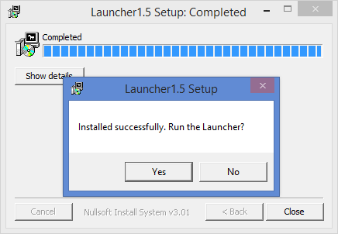

Select “Yes” to start the installation of CRIS and the configuration page shown below will appear. This can also be viewed by running the “cris.bat” file within “C:\cris3\HSSLauncher”.

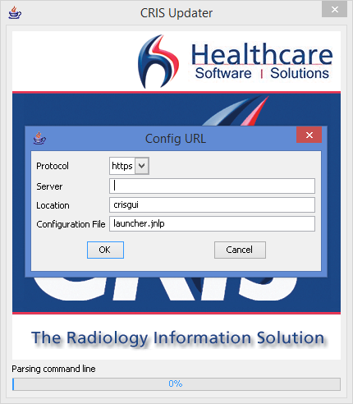

The configuration page sets up the Wellbeing Launcher to start the installation of CRIS.

A typical setup will only require the “Server” input box to be completed. This is usually the hostname of the CRIS application server which Wellbeing will have provided. Contact Wellbeing support if this is required.

After pressing the “OK” button, the below dialog window will be shown.

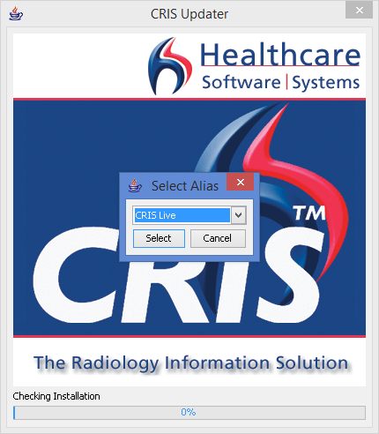

This window provides the list of available CRIS environments such as Live, Test and Train.

Pressing the “Select” button will start the process of downloading file from the CRIS application server to the terminal.

If installing multiple CRIS environments, run the “cris.bat” file found within “C:\cris3\HSSLauncher” to access the configuration page.

Once the download has completed, the CRIS application is launched and the login window is shown.

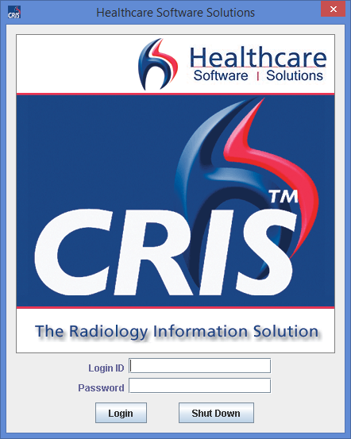

There may be a delay between the download completing and the login window showing when completing the installation for the first time.

A shortcut icon should also have been added to the Public user desktop.



Once the login details have been entered, the first time setup window will appear.

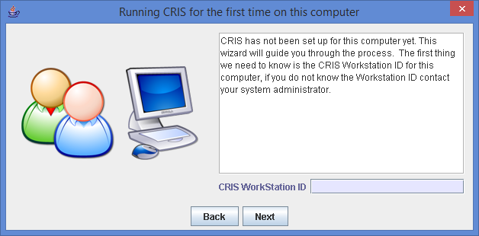

The “CRIS WorkStation ID” will be the given name of the terminal and is required before proceeding. A unique name is suggested such as the assigned asset number.

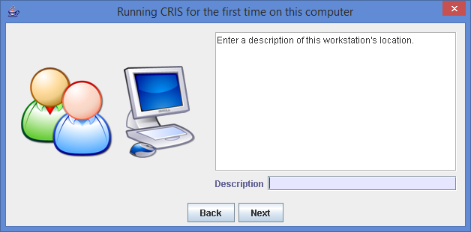

The “Description” is not a required field. This can be used to describe the terminal. A typical example would be “X-Ray reception”.

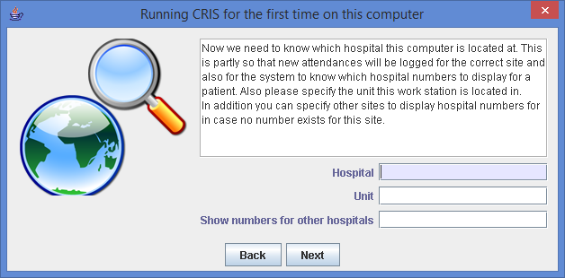

The “Hospital” field will be the location of the terminal and is required to be populated. It is possible to double-click or press F4 in these boxes to see the available options.

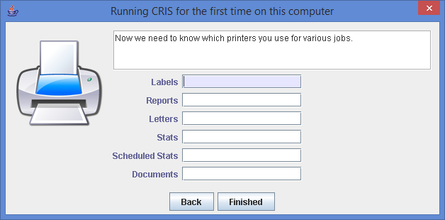

The above is the final window of the first time setup. These are for the setup of printers to be used within CRIS and are not required to be filled in to complete the installation. The printers can be later added from within the “Tools > Devices” menu within CRIS.

After clicking “Finished” the installation process has been completed and CRIS will be available.

# Permissions and exclusions

The “C:\cris3” directory and sub-directories will require the following permissions for all users:

* Execute
* Read
* Write
* Change
* Delete

It is also recommended that the “C:\cris3” directory and sub-directories are set to be in the anti-virus exclusion list.

# Removal of Wellbeing Launcher and CRIS

There is no automated method to remove the Wellbeing Launcher and the installed versions of CRIS.

To remove the Wellbeing Launcher and its components, delete the “C:\cris3” directory and the desktop shortcut found on the Public user desktop